

Performance Test Results

Translink

Trapeze Conventional Upgrade Performance Test Results

Trip Planner

Date: April 24, 2019

This report provides a summary of the results of performance tests conducted in the Trapeze Staging environment for Translink

Prepared by:

Chris Flint

Professional Quality Assurance Ltd.

# Executive Summary

PQA conducted several rounds of performance testing against Translink’s Trapeze Trip Planning implementation. The purpose of the testing was to determine whether the Trip Planning Service, as implemented, can sustain the typical load levels for normal and peak day-to-day operations.

The scope of the testing involved the creation of a new script that simulated the user activity over the course of an hour. The average user session lasted approximately 2 minutes, and involved typical trip planner usage (opening the trip planner page, searching for an origin and a destination, and reviewing returned results). Historical usage stats are found below – while this is expressed in terms of users/hour, it should be noted that, for the tests, the individual users were spread out fairly evenly across the course of an hour:

|  |  |
| --- | --- |
| Trip Planner historical peak | 4000 users/hour |
| Trip Planner typical hour | 1400-1500 users/hour |

Measurements of the response times and throughput captured during the testing were the primary metrics used to evaluate the service. Also of interest were the server resource usage statistics – comprising CPU use, memory use, network bandwidth, and disk R/W operations.

*High Level Results*

For the Trip Planner, there are 5 defined load scenarios, covered by 16 total test runs. The scenarios are:

* A historical peak test (1 run)
* Incremental increase to failure test (7 runs; increasing load per run)
* A spike test (1 run)
* A future capacity test (6 runs; increasing load per run)
* An endurance/stress test (1 run)

There are 2 servers currently set up in the staging environment: TRPPLNWEBS001 and TRPPLNWEBS002; both servers were exercised in the course of the testing. One set of runs were conducted against individual servers directly; the second set of runs were conducted against the load balancer.

In general, transaction times were good under typical day-to-day conditions, with a few slowdowns under heavier loads. In terms of overall results, our transaction breakdown looked like:

|  |  |  |
| --- | --- | --- |
| *Transaction* | *Average Response Times (Single Server)* | *Average Response Times (Load Balancer)* |
| Open Trip Planner page | ~1.6 secs | ~2.1 secs |
| Enter Origin (and get results back) | ~0.2 secs | ~0.2 secs |
| Enter Destination (and get results back) | ~0.1 secs | ~0.2 secs |
| Submit (by selecting locations from the returned origin and destination) | ~2.5 secs | ~3.5 secs |
| Retrieve Individual Itineraries (if any were found between the origin and destination) | ~0.3 secs | ~0.6 secs |

These should be fairly close to what we would expect an end-user to see, bearing in mind that their browsers will take slightly longer to “paint” the window (filling in the map, drawing itineraries, et cetera). The extra “hop” at the load balancer looks to add a bit of time to the response times.

Likewise, the server resource usage looked good, settling into a range like the following:

|  |  |  |
| --- | --- | --- |
| *Resource Statistic* | *Moderate Load (16 concurrent users)* | *High Load (125 concurrent users)* |
| CPU Usage | ~5% | ~24% |
| Memory Usage | ~28% | ~30% |
| Network Data Receive Rate | ~94 KBps | ~574 KBps |
| Network Data Transmit Rate | ~763 KBps | 5395 KBps |
| Virtual Disk Read Throughput | 0 KBps | ~0.7 KBps |
| Virtual Disk Write Throughput | ~59 KBps | 254 KBps |

However, TRPPLNWEBS001 did have remarkably high memory usage, described further below.

*Potential Issues Encountered*

While the averages above are useful for getting a broad sense of the majority of users’ experience, there are a few potential issues uncovered in the course of the testing:

* TRPPLNWEBS001 continues to have high memory usage – this was regularly recorded as being in the 90% range, as compared to a peak of 30% for TRPPLNWEBS002
* The Submit transaction continues to be our most system intensive transaction and can “bog down” as load increases. At moderate load levels, as many as 10% of users can end up waiting 20 seconds or more for a response; this may be related to the memory leak mentioned above.
  + This transaction consists of an Itinerary Lookup Request POSTed to InfoWeb, using the origin and destination locations selected by the user
* During the (single server) 24-hour endurance test, TRPPLNWEBS002 had a brief outage (lasting ~1 minute; May 24th 9:26-9:27 AM) where it refused all incoming connections.

# Testing Summary and Results

Performance Testing Methodology

5 Performance testing scenarios have been devised to realistically simulate users working with the Trip Planner site. These scenarios are intended to exercise the staging environment in order to determine the overall behavior and any thresholds for peak and maximum capacity. It should be noted that these scenarios are a subset of all scenarios devised for the Trapeze performance testing.

All scenarios will use scripts developed with Apache JMeter (an open-source performance testing tool).

Detailed descriptions of the Trip Planner load scenarios can be found below, alongside parameters for expected virtual users (derived from the test requirements) and test durations. In many cases, the expected users are listed as “users per hour” at the load balancer, that is, for the whole system. When the scenarios are run, the expected user counts are adapted to the staging environment of 2 servers and changed to a concurrent user count – the test results further below will have precise numbers.

Test Scenarios

**Scenario 1: Trip Planner Historical Peak**

* Navigate to the Trip Planner page
* Enter an origin location
* Enter a destination location
* Submit the two locations in a request to generate trip plans

*Expected Users*: Equivalent to at least 67 users/min at the load balancer

*Duration*: 60 minutes with 1-minute ramp-up

*Environment*: Staging

*Key Performance Metrics*: response time, concurrent users, server resource utilization (CPU, Memory)

**Scenario 2: Trip Planner Incremental Increase to Failure**

* This is several runs at increasing load levels to attempt to determine where the user error rate or transaction response time is over the acceptable level.

*Expected Users*: 16 -> 32 -> 48 -> 64 -> 80 -> 100 -> 125 (concurrent users/server; doubled for the load balancer runs)

*Duration*: 20 minutes with 1-minute ramp-up per run

*Environment*: Staging

*Key Performance Metrics*: response time, concurrent users, server resource utilization (CPU, Memory)

**Scenario 3: Trip Planner Spike Test**

* A drastic increase in users over a short time to simulate something like a snow day

*Expected Users*: 500 -> 5000 (per hour; at the load balancer)

*Duration*: 10-second ramp-up time

*Environment*: Staging

*Key Performance Metrics*: response time, concurrent users, server resource utilization (CPU, Memory)

**Scenario 4: Trip Planner Future Capacity**

* This explores whether the system has the capacity to cover several years of expected growth, in order to determine when future upgrades may be needed

*Expected Users*: Start from a typical user load, and complete 5 more runs, increasing by 10% each time

*Duration*: ~60 minutes with 1-minute ramp-up per run

*Environment*: Staging

*Key Performance Metrics*: response time, concurrent users, server resource utilization (CPU, Memory)

**Scenario 5: Trip Planner Endurance Test**

* A long run to see how the servers perform under lengthy periods of stress

*Expected Users*: 5000 (per hour; at the load balancer)

*Duration*: 24 hours

*Environment*: Staging

*Key Performance Metrics*: response time, concurrent users, server resource utilization (CPU, Memory)

Special Scenarios

In addition to the traditional server performance testing against the Trip Planning implementation, there were also several front-end scenarios of interest. In particular, there were 11 scenarios that needed to be executed against the Trip Planner and the OPS Web services.

This involved the creation of several new Selenium/WebDriver scripts that JMeter could execute automatically, using the Chrome Driver to run a Chrome browser instance, in order to simulate what an actual user would experience. The tables below provide a summary of the scenarios in question, their expected results, the actual results, and a pass/fail.

|  |  |  |  |  |  |  |  |  |
| --- | --- | --- | --- | --- | --- | --- | --- | --- |
| ***Trip Planner Scenarios*** | | | | | | | | |
| **Departing From** | **Going To** | **Arriving/Departing** | **Time** | **Date** | **Options** | **Expected Results** | **Actual Results** | **Pass/Fail** |
| Marine and Capilano | Georgia and Burrard | Arriving | 6:00 AM | Sunday Date | Accept Defaults | *Cannot match parameters*: Time out at 20 seconds and error message displayed | Time out after 30 seconds; error message displayed | **Fail** |
| Granville and Davie | Waterfront Station | Arriving | 5:00 PM | Today’s Date | Allow more Transfers | *Too many possible layouts*: Time out at 30 seconds and error message displayed | Time out after 30 seconds; error message displayed | **Pass** |
| Granville and Davie | Waterfront Station | Arriving | 5:00 PM | Today’s Date | Accept Defaults | Response within 12 seconds | Response returned within 12 seconds | **Pass** |
| Lonsdale and 29 | Steveston Village | Arriving | 12:00 PM | Today’s Date | Accept Defaults | Response within 12 seconds | Response returned within 12 seconds | **Pass** |
| 22nd Street Station | 29th Avenue Station | Arriving | 12:00 PM | Today’s Date | Accept Defaults | *Vanilla Trip*: Response within 5 seconds  *Rerun data set*: Response within 1 second  *Rerun data set, plus select “View Detail”*: Response within 2 seconds | *Vanilla Trip*: Response returned within 5 seconds  *Rerun*: Response returned within 1 second  *View Detail*: Response returned within 2 seconds | **Pass** |
| Burrard and Robson | Hamilton and Pender | Arriving | 12:00 PM | Today’s Date | Requires Wheelchair Access | *Wheelchair accessible with many layout possibilities*: Response within 20 seconds | Response returned within 30 seconds | **Fail** |
| Newton Exchange | Coquitlam Central Station | Arriving | 12:00 PM | Today’s Date | Allow More Transfers | *Involves 4 or more legs, with allow more transfers*: Response within 13 seconds | Response returned within 13 seconds | **Pass** |
| Newton Exchange | Coquitlam Central Station | Arriving | 12:00 PM | Today’s Date | Accept Default | *Involves 4 legs*: Response within 10 seconds | Response returned within 10 seconds | **Pass** |
| Waterfront Station | Scott Exchange | Arriving | 12:00 PM | Today’s Date | Get Lines and Stops for Origin only  De-select all  Re-select 014EAST | Response under 1 second  Subsequent runs should be under 1 second | These options are not available in the new Trip Planner, so this test was not run | **N/A** |

|  |  |  |  |  |
| --- | --- | --- | --- | --- |
| ***Next Bus Scenarios*** | | | | |
| **Scenario** | **Steps** | **Expected Results** | **Actual Results** | **Pass/Fail** |
| Schedule Lookup | Look up the schedule for the 116 bus route plan.  Steps:   1. Enter tripplanning.stg.translink.ca into browser 2. Enter “116” in Enter Location field 3. Select “116 EDMONDS STN/METROTOWN STN EAST” from the dropdown menu | Response under 1 second | Response returned under 1 second | **Pass** |
| Next Bus at Stop | Look up the next bus for a bus stop # 52707  Steps:   1. Enter tripplanning.stg.translink.ca into browser 2. Enter 52707 in the Enter Location field. 3. Select “52707 EB NORTH FRASER WAY AT 3700 BLOCK” from the dropdown menu | Response under 1 second | Response returned under 1 second | **Pass** |
| Find Nearby Stops | Look up nearby stops without using the bus stop number  Steps:   1. Enter tripplanning.stg.translink.ca into browser 2. Enter “Marine Way and Boundary” in the Enter Location field 3. Select “MARINE WAY @ BOUNDARY RD, VANCOUVER” from the drop down. | Response under 1 second | Response returned under 1 second | **Pass** |

|  |  |  |  |  |
| --- | --- | --- | --- | --- |
| ***OPS Web Scenarios*** | | | | |
| **Scenario** | **Steps** | **Expected Results** | **Actual Results** | **Pass/Fail** |
| Driver Login | User signs in  Steps:   1. Enter <http://trpopsapps002:9005/hiwire?.a=opHome>   into browser   1. Enter Badge Number: 1609 PIN: 1609 2. Click Login button | Less than 2 seconds | User logged in under 2 seconds | **Pass** |
| Driver Paddle | User opens the Paddle  Steps:   1. Enter <http://trpopsapps002:9005/hiwire?.a=opHome>   into browser   1. Enter Badge Number: 1609 PIN: 1609 2. Click Login button 3. Select Assignment Calendar from Daily Assignments menu 4. Select June from month drop down 5. Select 2018 from year drop down 6. Click on search button 7. Click a paddle icon in the calendar | Less than 24 seconds | Driver Paddle returned under 24 seconds | **Pass** |

Test Results

Here can be found the performance testing results. All scenarios executed with JMeter have measured transaction statistics, as well as the following graphs:

JMeter Graphs:

* Running Users – displays the number of active virtual users during the script execution. Intended to give a sense of the user load at any given point.
* Hits per Second – displays the number of hits on the server during each second of the test. Intended to give a sense of how active a user is at any given second.
* Transactions per Second – displays the number of completed transactions during each second of the test (successful or unsuccessful). Intended to give a sense of the actual transactional load on the system at any given point
* Average Transaction Response Time – displays the average time take to get a response from the server during the load test. Intended to approximate the end-user experience as load is applied to the service. If a transaction runs notably slower than the others, then a second graph is given with just the “fast” transactions.

All JMeter graphs have a granularity of 1 minute, which provides a smoother curve and has the advantage of being easier to read.

We also have a set of server graphs, grouped together by day and scenario, and an explanation of what’s happening is given.

Server Graphs:

* CPU Usage (% or MHz)
* Memory Usage (%)
* Network Data Receive Rate (KBps)
* Network Data Transmit Rate (KBps)
* Virtual Disk Read Throughput (KBps)
* Virtual Disk Write Throughput (KBps)

**Scenario 1.1 – Trip Planner Historical Peak – Single Server**

Scope: This run was completed to determine whether the service can handle a load equivalent to the most recent peak in usage. Given the peak was 4000 users/hour, and assuming that the production load balancer spreads the load out evenly between 16 servers, a load level of 250 users/hour was the target.

Tool: JMeter

JMeter Setup: 8 users, 60 second ramp-up, 31 loops

Server: TRPPLNWEBS001

Start Time: 2019-May-22 12:27 AM (PDT)

End Time: 2019-May-22 01:26 PM (PDT)

Notes: There appears to be an issue with a memory leak on this server, as the memory usage seems usually high. The Submit transaction appears to be the most adversely affected, particularly in the last 20 minutes of the run. 10% of users would likely see response times of 23 seconds or more, 1% of users would likely see response times of 53 seconds or more.

Running Users

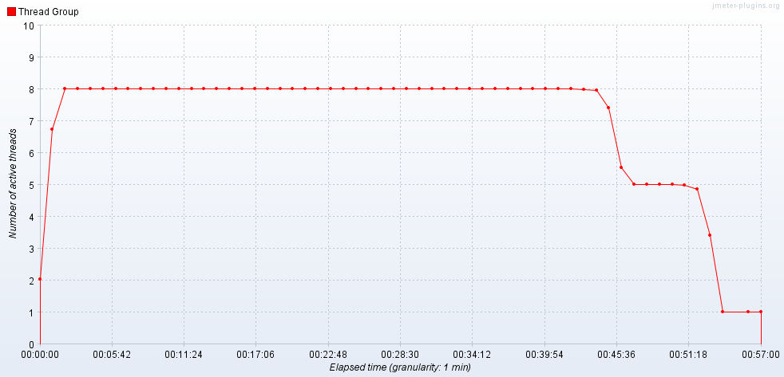

Hits per Second

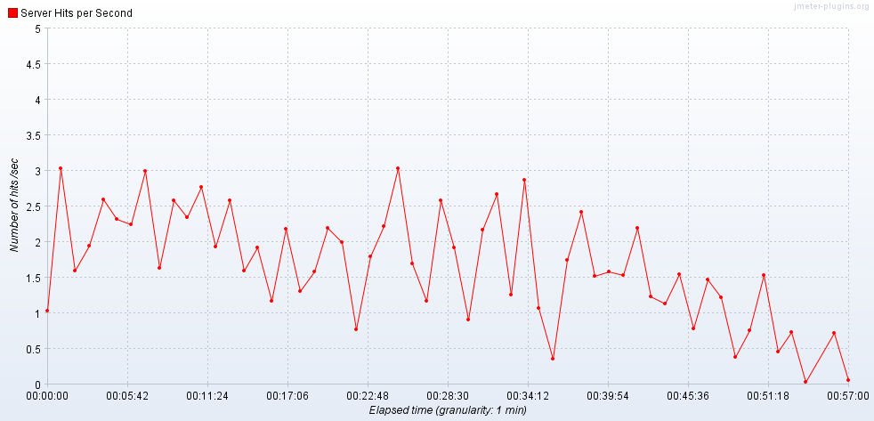

Transactions per Second

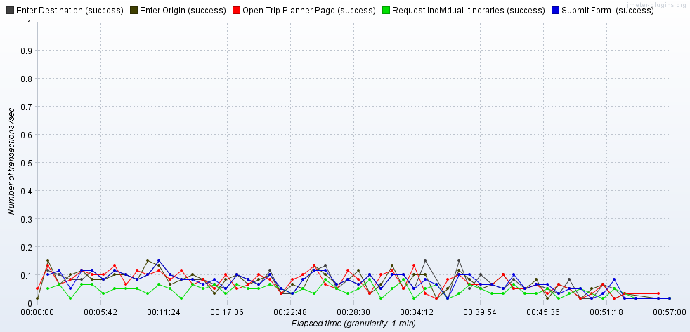

Transaction Statistics

|  |  |  |  |  |  |  |  |  |  |  |  |  |
| --- | --- | --- | --- | --- | --- | --- | --- | --- | --- | --- | --- | --- |
| Label | # Samples | Average | Median | 90% Line | 95% Line | 99% Line | Min | Max | Error % | Throughput | Received KB/sec | Sent KB/sec |
| Open Trip Planner Page | 248 | 1610 | 1575 | 1792 | 2276 | 2775 | 1101 | 2923 | 0.00% | 0.07342 | 317.76 | 1.78 |
| Enter Origin | 248 | 186 | 172 | 268 | 299 | 649 | 91 | 822 | 0.00% | 0.07351 | 0.29 | 0.04 |
| Enter Destination | 248 | 158 | 136 | 228 | 255 | 419 | 88 | 666 | 0.00% | 0.07353 | 0.27 | 0.04 |
| Submit | 248 | 6226 | 1734 | 23454 | 32853 | 48338 | 105 | 53638 | 0.00% | 0.07308 | 11.34 | 0.66 |
| Request Individual Itineraries | 146 | 311 | 289 | 436 | 573 | 673 | 80 | 721 | 0.00% | 0.04306 | 6.16 | 0.51 |
| TOTAL | 6842 | 593 | 7 | 1218 | 1622 | 21565 | 2 | 53638 | 0.00% | 1.99303 | 648.86 | 4.98 |

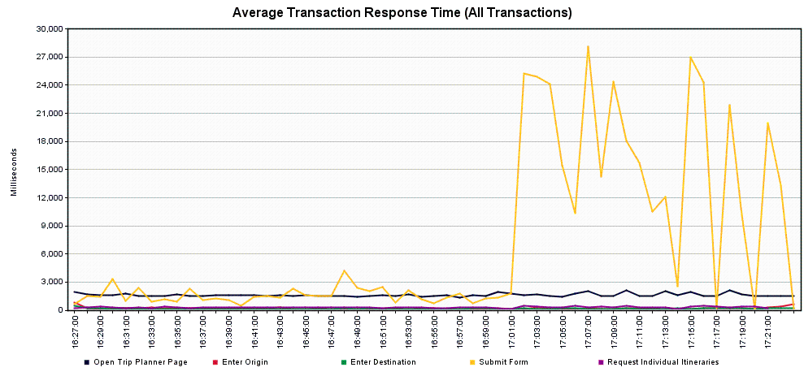

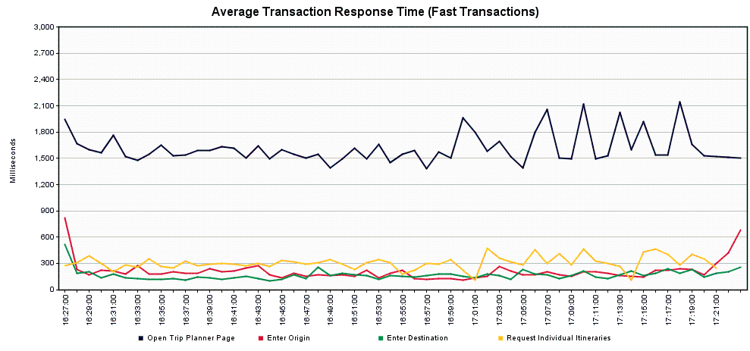

**Scenario 1.2 – Trip Planner Historical Peak – Load Balancer**

Scope: This run was completed to determine whether the service can handle a load equivalent to the most recent peak in usage. Given the peak was 4000 users/hour, and assuming that the production load balancer spreads the load out evenly between 16 servers, a load level of 500 users/hour was the target for 2 servers in staging.

Tool: JMeter

JMeter Setup: 16 users, 60 second ramp-up, 31 loops

Server: tripplanning.stg.translink.ca

Start Time: 2019-May-28 07:42 AM (PDT)

End Time: 2019-May-28 08:37 AM (PDT)

Notes: The service looks to perform admirably at this level of load. The only potential point of concern would be the Submit transaction, where 5% of users would likely see response times of 7 seconds or more, and 1% of users would likely see response times of 16 seconds or more.

Running Users

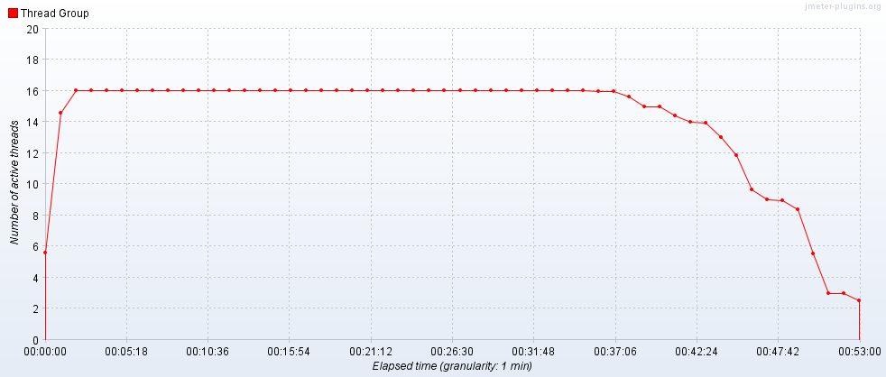

Hits per Second

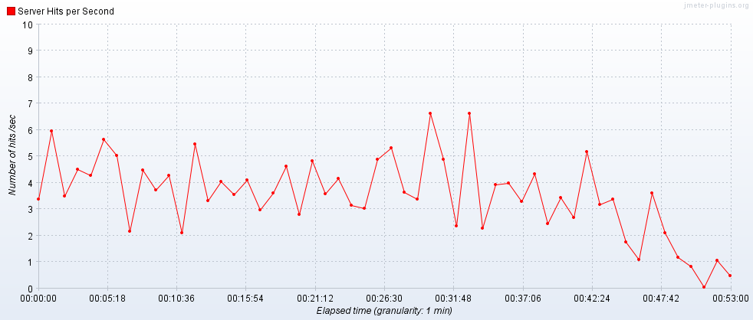

Transactions per Second

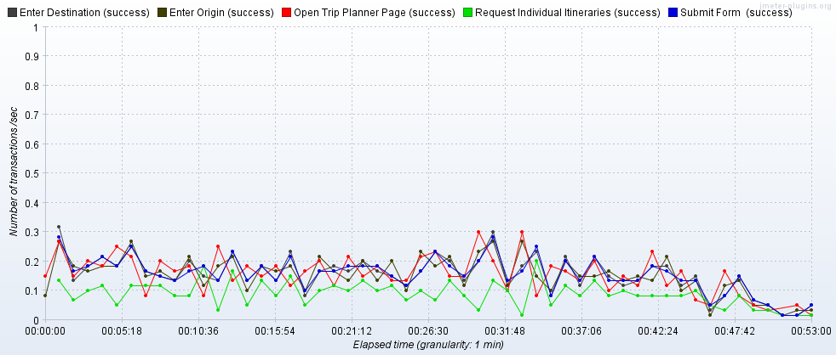

Transaction Statistics

|  |  |  |  |  |  |  |  |  |  |  |  |  |
| --- | --- | --- | --- | --- | --- | --- | --- | --- | --- | --- | --- | --- |
| Label | # Samples | Average | Median | 90% Line | 95% Line | 99% Line | Min | Max | Error % | Throughput | Received KB/sec | Sent KB/sec |
| Open Trip Planner Page | 496 | 2106 | 2031 | 2378 | 2604 | 3723 | 1542 | 10851 | 0.00% | 0.15685 | 676.76 | 5.25 |
| Enter Origin | 496 | 183 | 136 | 379 | 418 | 689 | 89 | 1105 | 0.00% | 0.15708 | 0.9 | 0.1 |
| Enter Destination | 496 | 150 | 122 | 193 | 300 | 673 | 88 | 1210 | 0.00% | 0.15718 | 0.61 | 0.1 |
| Submit | 496 | 2478 | 2553 | 4462 | 7228 | 16373 | 97 | 33667 | 0.00% | 0.15704 | 24.84 | 1.51 |
| Request Individual Itineraries | 282 | 577 | 546 | 813 | 846 | 915 | 92 | 2751 | 0.00% | 0.0894 | 14.11 | 1.16 |
| TOTAL | 13674 | 356 | 12 | 1678 | 2113 | 3674 | 3 | 33667 | 0.00% | 4.27352 | 1389.7 | 13.76 |

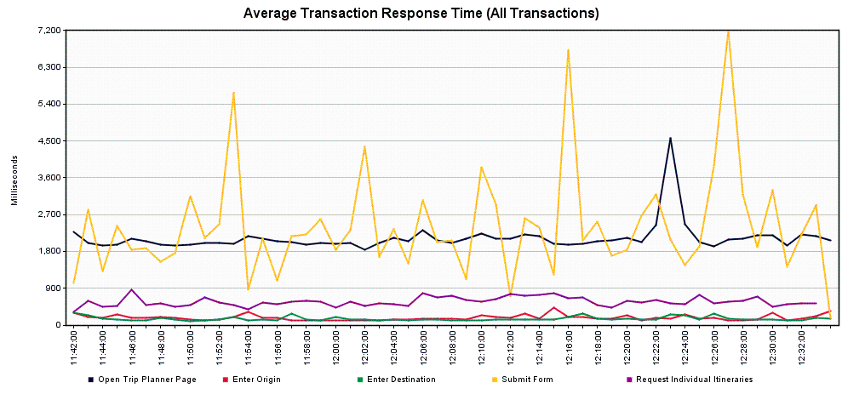

**Scenario 2.1 – Trip Planner Incremental Increase to Failure – Single Server**

Scope: This was completed as a series of runs to determine where the service encounters errors or excessively high response times for a significant number of users. In order to push the service, higher load levels were used, beginning with 16 concurrent users and culminating with 125 concurrent users.

*Scenario 2.1.1 – Trip Planner Incremental Increase to Failure – 16 concurrent users*

Tool: JMeter

JMeter Setup: 16 users, 60 second ramp-up, 10 loops

Server: TRPPLNWEBS002

Start Time: 2019-May-23 08:57 AM (PDT)

End Time: 2019-May-23 09:16 AM (PDT)

Notes: Luckily, this server doesn’t seem to have the same memory leak that the other one does. The Submit transaction starts to have a few slowdowns here – 10% of users would likely see response times of 3 seconds or more, 1% of users would likely see response times of 11 seconds or more.

Running Users

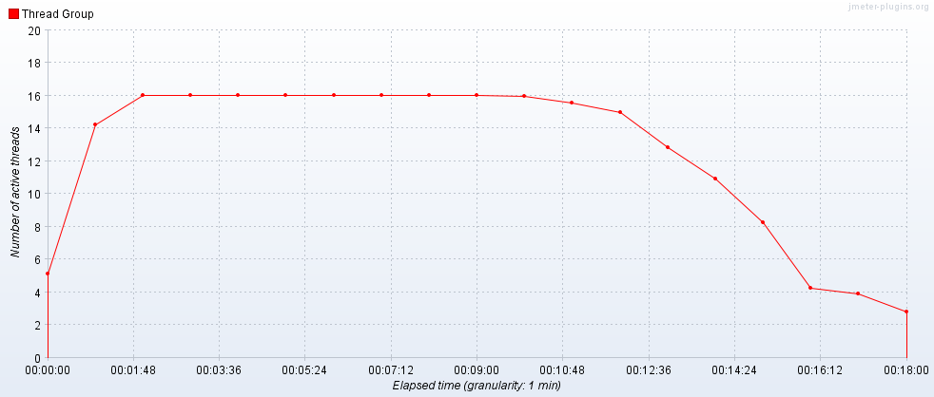

Hits per Second

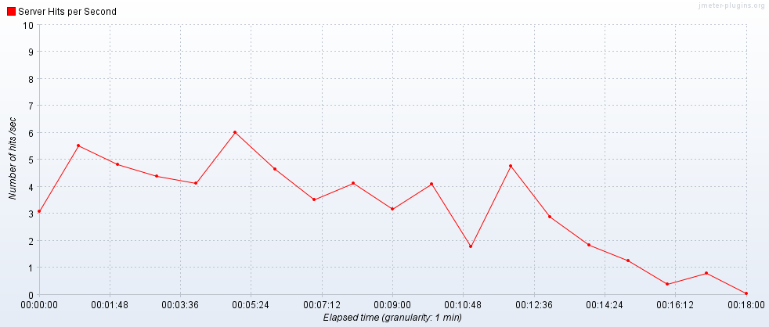

Transactions per Second

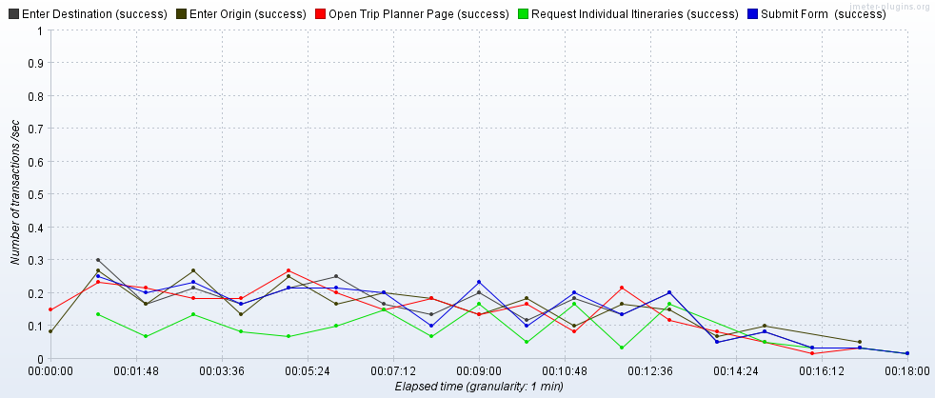

Transaction Statistics

|  |  |  |  |  |  |  |  |  |  |  |  |  |
| --- | --- | --- | --- | --- | --- | --- | --- | --- | --- | --- | --- | --- |
| Label | # Samples | Average | Median | 90% Line | 95% Line | 99% Line | Min | Max | Error % | Throughput | Received KB/sec | Sent KB/sec |
| Open Trip Planner Page | 160 | 1564 | 1546 | 1772 | 1947 | 2117 | 1140 | 2759 | 0.00% | 0.15655 | 677.58 | 3.8 |
| Enter Origin | 160 | 195 | 169 | 262 | 330 | 688 | 93 | 1349 | 0.00% | 0.15725 | 0.64 | 0.08 |
| Enter Destination | 160 | 156 | 122 | 214 | 255 | 486 | 93 | 1472 | 0.00% | 0.15725 | 0.62 | 0.08 |
| Submit | 160 | 1951 | 1500 | 3168 | 5002 | 11117 | 98 | 32032 | 0.00% | 0.15695 | 23.12 | 1.4 |
| Request Individual Itineraries | 91 | 287 | 252 | 352 | 387 | 455 | 112 | 2319 | 0.00% | 0.08958 | 12.32 | 1.08 |
| TOTAL | 4411 | 280 | 7 | 1228 | 1564 | 2647 | 2 | 32032 | 0.00% | 4.1619 | 1353.74 | 10.35 |

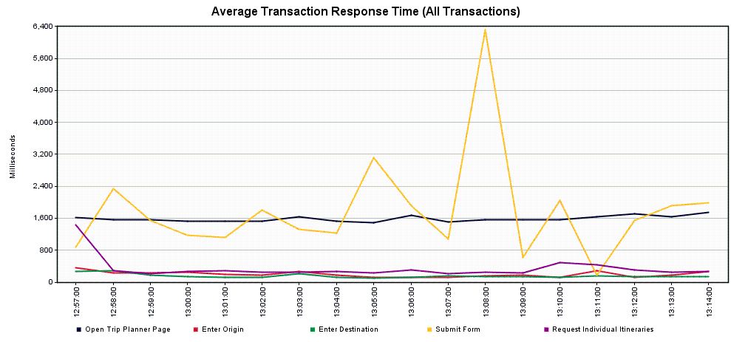

*Scenario 2.1.2 – Trip Planner Incremental Increase to Failure – 32 concurrent users*

Tool: JMeter

JMeter Setup: 32 users, 60 second ramp-up, 10 loops

Server: TRPPLNWEBS002

Start Time: 2019-May-23 09:17 AM (PDT)

End Time: 2019-May-23 09:36 AM (PDT)

Notes: The Submit transaction continues to slow – 10% of users would likely see response times of 4 seconds or more, 1% of users would likely see response times of 14 seconds or more.

Running Users

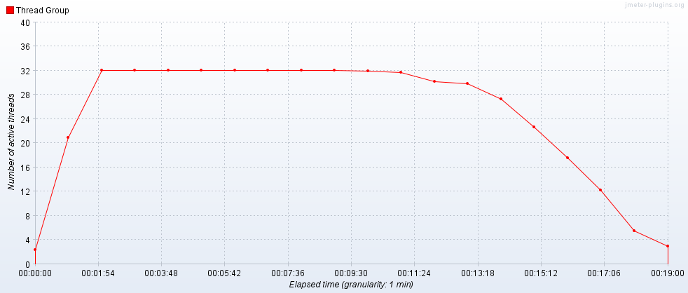

Hits per Second

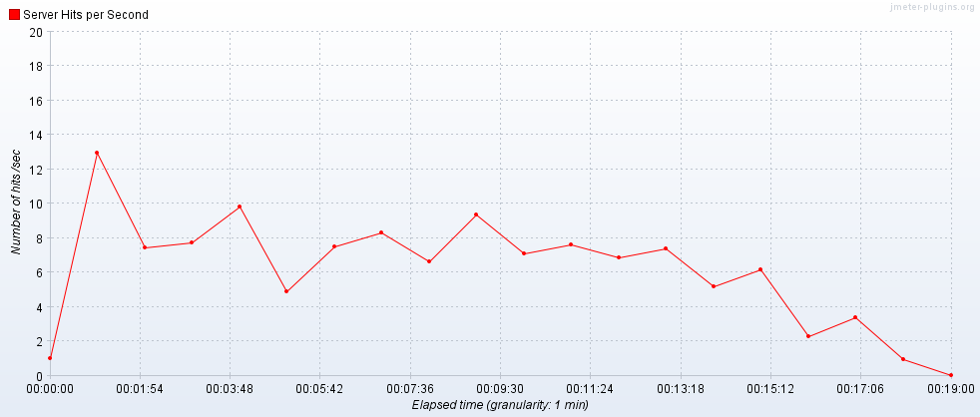

Transactions per Second

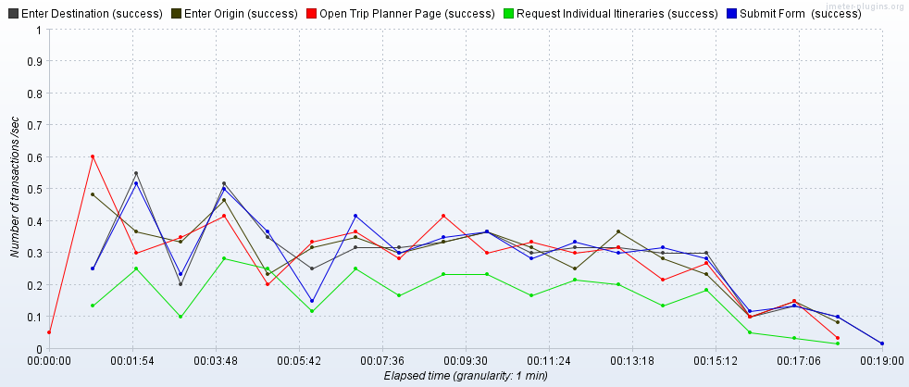

Transaction Statistics

|  |  |  |  |  |  |  |  |  |  |  |  |  |
| --- | --- | --- | --- | --- | --- | --- | --- | --- | --- | --- | --- | --- |
| Label | # Samples | Average | Median | 90% Line | 95% Line | 99% Line | Min | Max | Error % | Throughput | Received KB/sec | Sent KB/sec |
| Open Trip Planner Page | 320 | 1546 | 1537 | 1747 | 1856 | 2126 | 1095 | 3037 | 0.00% | 0.30373 | 1314.63 | 7.37 |
| Enter Origin | 320 | 154 | 137 | 210 | 263 | 445 | 88 | 696 | 0.00% | 0.30453 | 1.35 | 0.16 |
| Enter Destination | 320 | 133 | 117 | 189 | 219 | 301 | 88 | 430 | 0.00% | 0.30379 | 1 | 0.16 |
| Submit | 320 | 1954 | 1505 | 3997 | 6979 | 14359 | 96 | 31941 | 0.00% | 0.30379 | 46.64 | 2.7 |
| Request Individual Itineraries | 181 | 271 | 265 | 342 | 372 | 416 | 85 | 597 | 0.00% | 0.18295 | 27.46 | 2.19 |
| TOTAL | 8821 | 274 | 6 | 1182 | 1552 | 2869 | 2 | 31941 | 0.00% | 8.07501 | 2630.3 | 20.06 |

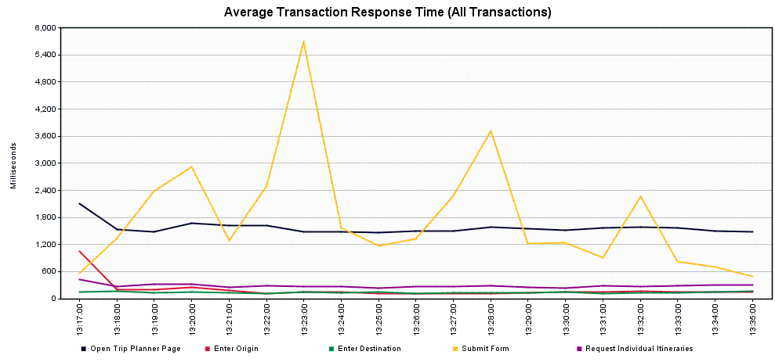

*Scenario 2.1.3 – Trip Planner Incremental Increase to Failure – 48 concurrent users*

Tool: JMeter

JMeter Setup: 48 users, 60 second ramp-up, 10 loops

Server: TRPPLNWEBS002

Start Time: 2019-May-23 09:39 AM (PDT)

End Time: 2019-May-23 10:00 AM (PDT)

Notes: The performance of the Submit transaction continues to degrade a bit – 10% of users would likely see response times of 5.5 seconds or more, 1% of users would likely see response times of 23 seconds or more.

Running Users

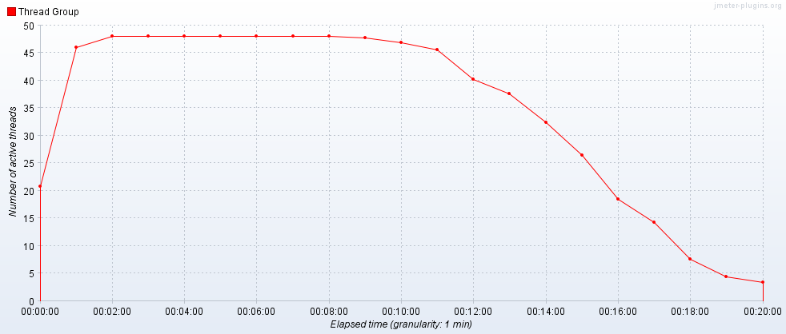

Hits per Second

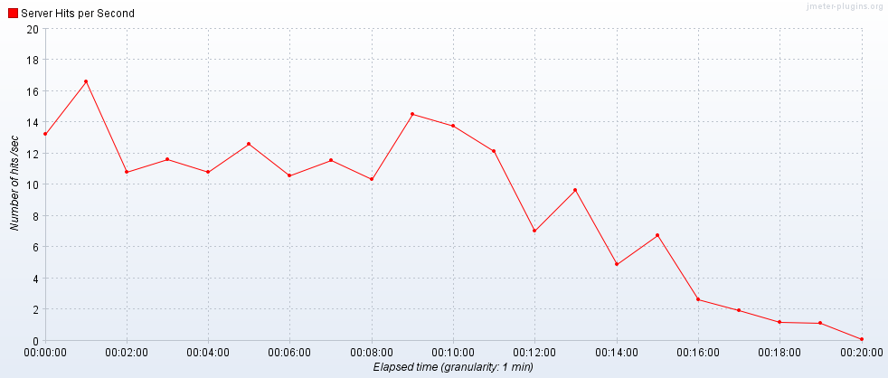

Transactions per Second

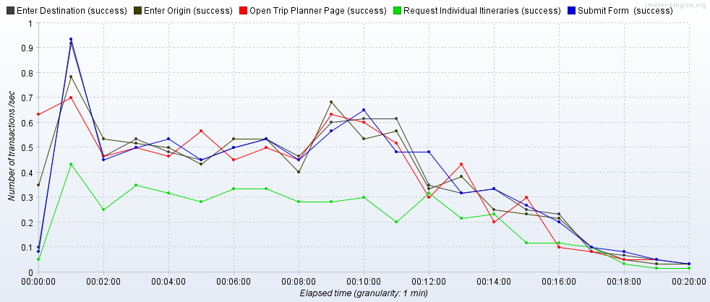

Transaction Statistics

|  |  |  |  |  |  |  |  |  |  |  |  |  |
| --- | --- | --- | --- | --- | --- | --- | --- | --- | --- | --- | --- | --- |
| Label | # Samples | Average | Median | 90% Line | 95% Line | 99% Line | Min | Max | Error % | Throughput | Received KB/sec | Sent KB/sec |
| Open Trip Planner Page | 480 | 1548 | 1544 | 1717 | 1817 | 2181 | 1072 | 2411 | 0.00% | 0.40554 | 1755.3 | 9.85 |
| Enter Origin | 480 | 139 | 129 | 185 | 203 | 358 | 86 | 759 | 0.00% | 0.4055 | 2.33 | 0.22 |
| Enter Destination | 480 | 132 | 114 | 184 | 218 | 391 | 87 | 699 | 0.00% | 0.40546 | 1.57 | 0.22 |
| Submit | 480 | 2564 | 1579 | 5479 | 10891 | 23064 | 96 | 32926 | 0.00% | 0.40501 | 64.24 | 3.61 |
| Request Individual Itineraries | 275 | 286 | 273 | 360 | 398 | 546 | 70 | 2293 | 0.00% | 0.23274 | 36.58 | 2.76 |
| TOTAL | 13235 | 318 | 7 | 1231 | 1570 | 3685 | 2 | 32926 | 0.00% | 10.82781 | 3531.52 | 26.92 |

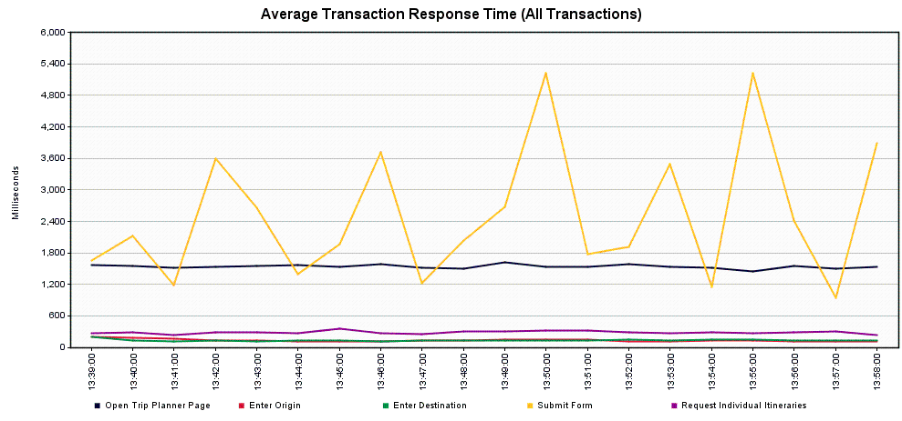

*Scenario 2.1.4 – Trip Planner Incremental Increase to Failure – 64 concurrent users*

Tool: JMeter

JMeter Setup: 64 users, 60 second ramp-up, 10 loops

Server: TRPPLNWEBS002

Start Time: 2019-May-23 10:04 AM (PDT)

End Time: 2019-May-23 10:24 AM (PDT)

Notes: The Submit transaction is roughly consistent with the previous run – 10% of users would likely see response times of 6 seconds or more, 1% of users would likely see response times of 23 seconds or more.

Running Users

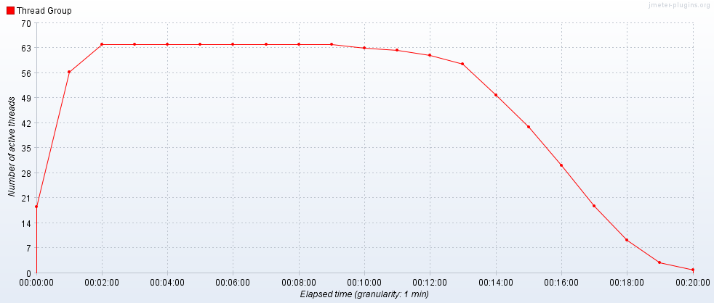

Hits per Second

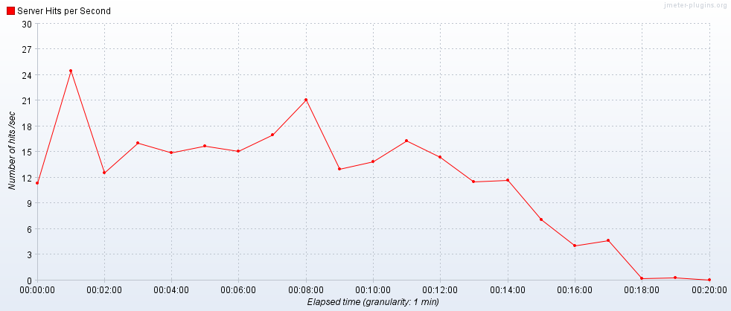

Transactions per Second

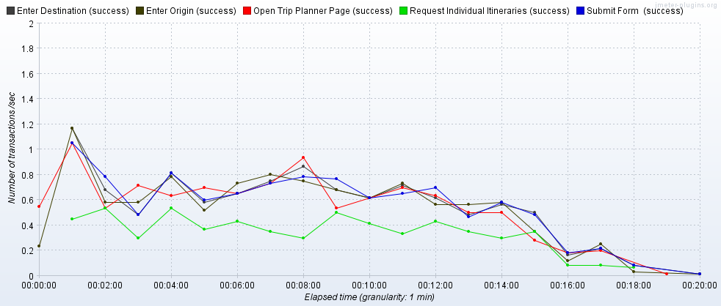

Transaction Statistics

|  |  |  |  |  |  |  |  |  |  |  |  |  |
| --- | --- | --- | --- | --- | --- | --- | --- | --- | --- | --- | --- | --- |
| Label | # Samples | Average | Median | 90% Line | 95% Line | 99% Line | Min | Max | Error % | Throughput | Received KB/sec | Sent KB/sec |
| Open Trip Planner Page | 640 | 1552 | 1552 | 1731 | 1828 | 2092 | 1043 | 2760 | 0.00% | 0.54734 | 2369.04 | 13.29 |
| Enter Origin | 640 | 139 | 116 | 200 | 241 | 386 | 84 | 691 | 0.00% | 0.54784 | 2.94 | 0.29 |
| Enter Destination | 640 | 130 | 114 | 181 | 225 | 279 | 83 | 733 | 0.00% | 0.54821 | 2.4 | 0.29 |
| Submit | 640 | 2800 | 1612 | 6350 | 11966 | 22772 | 114 | 33019 | 0.00% | 0.54822 | 87.64 | 4.92 |
| Request Individual Itineraries | 371 | 295 | 288 | 391 | 427 | 515 | 66 | 939 | 0.00% | 0.3534 | 55.27 | 4.17 |
| TOTAL | 17651 | 335 | 7 | 1220 | 1595 | 4668 | 2 | 33019 | 0.00% | 14.6716 | 4785.49 | 36.51 |

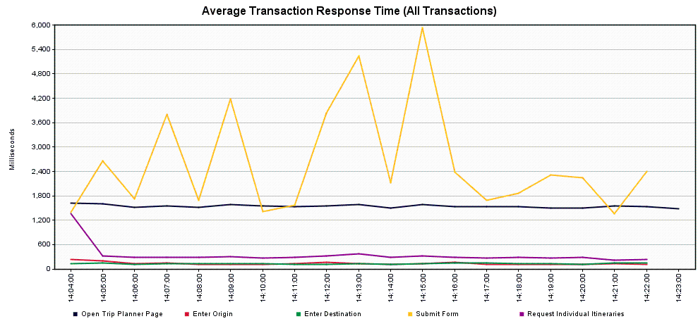

*Scenario 2.1.5 – Trip Planner Incremental Increase to Failure – 80 concurrent users*

Tool: JMeter

JMeter Setup: 80 users, 60 second ramp-up, 10 loops

Server: TRPPLNWEBS002

Start Time: 2019-May-23 10:26 AM (PDT)

End Time: 2019-May-23 10:49 AM (PDT)

Notes: The Submit transaction continues to degrade slightly – 10% of users would likely see response times of ~8 seconds or more, 1% of users would likely see response times of 26 seconds or more.

Running Users

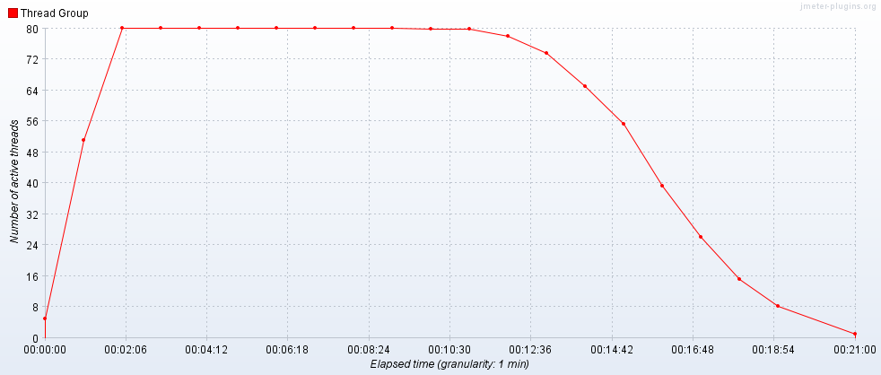

Hits per Second

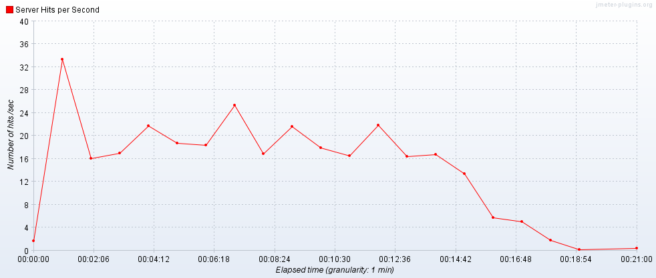

Transactions per Second

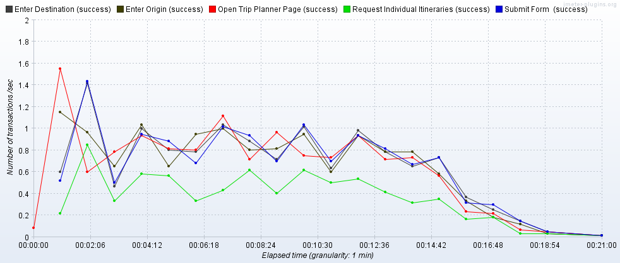

Transaction Statistics

|  |  |  |  |  |  |  |  |  |  |  |  |  |
| --- | --- | --- | --- | --- | --- | --- | --- | --- | --- | --- | --- | --- |
| Label | # Samples | Average | Median | 90% Line | 95% Line | 99% Line | Min | Max | Error % | Throughput | Received KB/sec | Sent KB/sec |
| Open Trip Planner Page | 800 | 1644 | 1591 | 1942 | 2098 | 2683 | 1031 | 6166 | 0.00% | 0.66173 | 2864.16 | 16.07 |
| Enter Origin | 800 | 138 | 111 | 205 | 265 | 484 | 78 | 1193 | 0.00% | 0.66132 | 3.45 | 0.35 |
| Enter Destination | 800 | 137 | 113 | 197 | 250 | 526 | 79 | 882 | 0.00% | 0.66071 | 3.5 | 0.35 |
| Submit | 800 | 3236 | 1836 | 7935 | 13238 | 26394 | 108 | 33008 | 0.00% | 0.65949 | 101.8 | 5.8 |
| Request Individual Itineraries | 450 | 329 | 311 | 467 | 520 | 694 | 65 | 1518 | 0.00% | 0.37172 | 57.82 | 4.4 |
| TOTAL | 22050 | 374 | 8 | 1254 | 1663 | 5938 | 2 | 33008 | 0.00% | 17.63922 | 5750.97 | 43.7 |

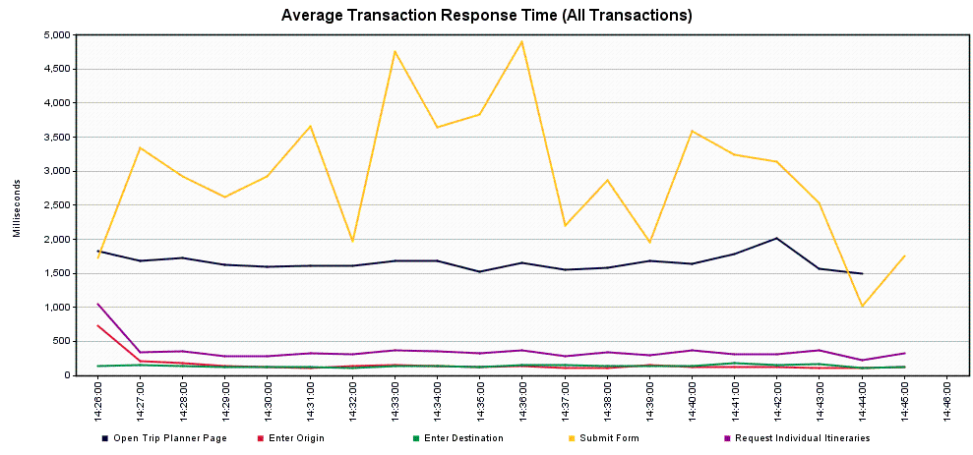

*Scenario 2.1.6 – Trip Planner Incremental Increase to Failure – 100 concurrent users*

Tool: JMeter

JMeter Setup: 100 users, 60 second ramp-up, 10 loops

Server: TRPPLNWEBS002

Start Time: 2019-May-23 11:19 AM (PDT)

End Time: 2019-May-23 11:41 AM (PDT)

Notes: The Submit transaction is fairly consistent with the previous run – 10% of users would likely see response times of 8 seconds or more, but 1% of users would likely now see response times of 32 seconds or more.

Running Users

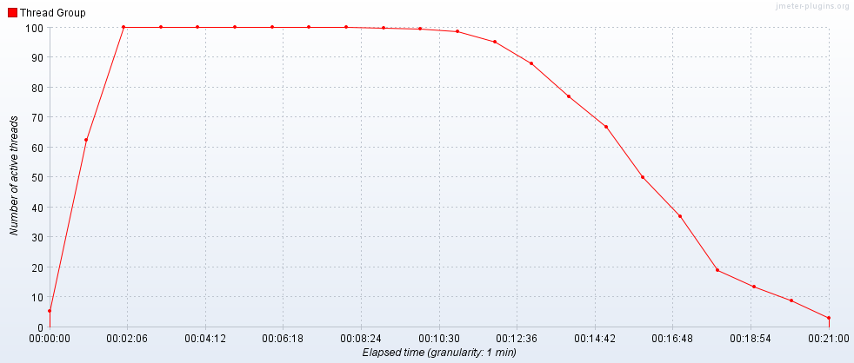

Hits per Second

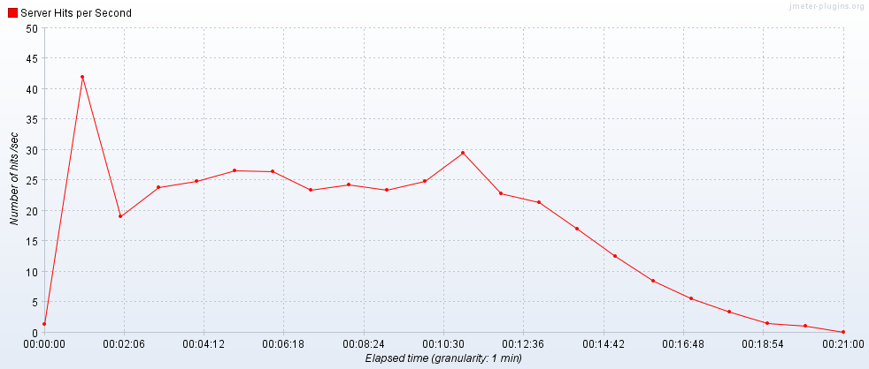

Transactions per Second

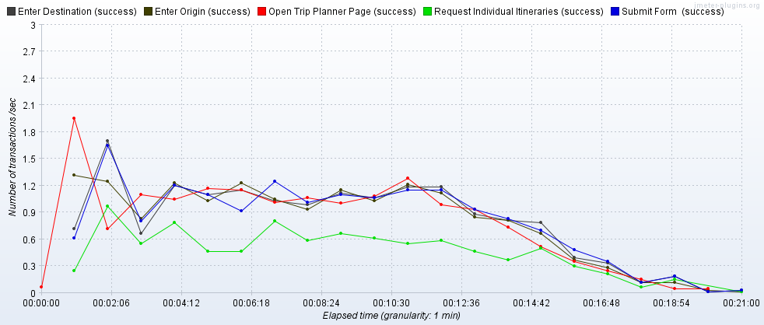

Transaction Statistics

|  |  |  |  |  |  |  |  |  |  |  |  |  |
| --- | --- | --- | --- | --- | --- | --- | --- | --- | --- | --- | --- | --- |
| Label | # Samples | Average | Median | 90% Line | 95% Line | 99% Line | Min | Max | Error % | Throughput | Received KB/sec | Sent KB/sec |
| Open Trip Planner Page | 1000 | 1634 | 1606 | 1927 | 2114 | 2461 | 1008 | 4651 | 0.00% | 0.84224 | 3645.46 | 20.45 |
| Enter Origin | 1000 | 168 | 116 | 206 | 290 | 1483 | 78 | 4224 | 0.00% | 0.84409 | 4.22 | 0.45 |
| Enter Destination | 1000 | 139 | 112 | 193 | 242 | 508 | 76 | 3473 | 0.00% | 0.84696 | 4.27 | 0.45 |
| Submit | 1000 | 3471 | 1854 | 8105 | 14057 | 31664 | 98 | 34376 | 0.00% | 0.84549 | 127.96 | 7.42 |
| Request Individual Itineraries | 562 | 340 | 319 | 489 | 563 | 710 | 70 | 1241 | 0.00% | 0.47663 | 71.59 | 5.64 |
| TOTAL | 27562 | 392 | 9 | 1254 | 1686 | 6119 | 2 | 34376 | 0.00% | 22.53957 | 7343.09 | 55.81 |

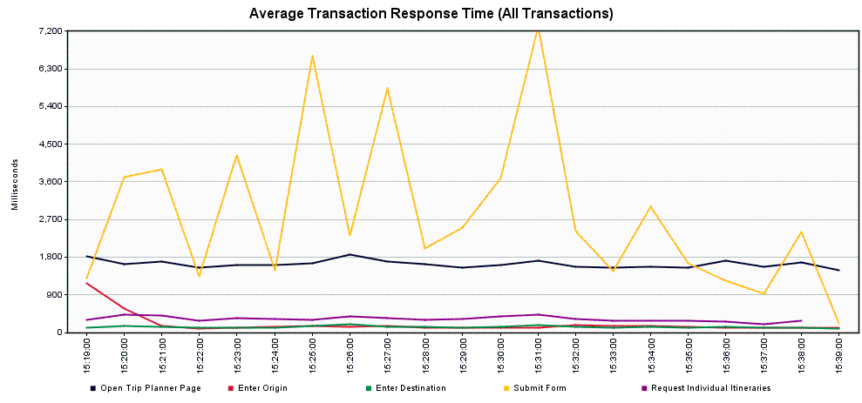

*Scenario 2.1.7 – Trip Planner Incremental Increase to Failure – 125 concurrent users*

Tool: JMeter

JMeter Setup: 125 users, 60 second ramp-up, 10 loops

Server: TRPPLNWEBS002

Start Time: 2019-May-23 11:48 AM (PDT)

End Time: 2019-May-23 12:10 PM (PDT)

Notes: The Submit transaction performance has degraded slightly more – 10% of users would likely see response times of 10 seconds or more, 1% of users would likely see response times of 32 seconds or more.

Running Users

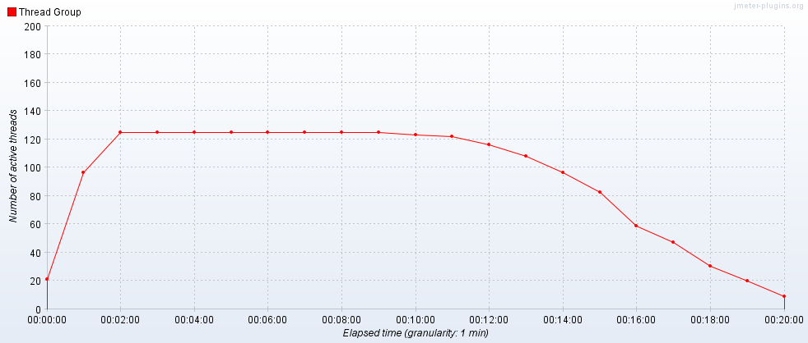

Hits per Second

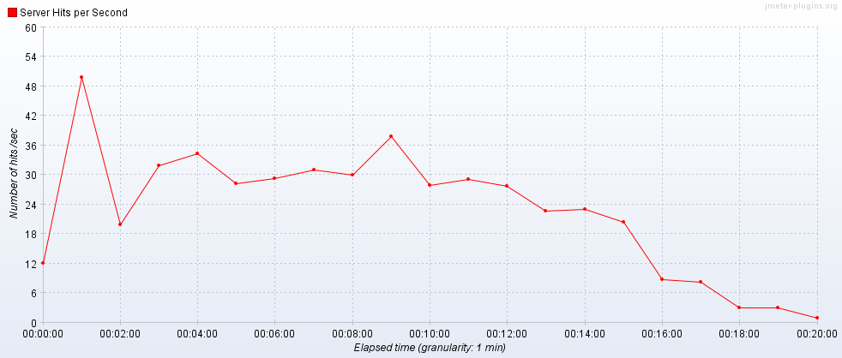

Transactions per Second

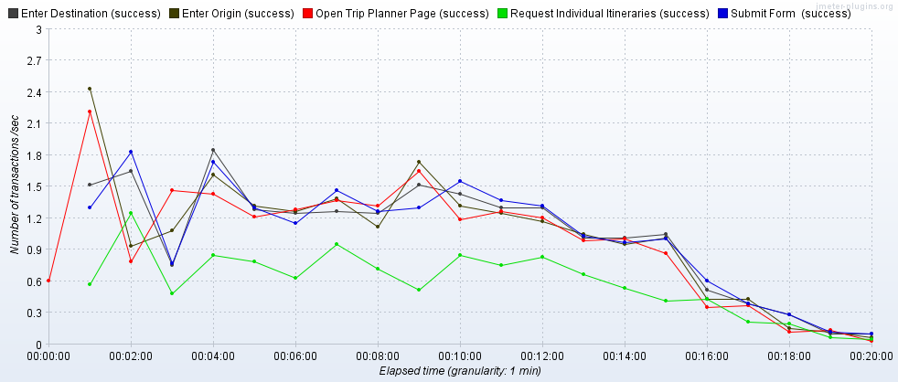

Transaction Statistics

|  |  |  |  |  |  |  |  |  |  |  |  |  |
| --- | --- | --- | --- | --- | --- | --- | --- | --- | --- | --- | --- | --- |
| Label | # Samples | Average | Median | 90% Line | 95% Line | 99% Line | Min | Max | Error % | Throughput | Received KB/sec | Sent KB/sec |
| Open Trip Planner Page | 1250 | 1623 | 1597 | 1874 | 2023 | 2284 | 1028 | 8015 | 0.00% | 1.06627 | 4615.13 | 25.89 |
| Enter Origin | 1250 | 138 | 113 | 207 | 248 | 446 | 77 | 1917 | 0.00% | 1.06612 | 5.82 | 0.57 |
| Enter Destination | 1250 | 131 | 107 | 200 | 247 | 438 | 78 | 857 | 0.00% | 1.06727 | 4.97 | 0.57 |
| Submit | 1250 | 4058 | 2010 | 10176 | 17081 | 32388 | 113 | 33701 | 0.00% | 1.06505 | 165.06 | 9.38 |
| Request Individual Itineraries | 706 | 368 | 340 | 508 | 592 | 1212 | 63 | 2558 | 0.00% | 0.60299 | 93.35 | 7.14 |
| TOTAL | 34456 | 431 | 9 | 1253 | 1702 | 8013 | 2 | 33701 | 0.00% | 28.48644 | 9287.22 | 70.61 |

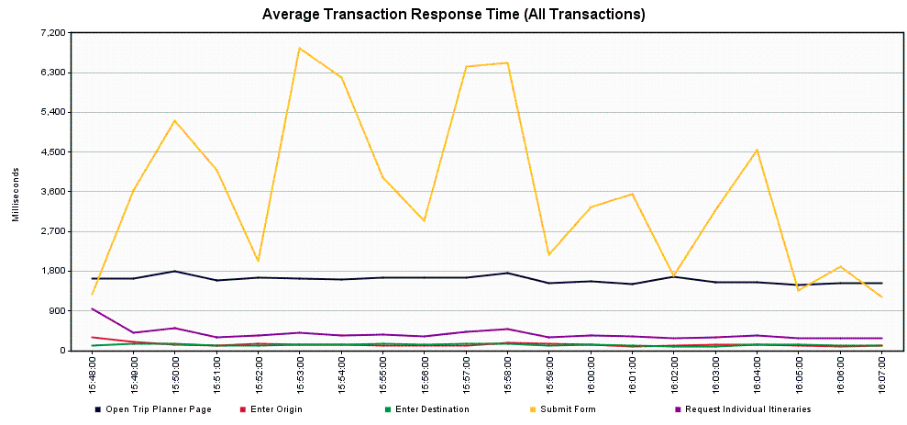

**Scenario 2.2 – Trip Planner Incremental Increase to Failure – Load Balancer**

Scope: This was completed as a series of runs to determine where the service encounters errors or excessively high response times for a significant number of users. In order to push the service, higher load levels were used, beginning with 32 concurrent users and culminating with 250 concurrent users.

*Scenario 2.2.1 – Trip Planner Incremental Increase to Failure – 32 concurrent users*

Tool: JMeter

JMeter Setup: 32 users, 60 second ramp-up, 10 loops

Server: tripplanning.stg.translink.ca

Start Time: 2019-May-29 05:18 AM (PDT)

End Time: 2019-May-29 05:35 AM (PDT)

Notes: The Submit transaction is noticeably slow in this run – 10% of users would likely see response times of 19 seconds or more, and 1% of users would likely see response times of 30 seconds or more

Running Users

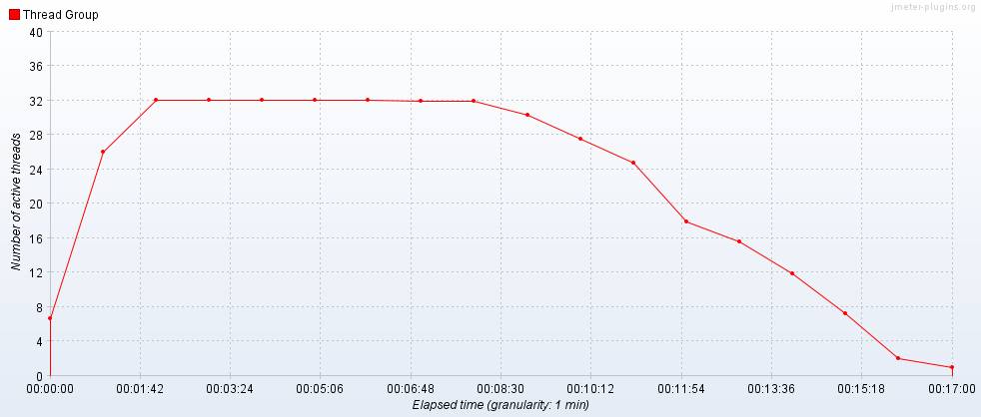

Hits per Second

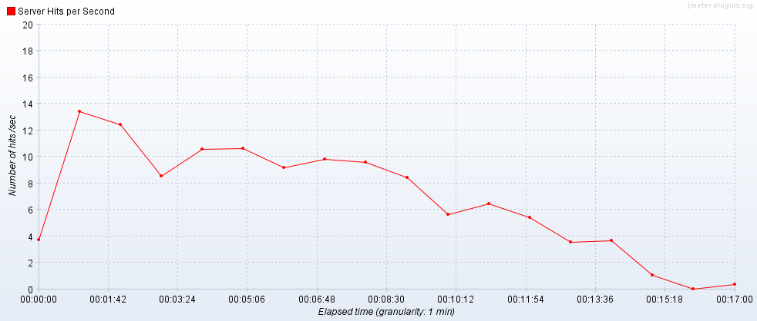

Transactions per Second

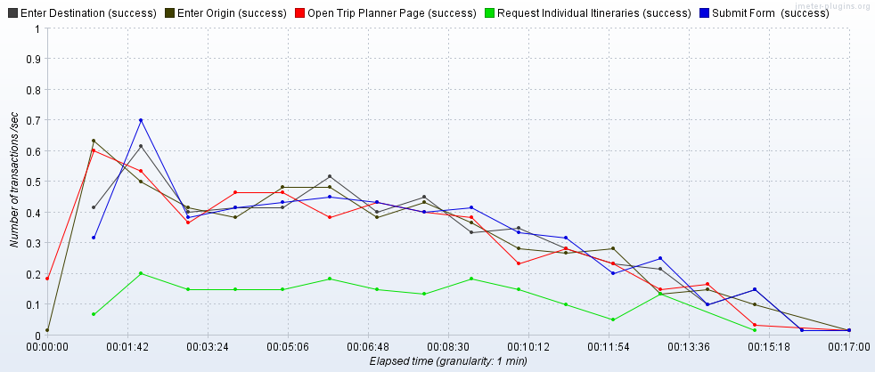

Transaction Statistics

|  |  |  |  |  |  |  |  |  |  |  |  |  |
| --- | --- | --- | --- | --- | --- | --- | --- | --- | --- | --- | --- | --- |
| Label | # Samples | Average | Median | 90% Line | 95% Line | 99% Line | Min | Max | Error % | Throughput | Received KB/sec | Sent KB/sec |
| Open Trip Planner Page | 320 | 1905 | 1862 | 2227 | 2385 | 2815 | 1412 | 3778 | 0.00% | 0.32139 | 1386.85 | 10.75 |
| Enter Origin | 320 | 195 | 146 | 356 | 424 | 619 | 85 | 2352 | 0.00% | 0.32276 | 1.43 | 0.21 |
| Enter Destination | 320 | 154 | 125 | 202 | 270 | 485 | 87 | 2258 | 0.00% | 0.32315 | 1.06 | 0.21 |
| Submit | 320 | 5116 | 1429 | 19539 | 30222 | 30365 | 137 | 37074 | 0.00% | 0.32315 | 26.99 | 2.05 |
| Request Individual Itineraries | 109 | 534 | 533 | 791 | 827 | 1007 | 62 | 1164 | 0.00% | 0.1301 | 17.15 | 1.57 |
| TOTAL | 8749 | 539 | 8 | 1475 | 1933 | 9572 | 3 | 37074 | 0.00% | 8.49494 | 2738.16 | 25.54 |

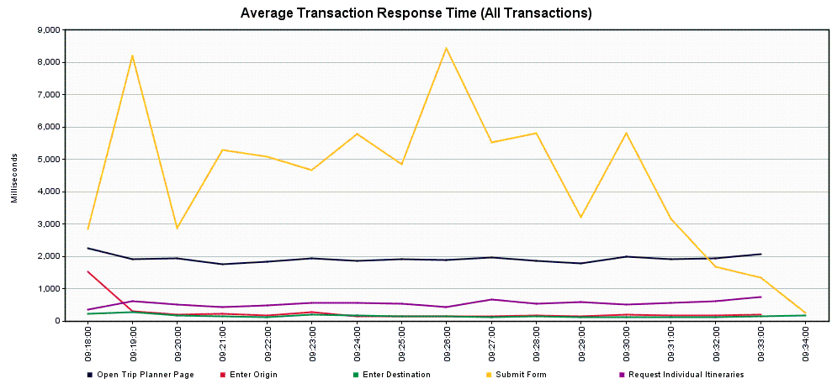

*Scenario 2.2.2 – Trip Planner Incremental Increase to Failure – 64 concurrent users*

Tool: JMeter

JMeter Setup: 64 users, 60 second ramp-up, 10 loops

Server: tripplanning.stg.translink.ca

Start Time: 2019-May-29 05:53 AM (PDT)

End Time: 2019-May-29 06:14 AM (PDT)

Notes: The Submit transaction actually recovers somewhat in this run – 10% of users would likely see response times of only 6 seconds or more, but 1% of users would likely still see response times of 30 seconds or more

Running Users

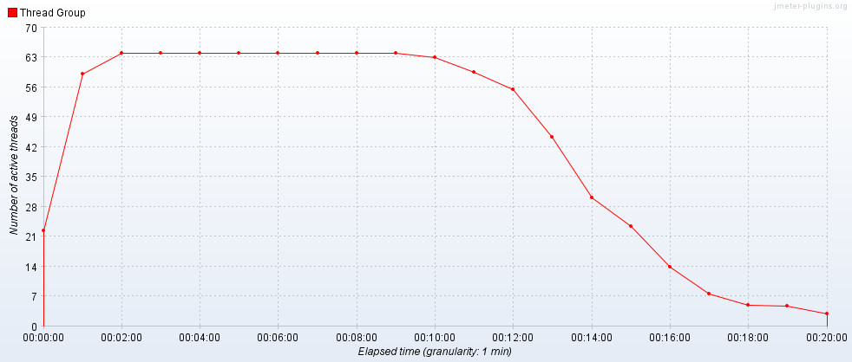

Hits per Second

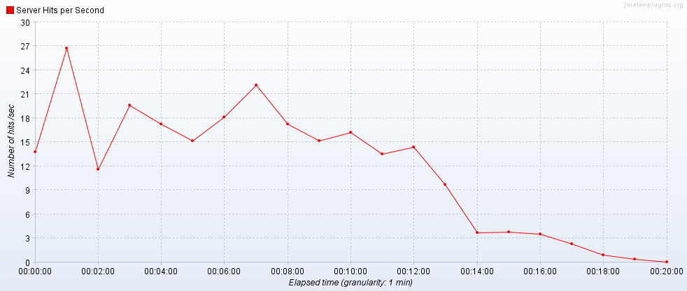

Transactions per Second

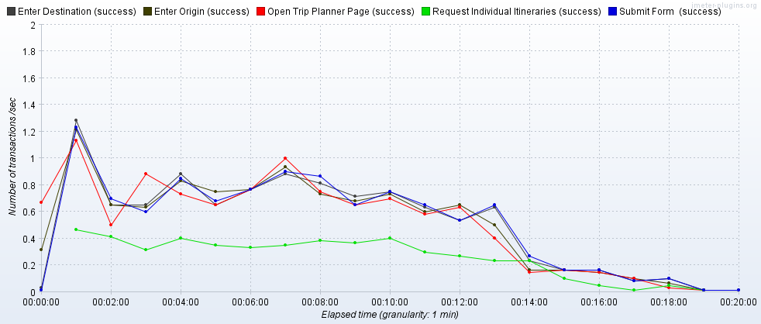

Transaction Statistics

|  |  |  |  |  |  |  |  |  |  |  |  |  |
| --- | --- | --- | --- | --- | --- | --- | --- | --- | --- | --- | --- | --- |
| Label | # Samples | Average | Median | 90% Line | 95% Line | 99% Line | Min | Max | Error % | Throughput | Received KB/sec | Sent KB/sec |
| Open Trip Planner Page | 640 | 1904 | 1883 | 2196 | 2349 | 2691 | 1438 | 3490 | 0.00% | 0.55786 | 2407.5 | 18.67 |
| Enter Origin | 640 | 171 | 117 | 368 | 413 | 719 | 82 | 1661 | 0.00% | 0.55804 | 3 | 0.36 |
| Enter Destination | 640 | 146 | 114 | 219 | 354 | 655 | 83 | 804 | 0.00% | 0.55818 | 2.44 | 0.36 |
| Submit | 640 | 3618 | 2363 | 6279 | 14730 | 30391 | 97 | 33616 | 0.00% | 0.55814 | 66.92 | 4.5 |
| Request Individual Itineraries | 303 | 559 | 541 | 803 | 844 | 940 | 71 | 3336 | 0.00% | 0.27802 | 39.02 | 3.43 |
| TOTAL | 17583 | 425 | 10 | 1494 | 1970 | 4589 | 3 | 33616 | 0.00% | 14.84614 | 4804.25 | 46.28 |

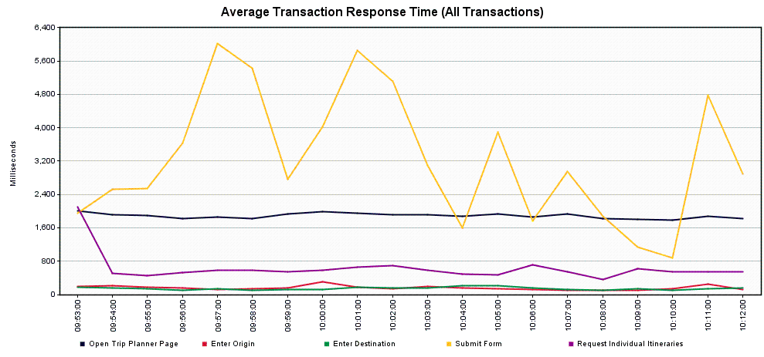

*Scenario 2.2.3 – Trip Planner Incremental Increase to Failure – 96 concurrent users*

Tool: JMeter

JMeter Setup: 96 users, 60 second ramp-up, 10 loops

Server: tripplanning.stg.translink.ca

Start Time: 2019-May-29 06:19 AM (PDT)

End Time: 2019-May-29 06:40 AM (PDT)

Notes: The performance of the Submit transaction improves slightly over the previous run – 10% of users would likely see response times of 5 seconds or more, 1% of users would likely see response times of 30 seconds or more. There was one error encountered, a Get Trip Planner Page transaction failed to connect to a font file from the Google API – this appears to be unrelated to the service.

Running Users

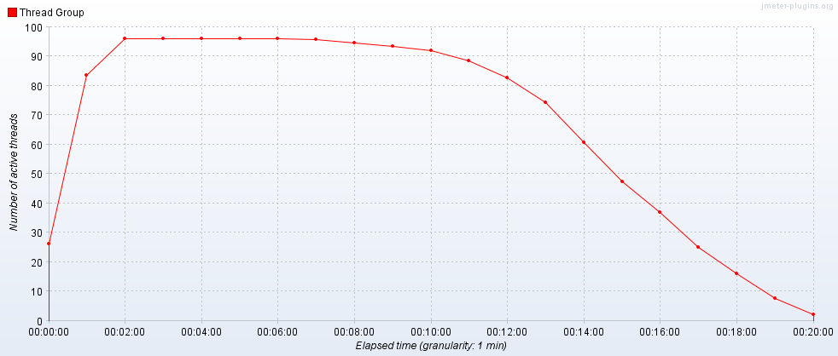

Hits per Second

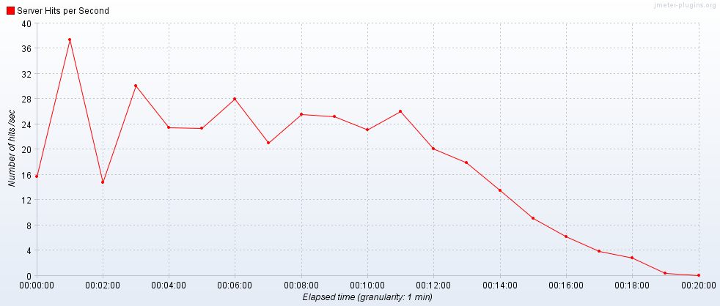

Transactions per Second

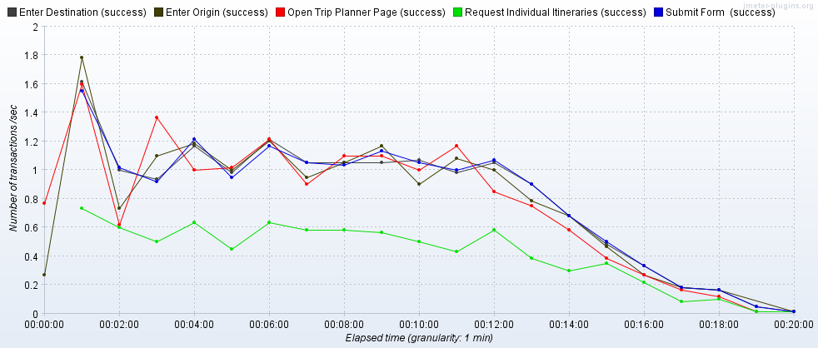

Transaction Statistics

|  |  |  |  |  |  |  |  |  |  |  |  |  |
| --- | --- | --- | --- | --- | --- | --- | --- | --- | --- | --- | --- | --- |
| Label | # Samples | Average | Median | 90% Line | 95% Line | 99% Line | Min | Max | Error % | Throughput | Received KB/sec | Sent KB/sec |
| Open Trip Planner Page | 960 | 1936 | 1913 | 2205 | 2367 | 2697 | 1448 | 3281 | 0.10% | 0.82283 | 3550.62 | 27.53 |
| Enter Origin | 959 | 160 | 117 | 345 | 403 | 651 | 83 | 1493 | 0.00% | 0.82372 | 4.2 | 0.53 |
| Enter Destination | 959 | 151 | 110 | 271 | 396 | 637 | 84 | 1012 | 0.00% | 0.82173 | 4.13 | 0.53 |
| Submit | 959 | 2891 | 2476 | 5192 | 8158 | 30172 | 107 | 34213 | 0.00% | 0.81934 | 110.07 | 7.23 |
| Request Individual Itineraries | 496 | 551 | 532 | 816 | 860 | 998 | 69 | 1314 | 0.00% | 0.42497 | 61.11 | 5.42 |
| TOTAL | 26391 | 373 | 12 | 1546 | 2000 | 4277 | 3 | 34213 | 0.01% | 21.83292 | 7083.33 | 69.2 |



*Scenario 2.2.4 – Trip Planner Incremental Increase to Failure – 128 concurrent users*

Tool: JMeter

JMeter Setup: 128 users, 60 second ramp-up, 10 loops

Server: tripplanning.stg.translink.ca

Start Time: 2019-May-29 06:47 AM (PDT)

End Time: 2019-May-29 07:09 AM (PDT)

Notes: The Submit transaction is slightly improved over the previous run – 10% of users would likely see response times of 6 seconds or more, 1% of users would likely see response times of 24 seconds or more. We encountered 4 errors: 3 were failed attempts to retrieve resources from the Google API, so unlikely to be service related. The last error happened on a Submit transaction:

*Response Headers*:

HTTP/1.1 500 Exception occurred in service dispatch

Content-Type: text/xml; charset=UTF-8

Content-Length: 1107

SOAPAction: "TCF.Fault"

Server: Trapeze-Srv/6.0

Date: Wed, 29 May 2019 14:02:48 GMT

Cache-Control: no-cache,no-store

Pragma: no-cache

*Response Text*:

<?xml version="1.0" encoding="UTF-8"?><SOAP-ENV:Envelope xmlns:SOAP-ENV='http://schemas.xmlsoap.org/soap/envelope/' SOAP-ENV:encodingStyle='http://schemas.xmlsoap.org/soap/encoding/' xmlns:enc='http://www.w3.org/2001/06/soap-encoding'><SOAP-ENV:Body><SOAP-ENV:Fault><faultcode>SOAP-ENV:Server</faultcode><faultstring>Server: _ServiceDispatch: Caught Exception while dispatching InfoWeb.ItineraryLookup</faultstring><faultactor>tripplanning.stg.translink.ca</faultactor><detail><TCF_Exception xmlns="http://www.trapezesoftware.com/wsdl/TCF"><Class>SeException</Class><Message>EXCEPTION_ACCESS_VIOLATION (The thread tried to read from a virtual address for which it does not have the appropriate access.)

Exception Address=0x180431e21</Message><File></File><Line>0</Line><OriginDump></OriginDump><StackTrace>[ThreadId: 6516, ProcessId=2808, Computer=TRPPLNWEBS002]

InfoWeb/ItineraryLookup/CacheProcess

InfoWeb/ItineraryLookup/Internal

InfoWeb/ItineraryLookup

SrvShell/_ServiceDispatch</StackTrace><ErrorCode>-1073741819</ErrorCode></TCF_Exception></detail></SOAP-ENV:Fault></SOAP-ENV:Body></SOAP-ENV:Envelope>

Running Users

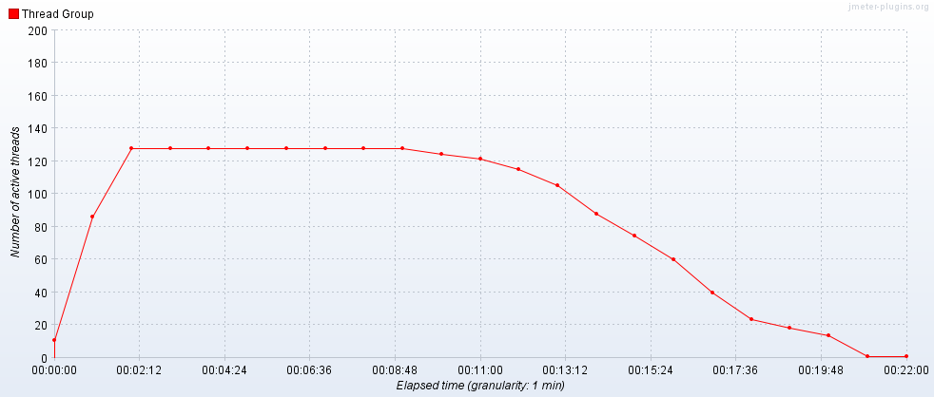

Hits per Second

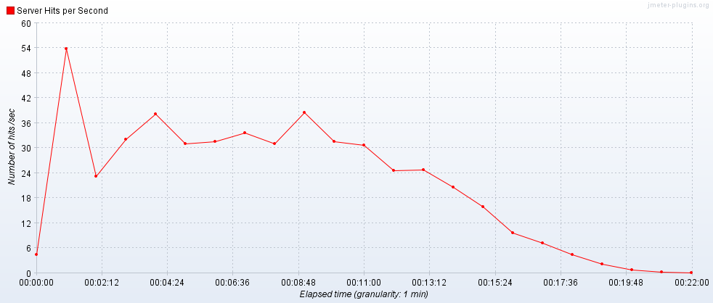

Transactions per Second

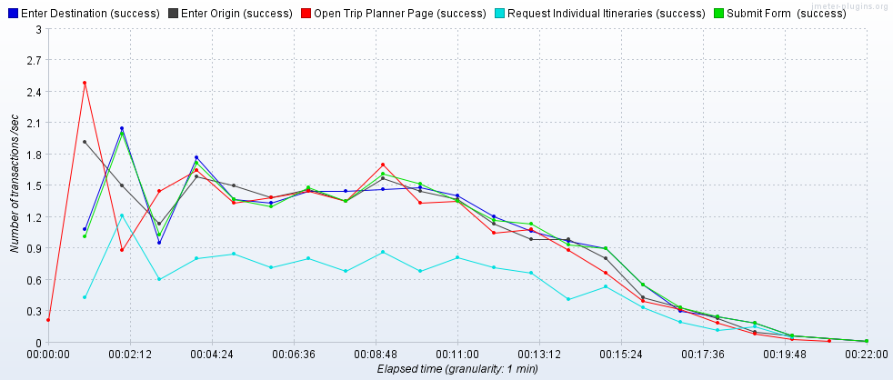

Transaction Statistics

|  |  |  |  |  |  |  |  |  |  |  |  |  |
| --- | --- | --- | --- | --- | --- | --- | --- | --- | --- | --- | --- | --- |
| Label | # Samples | Average | Median | 90% Line | 95% Line | 99% Line | Min | Max | Error % | Throughput | Received KB/sec | Sent KB/sec |
| Open Trip Planner Page | 1280 | 2030 | 1940 | 2224 | 2405 | 2864 | 1471 | 30063 | 0.16% | 1.01078 | 4361.46 | 33.81 |
| Enter Origin | 1278 | 162 | 116 | 343 | 413 | 676 | 81 | 2072 | 0.00% | 1.00992 | 5.49 | 0.65 |
| Enter Destination | 1278 | 149 | 111 | 240 | 367 | 565 | 81 | 3998 | 0.00% | 1.00808 | 4.77 | 0.65 |
| Submit | 1278 | 3000 | 2517 | 6198 | 9359 | 24388 | 97 | 34161 | 0.08% | 1.00641 | 147.61 | 9.31 |
| Request Individual Itineraries | 699 | 589 | 552 | 828 | 879 | 1059 | 74 | 13542 | 0.00% | 0.60041 | 90.82 | 7.7 |
| TOTAL | 35209 | 388 | 12 | 1581 | 2029 | 4918 | 3 | 34161 | 0.02% | 26.96553 | 8767.01 | 86.22 |

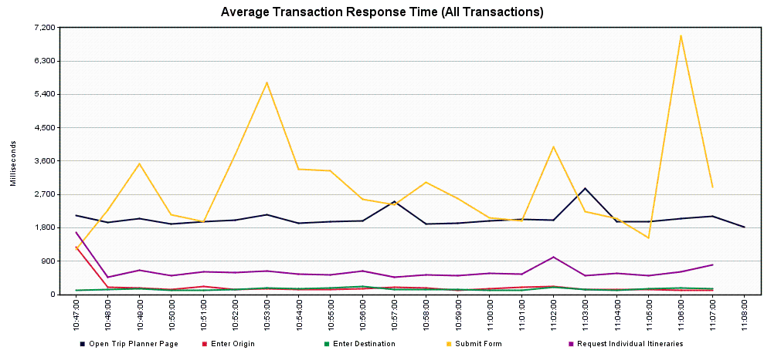

*Scenario 2.2.5 – Trip Planner Incremental Increase to Failure – 160 concurrent users*

Tool: JMeter

JMeter Setup: 160 users, 60 second ramp-up, 10 loops

Server: tripplanning.stg.translink.ca

Start Time: 2019-May-29 07:19 AM (PDT)

End Time: 2019-May-29 07:40 AM (PDT)

Notes: The Submit transaction has degraded slightly – 10% of users would likely see response times of 9 seconds or more, 1% of users would likely see response times of 30 seconds or more. However, no errors were encountered at all.

Running Users

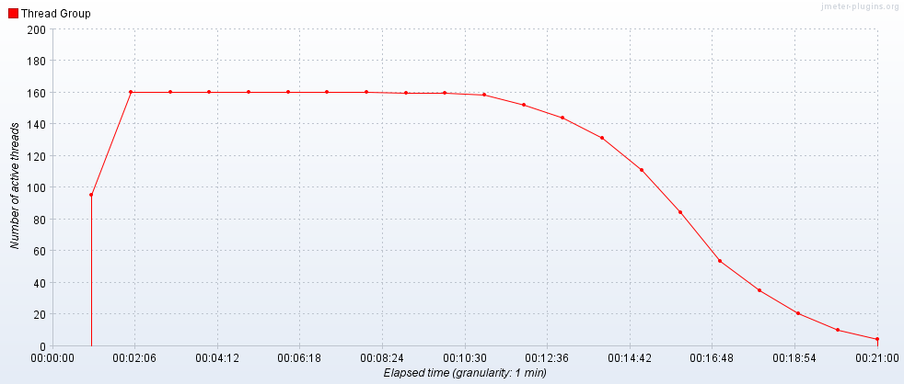

Hits per Second

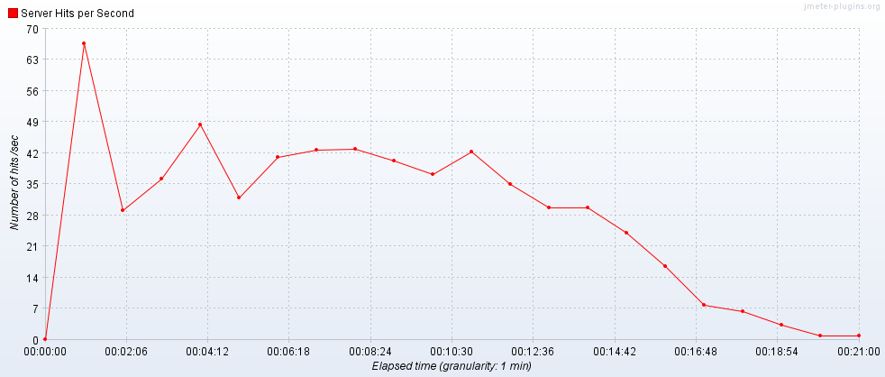

Transactions per Second

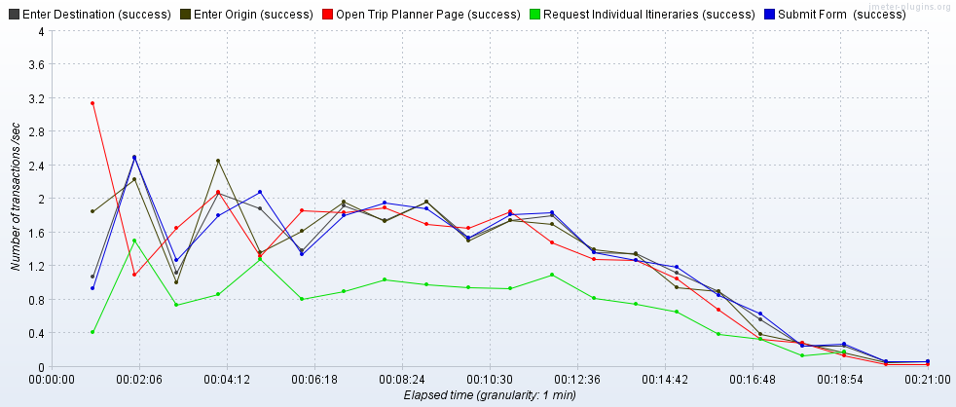

Transaction Statistics

|  |  |  |  |  |  |  |  |  |  |  |  |  |
| --- | --- | --- | --- | --- | --- | --- | --- | --- | --- | --- | --- | --- |
| Label | # Samples | Average | Median | 90% Line | 95% Line | 99% Line | Min | Max | Error % | Throughput | Received KB/sec | Sent KB/sec |
| Open Trip Planner Page | 1600 | 2054 | 2013 | 2357 | 2561 | 2998 | 1499 | 3870 | 0.00% | 1.3054 | 5633.45 | 43.69 |
| Enter Origin | 1600 | 165 | 117 | 347 | 415 | 734 | 84 | 1790 | 0.00% | 1.31 | 6.88 | 0.84 |
| Enter Destination | 1600 | 166 | 118 | 347 | 416 | 710 | 83 | 1384 | 0.00% | 1.30929 | 6.94 | 0.84 |
| Submit | 1600 | 3837 | 2694 | 8945 | 14446 | 29552 | 102 | 38370 | 0.00% | 1.30925 | 195.77 | 12.28 |
| Request Individual Itineraries | 885 | 635 | 580 | 861 | 942 | 1354 | 71 | 7919 | 0.00% | 0.80457 | 123.25 | 10.4 |
| TOTAL | 44085 | 451 | 16 | 1641 | 2120 | 6677 | 3 | 38370 | 0.00% | 35.03715 | 11382.46 | 112.25 |

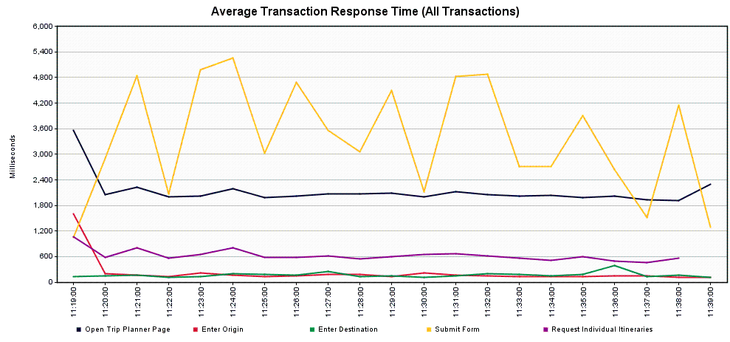

*Scenario 2.2.6 – Trip Planner Incremental Increase to Failure – 200 concurrent users*

Tool: JMeter

JMeter Setup: 200 users, 60 second ramp-up, 10 loops

Server: tripplanning.stg.translink.ca

Start Time: 2019-May-29 09:07 AM (PDT)

End Time: 2019-May-29 09:31 AM (PDT)

Notes: The Submit transaction slowed down as compared with the previous run – 10% of users would likely see response times of 16 seconds or more, and 1% of users would likely see response times of 35 seconds or more. Again, no errors were encountered.

Running Users

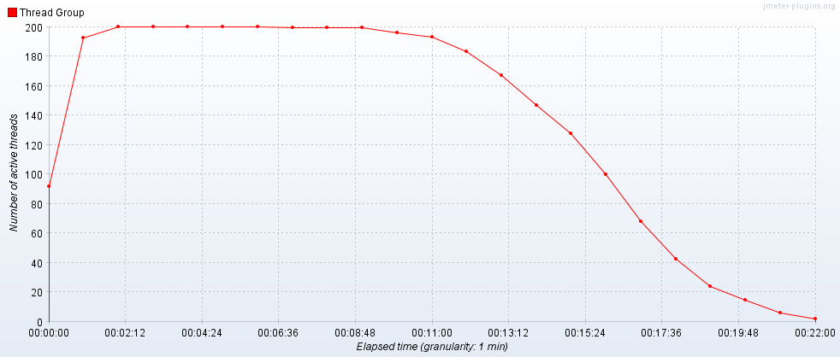

Hits per Second

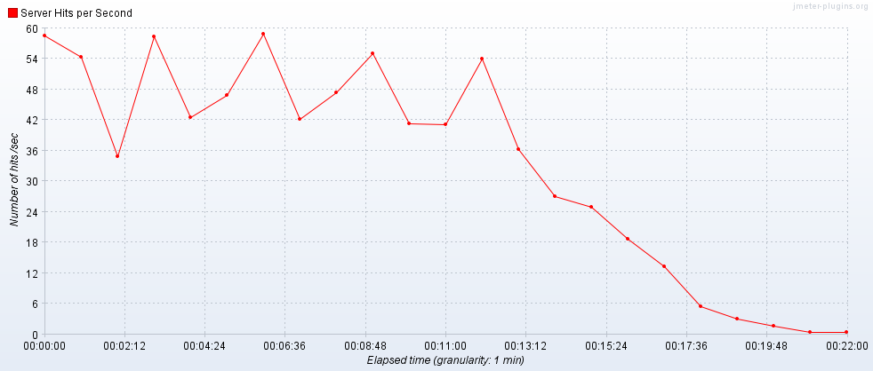

Transactions per Second

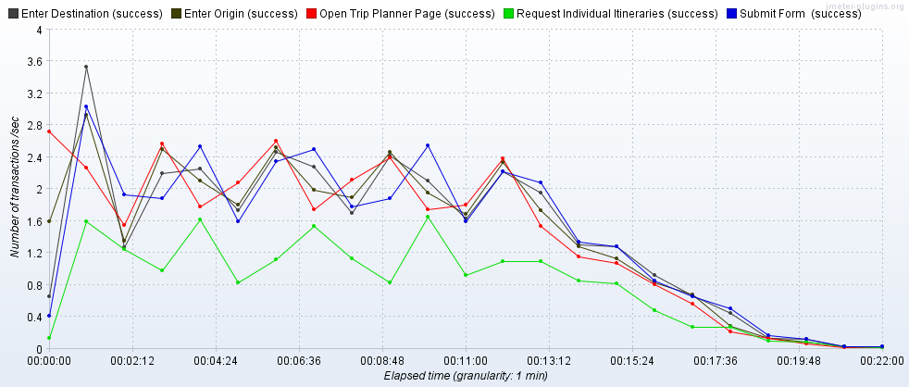

Transaction Statistics

|  |  |  |  |  |  |  |  |  |  |  |  |  |
| --- | --- | --- | --- | --- | --- | --- | --- | --- | --- | --- | --- | --- |
| Label | # Samples | Average | Median | 90% Line | 95% Line | 99% Line | Min | Max | Error % | Throughput | Received KB/sec | Sent KB/sec |
| Open Trip Planner Page | 2000 | 2182 | 2093 | 2601 | 2825 | 3450 | 1517 | 6476 | 0.00% | 1.50853 | 6510.03 | 50.48 |
| Enter Origin | 2000 | 190 | 132 | 375 | 481 | 835 | 83 | 2879 | 0.00% | 1.50922 | 8.13 | 0.97 |
| Enter Destination | 2000 | 182 | 126 | 357 | 440 | 854 | 85 | 6745 | 0.00% | 1.50751 | 7.43 | 0.97 |
| Submit | 2000 | 5984 | 3273 | 16049 | 26210 | 35793 | 96 | 49996 | 0.00% | 1.50461 | 232.73 | 14.33 |
| Request Individual Itineraries | 1123 | 757 | 645 | 998 | 1178 | 3315 | 74 | 22688 | 0.00% | 0.84794 | 132.09 | 11.01 |
| TOTAL | 55123 | 619 | 17 | 1711 | 2349 | 12661 | 3 | 49996 | 0.00% | 40.36686 | 13124.34 | 129.7 |

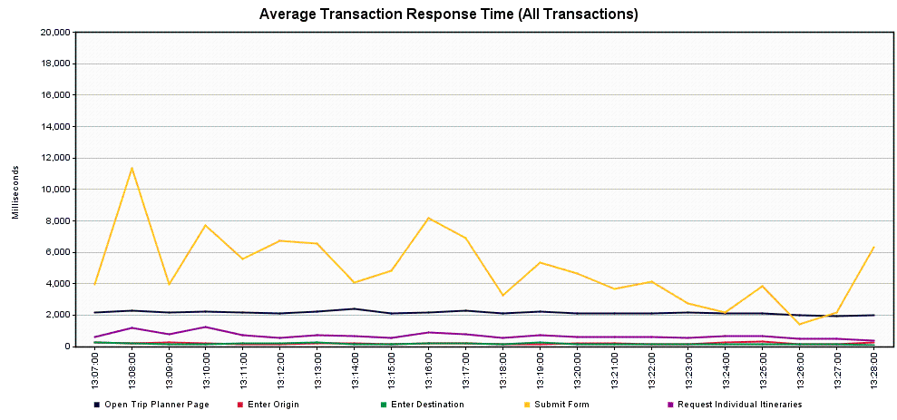

*Scenario 2.2.7 – Trip Planner Incremental Increase to Failure – 250 concurrent users*

Tool: JMeter

JMeter Setup: 250 users, 60 second ramp-up, 10 loops

Server: tripplanning.stg.translink.ca

Start Time: 2019-May-29 09:35 AM (PDT)

End Time: 2019-May-29 09:59 PM (PDT)

Notes: The Submit transaction performance has continued to degrade – 10% of users would likely see response times of 19 seconds or more, 1% of users would likely see response times of 38 seconds or more. We encountered two errors – both were failures to respond from a Google API, and didn’t have anything to do with the Trip Planner service directly.

Running Users

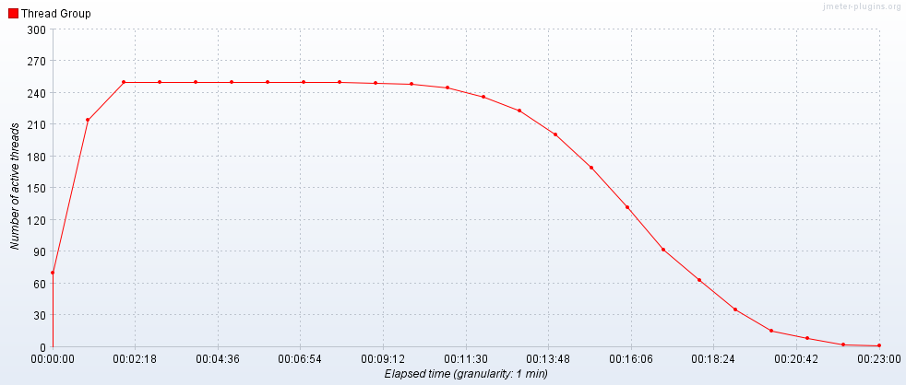

Hits per Second

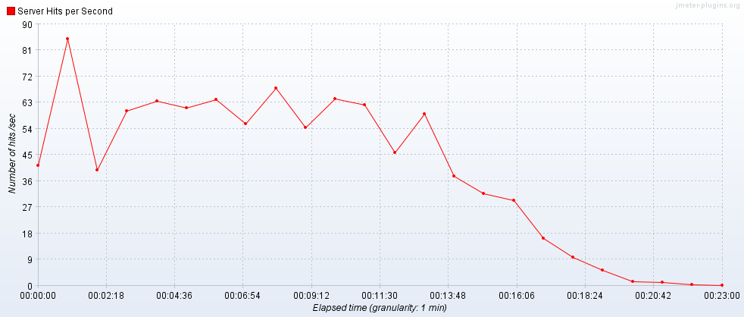

Transactions per Second

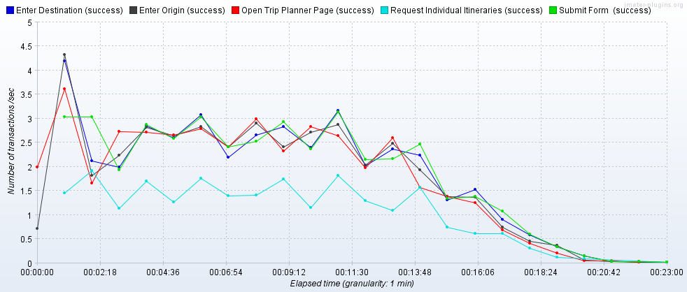

Transaction Statistics

|  |  |  |  |  |  |  |  |  |  |  |  |  |
| --- | --- | --- | --- | --- | --- | --- | --- | --- | --- | --- | --- | --- |
| Label | # Samples | Average | Median | 90% Line | 95% Line | 99% Line | Min | Max | Error % | Throughput | Received KB/sec | Sent KB/sec |
| Open Trip Planner Page | 2500 | 2210 | 2133 | 2641 | 2852 | 3262 | 1563 | 6298 | 0.08% | 1.85955 | 8024.33 | 62.22 |
| Enter Origin | 2498 | 191 | 136 | 375 | 483 | 832 | 84 | 4529 | 0.00% | 1.86082 | 9.65 | 1.2 |
| Enter Destination | 2498 | 190 | 137 | 375 | 475 | 862 | 84 | 2080 | 0.00% | 1.86204 | 9.68 | 1.2 |
| Submit | 2498 | 6562 | 3552 | 19690 | 29984 | 38128 | 103 | 52313 | 0.00% | 1.8589 | 283.35 | 17.59 |
| Request Individual Itineraries | 1396 | 1019 | 718 | 1135 | 2035 | 8741 | 71 | 14898 | 0.00% | 1.04161 | 160.25 | 13.48 |
| TOTAL | 68846 | 664 | 18 | 1740 | 2469 | 13861 | 3 | 52313 | 0.01% | 49.90877 | 16230.8 | 160.21 |

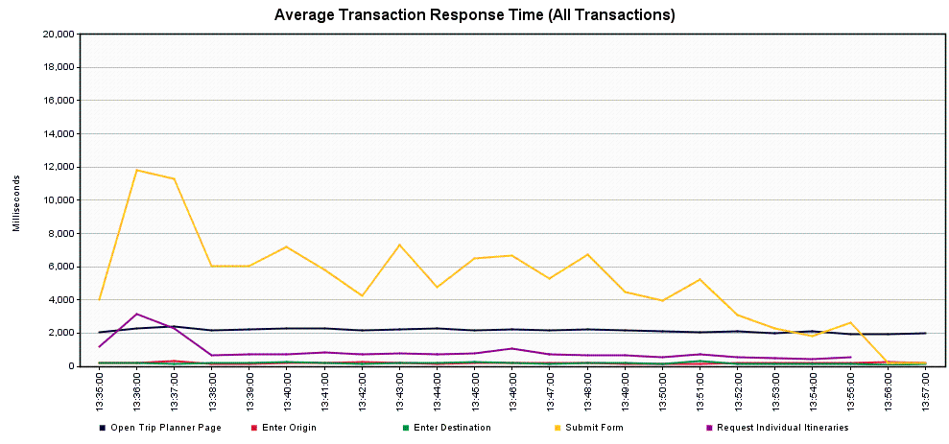

**Scenario 3.1 – Trip Planner Spike Test – Single Server**

Scope: This run was completed to determine what happens with a sudden spike in demand (like a snow day).

Tool: JMeter

JMeter Setup: 67 users, 10 second ramp-up, 10 loops

Server: TRPPLNWEBS002

Start Time: 2019-May-27 05:57 AM (PDT)

End Time: 2019-May-27 06:16 AM (PDT)

Notes: Much like Scenario 2.1, the Submit transaction is our slowest transaction – 10% of users would likely see response times of 12 seconds or more, 1% of users would likely see response times of 30 seconds or more. The sharp shock of a sudden influx of users is definitely noticeable. However, this server recovered well after the spike test was over, reverting to the typical response times of ~2.5 seconds.

Running Users

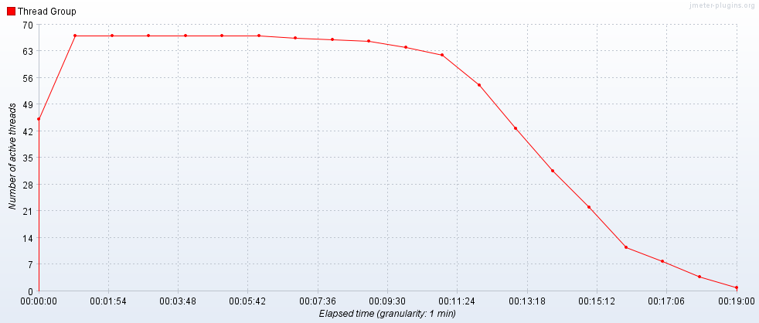

Hits per Second

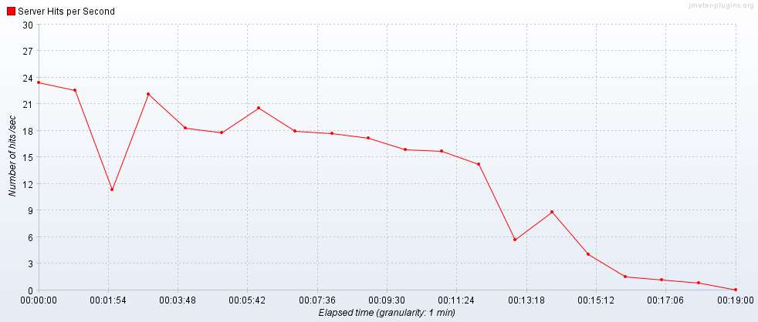

Transactions per Second

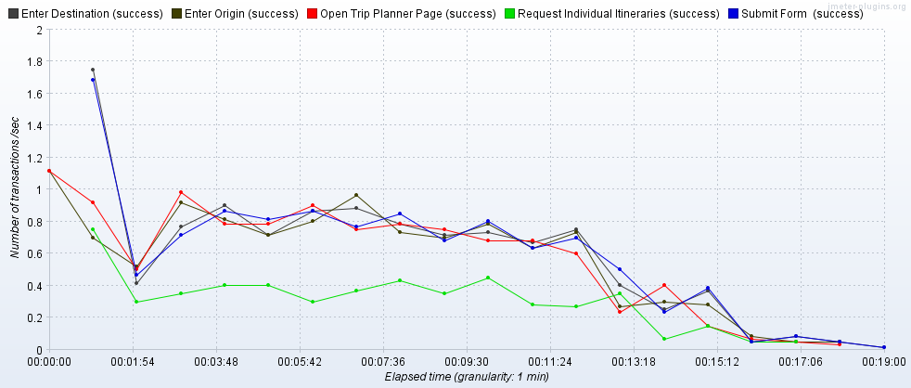

Transaction Statistics

|  |  |  |  |  |  |  |  |  |  |  |  |  |
| --- | --- | --- | --- | --- | --- | --- | --- | --- | --- | --- | --- | --- |
| Label | # Samples | Average | Median | 90% Line | 95% Line | 99% Line | Min | Max | Error % | Throughput | Received KB/sec | Sent KB/sec |
| Open Trip Planner Page | 670 | 1429 | 1397 | 1716 | 1827 | 2584 | 940 | 5977 | 0.00% | 0.61218 | 2643.7 | 14.86 |
| Enter Origin | 670 | 139 | 118 | 209 | 243 | 416 | 79 | 1943 | 0.00% | 0.61267 | 3.26 | 0.33 |
| Enter Destination | 670 | 130 | 114 | 180 | 226 | 325 | 76 | 830 | 0.00% | 0.61243 | 2.74 | 0.33 |
| Submit | 670 | 4238 | 2109 | 12213 | 17512 | 30497 | 152 | 36361 | 0.00% | 0.61234 | 74.08 | 4.62 |
| Request Individual Itineraries | 319 | 338 | 319 | 463 | 514 | 924 | 70 | 2352 | 0.00% | 0.32127 | 45.16 | 3.65 |
| TOTAL | 18409 | 432 | 7 | 1098 | 1586 | 7530 | 2 | 36361 | 0.00% | 16.29862 | 5278.52 | 39.02 |

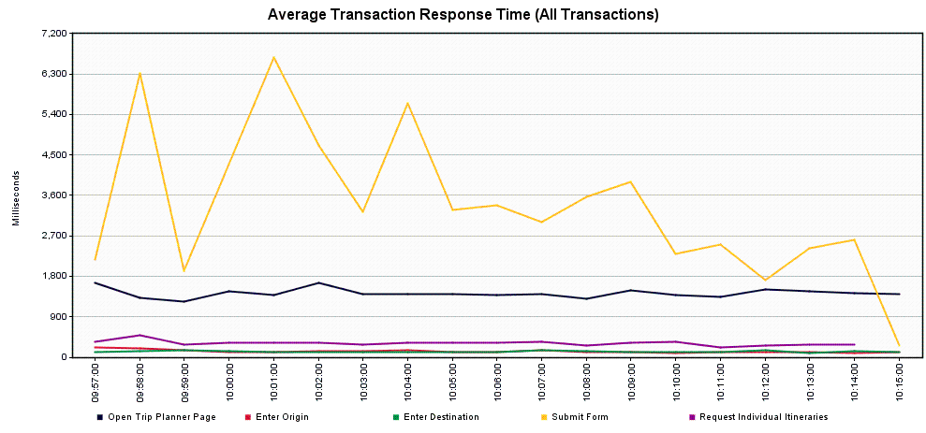

**Scenario 3.2 – Trip Planner Spike Test – Load Balancer**

Scope: This run was completed to determine what happens with a sudden spike in demand (like a snow day).

Tool: JMeter

JMeter Setup: 84 users, 60 second ramp-up, 31 loops

Server: tripplanning.stg.translink.ca

Start Time: 2019-May-28 09:44 AM (PDT)

End Time: 2019-May-28 10:44 AM (PDT)

Notes: Much like Scenario 2.2, the Submit transaction is our slowest transaction – 10% of users would likely see response times of 6 seconds or more, 1% of users would likely see response times of 25 seconds or more. The service recovered well after the spike test was over, reverting to the typical response times of ~2.5 seconds.

Running Users

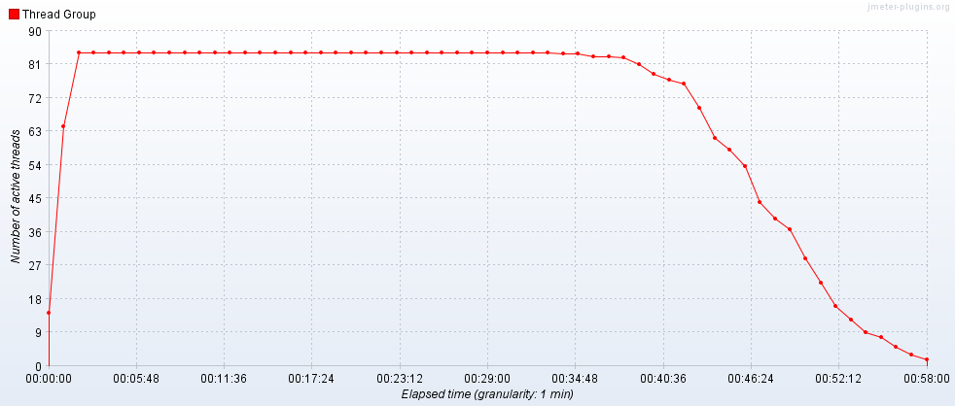

Hits per Second

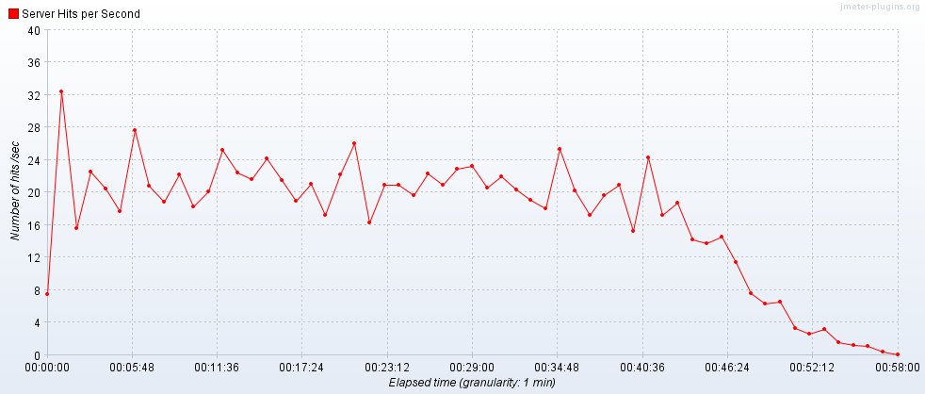

Transactions per Second

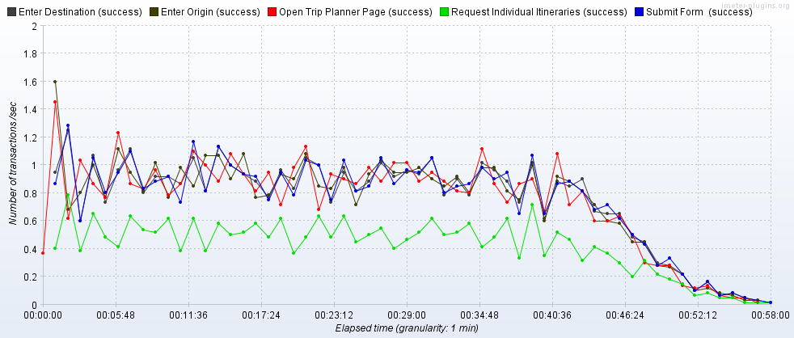

Transaction Statistics

|  |  |  |  |  |  |  |  |  |  |  |  |  |
| --- | --- | --- | --- | --- | --- | --- | --- | --- | --- | --- | --- | --- |
| Label | # Samples | Average | Median | 90% Line | 95% Line | 99% Line | Min | Max | Error % | Throughput | Received KB/sec | Sent KB/sec |
| Open Trip Planner Page | 2604 | 2060 | 2004 | 2381 | 2565 | 3005 | 1551 | 6852 | 0.00% | 0.7619 | 3288.02 | 25.51 |
| Enter Origin | 2604 | 159 | 116 | 323 | 409 | 673 | 83 | 1196 | 0.00% | 0.763 | 3.95 | 0.49 |
| Enter Destination | 2604 | 163 | 114 | 293 | 401 | 628 | 82 | 21004 | 0.04% | 0.76268 | 3.96 | 0.49 |
| Submit | 2603 | 3000 | 2461 | 6281 | 10150 | 25272 | 95 | 34154 | 0.00% | 0.76172 | 117.35 | 7.25 |
| Request Individual Itineraries | 1466 | 561 | 541 | 807 | 844 | 988 | 71 | 3352 | 0.00% | 0.42947 | 66.37 | 5.55 |
| TOTAL | 71772 | 390 | 15 | 1650 | 2090 | 4561 | 3 | 34154 | 0.00% | 20.77981 | 6755.04 | 66.76 |

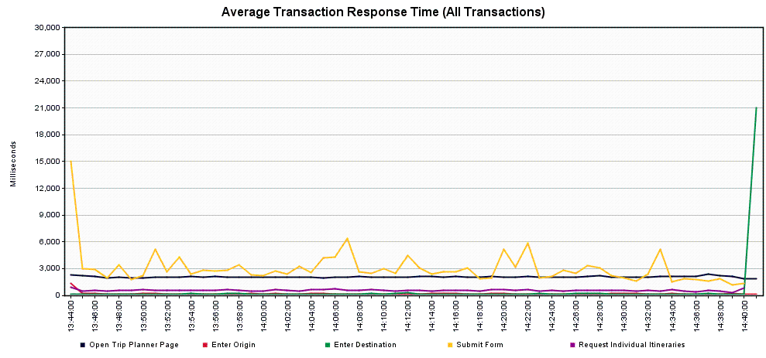

**Scenario 4.1 – Trip Planner Future Capacity – Single Server**

Scope: This was completed as a series of runs to examine how the service would cope with an expected 10% yearly increase, for 5 years. Given a typical daily usage of approximately 1400 users/hour, a load level of 90 users/hour was the starting target for a single server.

*Scenario 4.1.1 – Trip Planner Future Capacity – Year 0 (baseline/current)*

Tool: JMeter

JMeter Setup: 3 users, 60 second ramp-up, 30 loops

Server: TRPPLNWEBS001

Start Time: 2019-May-22 05:42 AM (PDT)

End Time: 2019-May-22 06:26 AM (PDT)

Notes: This is the same server as used during Scenario 1.1 (the historical peak) and the memory issues are still present. That said, at this lower load level, no performance issues are readily evident.

Running Users

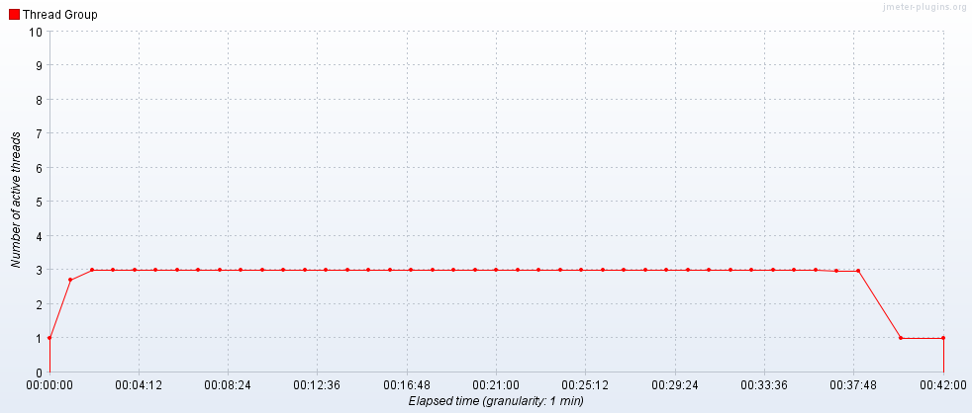

Hits per Second

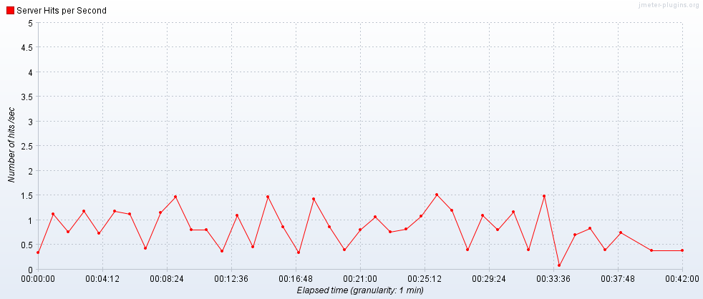

Transactions per Second

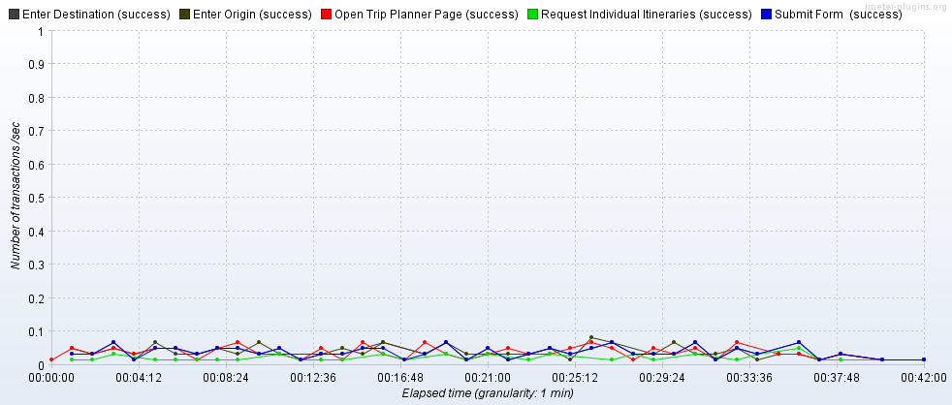

Transaction Statistics

|  |  |  |  |  |  |  |  |  |  |  |  |  |
| --- | --- | --- | --- | --- | --- | --- | --- | --- | --- | --- | --- | --- |
| Label | # Samples | Average | Median | 90% Line | 95% Line | 99% Line | Min | Max | Error % | Throughput | Received KB/sec | Sent KB/sec |
| Open Trip Planner Page | 90 | 1487 | 1382 | 1647 | 1715 | 5227 | 1028 | 5552 | 0.00% | 0.03608 | 156.18 | 0.88 |
| Enter Origin | 90 | 291 | 234 | 347 | 506 | 1442 | 175 | 1863 | 0.00% | 0.03615 | 0.09 | 0.02 |
| Enter Destination | 90 | 194 | 151 | 241 | 285 | 739 | 104 | 1552 | 0.00% | 0.0362 | 0.12 | 0.02 |
| Submit | 90 | 1470 | 786 | 2419 | 2887 | 4133 | 103 | 30176 | 0.00% | 0.03618 | 3.52 | 0.26 |
| Request Individual Itineraries | 41 | 246 | 247 | 306 | 324 | 361 | 74 | 361 | 0.00% | 0.01651 | 1.67 | 0.19 |
| TOTAL | 2471 | 250 | 7 | 986 | 1400 | 2323 | 3 | 30176 | 0.00% | 0.9769 | 315.35 | 2.32 |

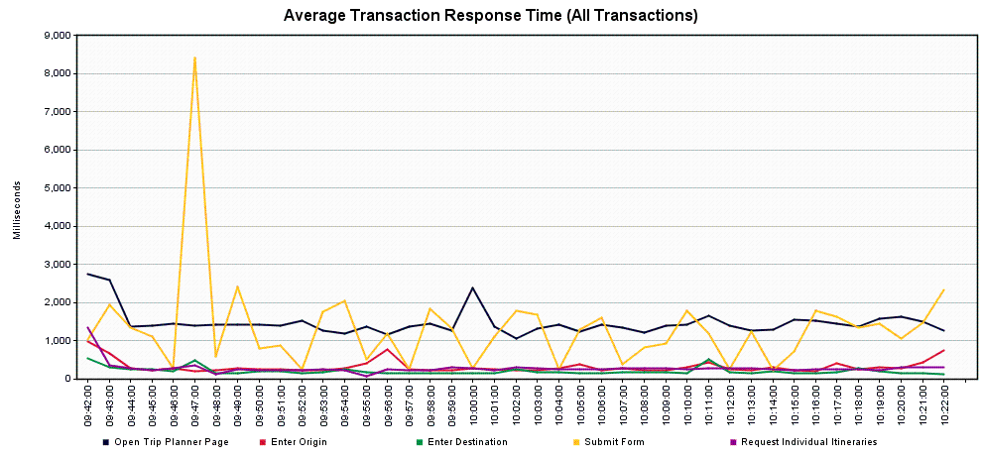

*Scenario 4.1.2 – Trip Planner Future Capacity – Year 1 (99 users/10% increase over previous year)*

Tool: JMeter

JMeter Setup: 4 users, 60 second ramp-up, 25 loops

Server: TRPPLNWEBS001

Start Time: 2019-May-22 06:35 AM (PDT)

End Time: 2019-May-22 07:15 AM (PDT)

Notes: The estimated yearly increase is easily absorbed by the service, with no noticeable performance degradation.

Running Users

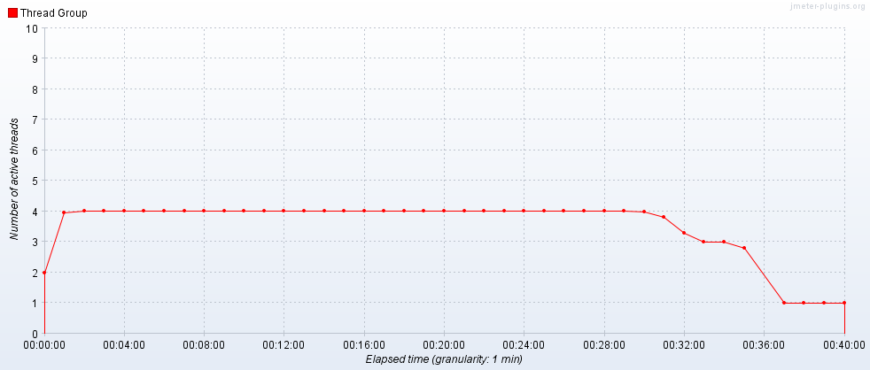

Hits per Second

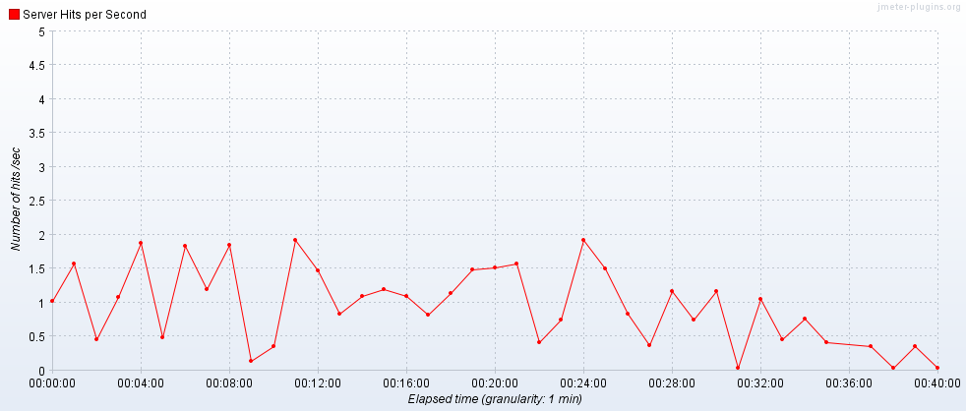

Transactions per Second

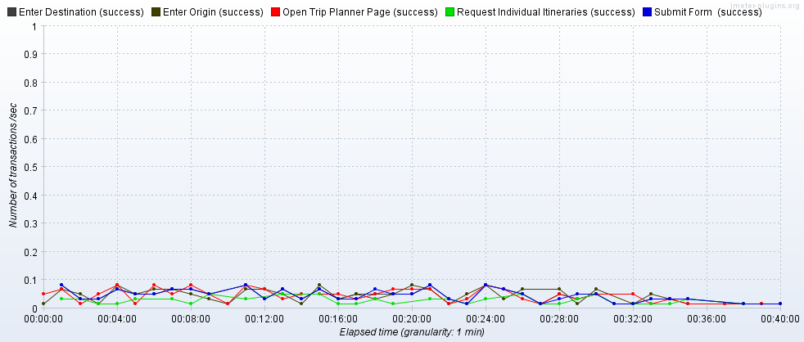

Transaction Statistics

|  |  |  |  |  |  |  |  |  |  |  |  |  |
| --- | --- | --- | --- | --- | --- | --- | --- | --- | --- | --- | --- | --- |
| Label | # Samples | Average | Median | 90% Line | 95% Line | 99% Line | Min | Max | Error % | Throughput | Received KB/sec | Sent KB/sec |
| Open Trip Planner Page | 100 | 1487 | 1477 | 1713 | 1745 | 1971 | 1088 | 2619 | 0.00% | 0.04277 | 185.12 | 1.04 |
| Enter Origin | 100 | 230 | 191 | 323 | 515 | 675 | 112 | 707 | 0.00% | 0.04281 | 0.11 | 0.02 |
| Enter Destination | 100 | 149 | 132 | 193 | 229 | 438 | 94 | 494 | 0.00% | 0.04273 | 0.14 | 0.02 |
| Submit | 100 | 1325 | 1254 | 2482 | 2980 | 5231 | 125 | 7367 | 0.00% | 0.04273 | 5.26 | 0.35 |
| Request Individual Itineraries | 51 | 265 | 262 | 323 | 338 | 359 | 77 | 390 | 0.00% | 0.02297 | 2.76 | 0.27 |
| TOTAL | 2751 | 232 | 7 | 1110 | 1484 | 2265 | 2 | 7367 | 0.00% | 1.15679 | 374.84 | 2.82 |

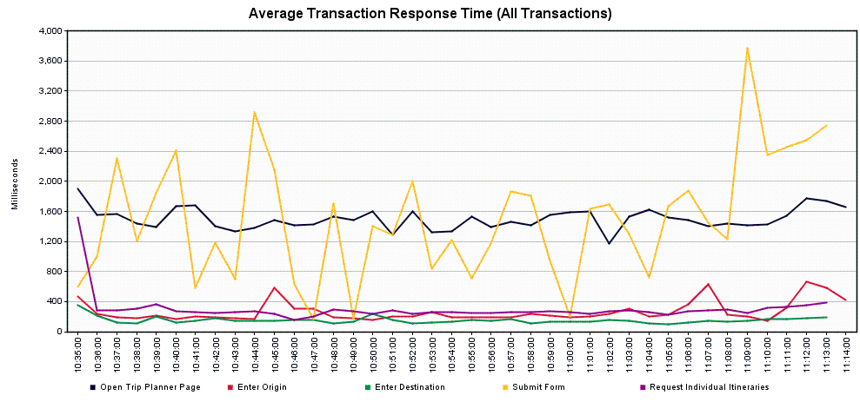

*Scenario 4.1.3 – Trip Planner Future Capacity – Year 2 (109 users/10% increase over previous year)*

Tool: JMeter

JMeter Setup: 4 users, 60 second ramp-up, 28 loops

Server: TRPPLNWEBS001

Start Time: 2019-May-22 07:19 AM (PDT)

End Time: 2019-May-22 08:01 AM (PDT)

Notes: There is a slight increase in the Submit transaction response times, 1% of users would appear to see response times of 9 seconds or more. It is possible that the memory usage is affecting these results.

Running Users

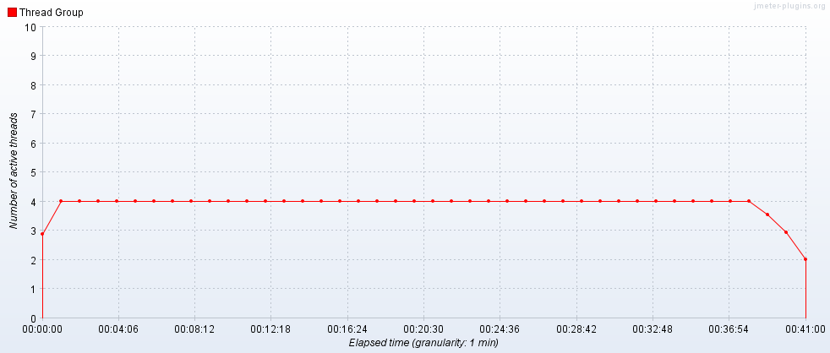

Hits per Second

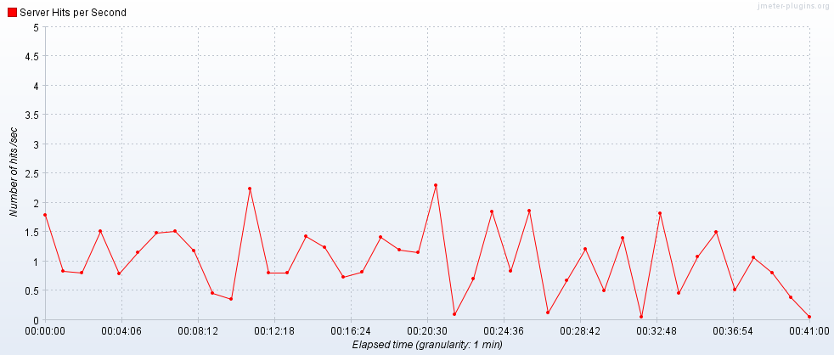

Transactions per Second

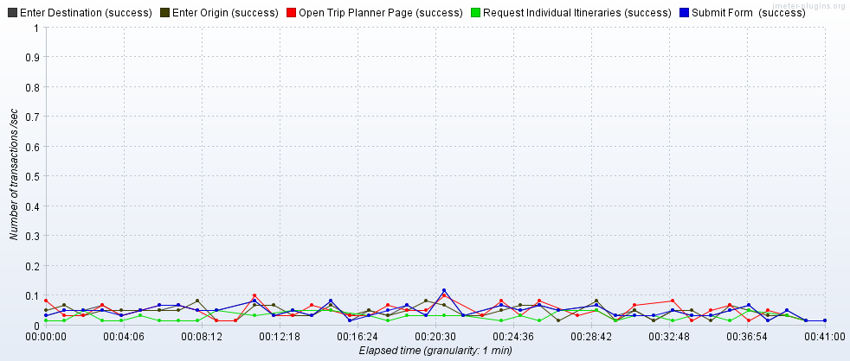

Transaction Statistics

|  |  |  |  |  |  |  |  |  |  |  |  |  |
| --- | --- | --- | --- | --- | --- | --- | --- | --- | --- | --- | --- | --- |
| Label | # Samples | Average | Median | 90% Line | 95% Line | 99% Line | Min | Max | Error % | Throughput | Received KB/sec | Sent KB/sec |
| Open Trip Planner Page | 112 | 1636 | 1577 | 1770 | 1814 | 4620 | 1162 | 5866 | 0.00% | 0.04566 | 197.61 | 1.11 |
| Enter Origin | 112 | 247 | 224 | 310 | 352 | 703 | 103 | 1457 | 0.00% | 0.04573 | 0.12 | 0.02 |
| Enter Destination | 112 | 164 | 142 | 233 | 253 | 467 | 97 | 609 | 0.00% | 0.04576 | 0.14 | 0.02 |
| Submit | 112 | 1655 | 1361 | 2699 | 3447 | 9455 | 109 | 22314 | 0.00% | 0.04564 | 5.98 | 0.39 |
| Request Individual Itineraries | 59 | 267 | 265 | 308 | 329 | 377 | 174 | 381 | 0.00% | 0.0249 | 3.12 | 0.3 |
| TOTAL | 3083 | 269 | 6 | 1214 | 1580 | 2491 | 2 | 22314 | 0.00% | 1.23522 | 400.72 | 3.04 |

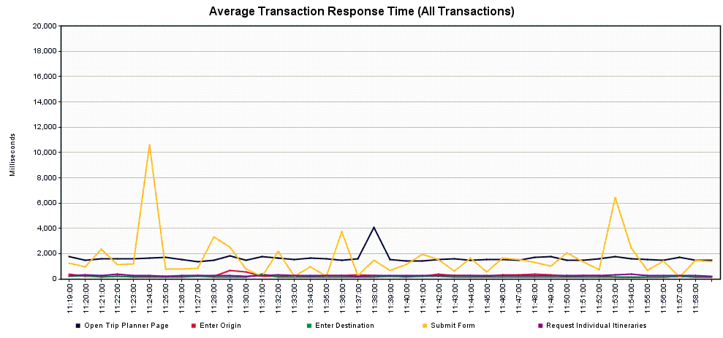

*Scenario 4.1.4 – Trip Planner Future Capacity – Year 3 (120 users/10% increase over previous year)*

Tool: JMeter

JMeter Setup: 4 users, 60 second ramp-up, 30 loops

Server: TRPPLNWEBS001

Start Time: 2019-May-22 08:58 AM (PDT)

End Time: 2019-May-22 09:54 AM (PDT)

Notes: There is another slight increase in the Submit transaction response times, 1% of users would appear to see response times of 11 seconds or more. It is possible that the memory usage is affecting these results.

Running Users

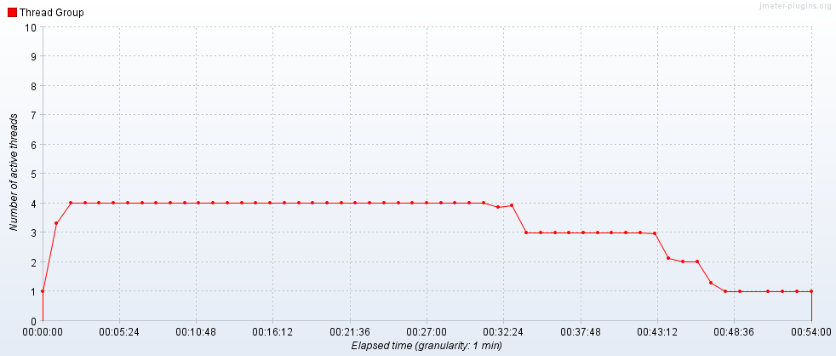

Hits per Second

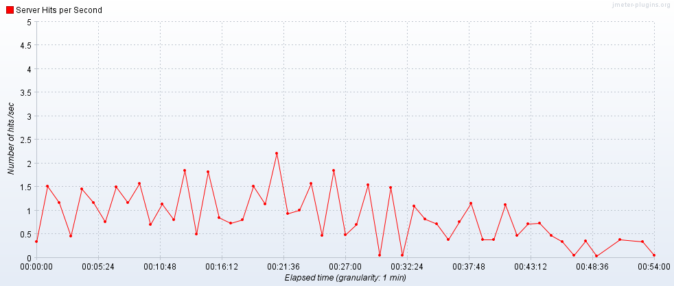

Transactions per Second

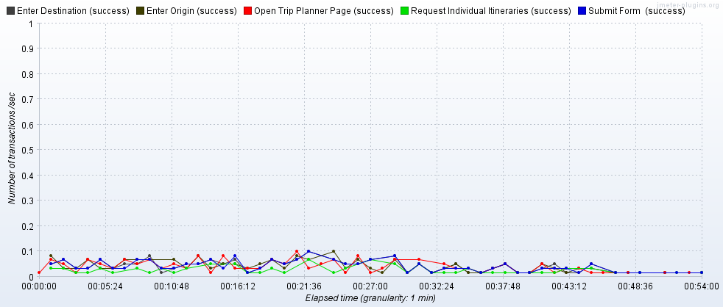

Transaction Statistics

|  |  |  |  |  |  |  |  |  |  |  |  |  |
| --- | --- | --- | --- | --- | --- | --- | --- | --- | --- | --- | --- | --- |
| Label | # Samples | Average | Median | 90% Line | 95% Line | 99% Line | Min | Max | Error % | Throughput | Received KB/sec | Sent KB/sec |
| Open Trip Planner Page | 120 | 1616 | 1581 | 1744 | 1878 | 3181 | 1081 | 4594 | 0.00% | 0.0377 | 163.18 | 0.92 |
| Enter Origin | 120 | 233 | 200 | 355 | 485 | 730 | 102 | 730 | 0.00% | 0.03775 | 0.11 | 0.02 |
| Enter Destination | 120 | 160 | 134 | 216 | 254 | 714 | 92 | 1013 | 0.00% | 0.03772 | 0.14 | 0.02 |
| Submit | 120 | 1754 | 1587 | 2750 | 3291 | 11378 | 97 | 28558 | 0.00% | 0.0377 | 5.39 | 0.33 |
| Request Individual Itineraries | 66 | 281 | 271 | 352 | 374 | 384 | 138 | 400 | 0.00% | 0.02075 | 2.79 | 0.25 |
| TOTAL | 3306 | 273 | 7 | 1243 | 1597 | 2543 | 3 | 28558 | 0.00% | 1.02697 | 333.83 | 2.55 |

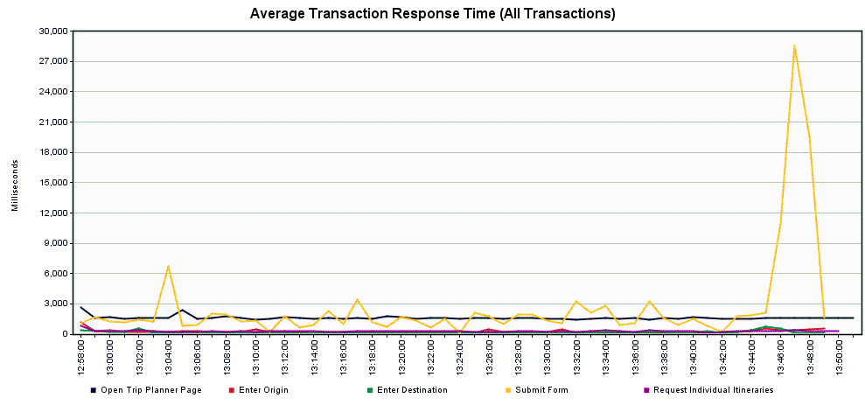

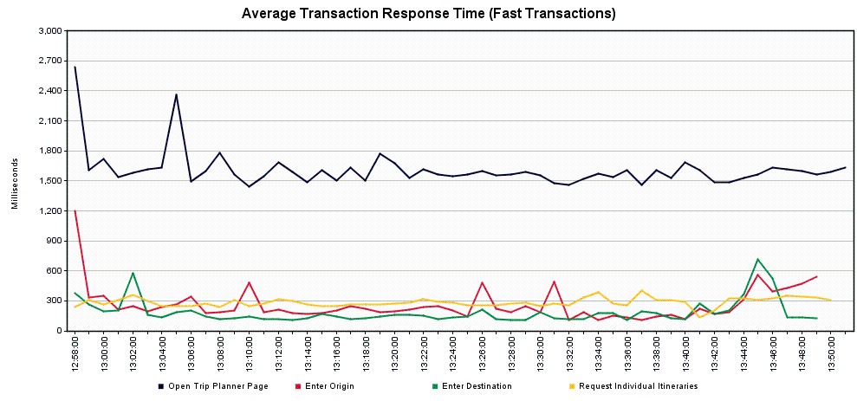

*Scenario 4.1.5 – Trip Planner Future Capacity – Year 4 (132 users/10% increase over previous year)*

Tool: JMeter

JMeter Setup: 5 users, 60 second ramp-up, 26 loops

Server: TRPPLNWEBS001

Start Time: 2019-May-22 10:02 AM (PDT)

End Time: 2019-May-22 10:47 AM (PDT)

Notes: Interestingly, there is a slight decrease in the Submit transaction response times here, 1% of users would appear to see response times of 9 seconds or more.

Running Users

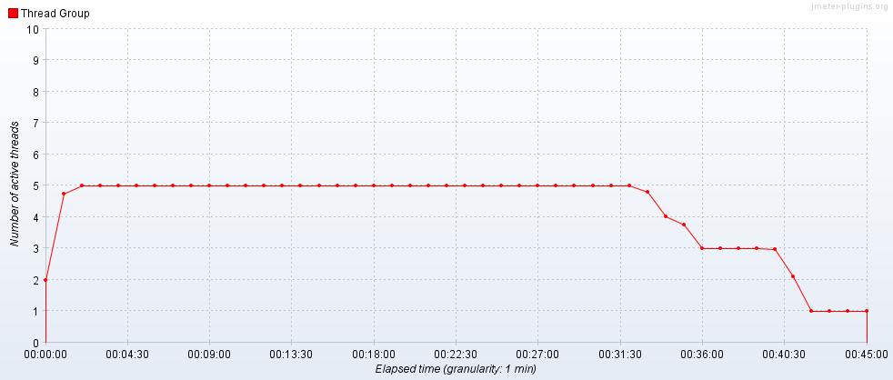

Hits per Second

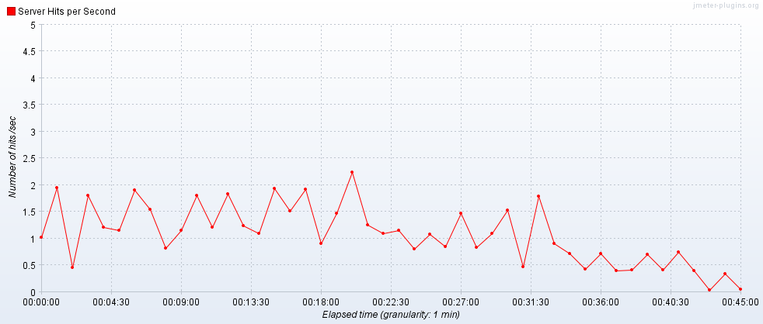

Transactions per Second

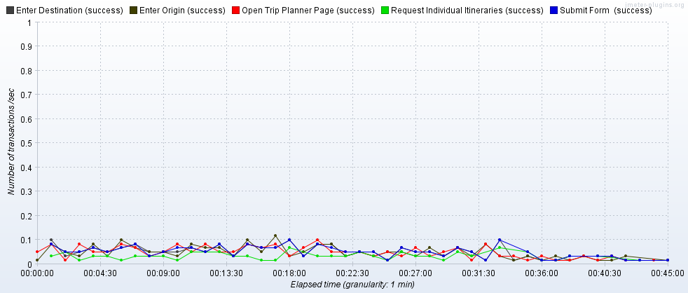

Transaction Statistics

|  |  |  |  |  |  |  |  |  |  |  |  |  |
| --- | --- | --- | --- | --- | --- | --- | --- | --- | --- | --- | --- | --- |
| Label | # Samples | Average | Median | 90% Line | 95% Line | 99% Line | Min | Max | Error % | Throughput | Received KB/sec | Sent KB/sec |
| Open Trip Planner Page | 130 | 1860 | 1732 | 2017 | 2159 | 5745 | 1333 | 8534 | 0.00% | 0.04903 | 212.23 | 1.19 |
| Enter Origin | 130 | 205 | 186 | 272 | 294 | 643 | 97 | 651 | 0.00% | 0.04904 | 0.17 | 0.03 |
| Enter Destination | 130 | 154 | 133 | 215 | 268 | 435 | 98 | 446 | 0.00% | 0.04905 | 0.18 | 0.03 |
| Submit | 130 | 1617 | 1503 | 2796 | 3173 | 9711 | 113 | 25668 | 0.00% | 0.04905 | 6.98 | 0.43 |
| Request Individual Itineraries | 73 | 301 | 296 | 385 | 414 | 450 | 107 | 466 | 0.00% | 0.02905 | 3.79 | 0.35 |
| TOTAL | 3583 | 278 | 12 | 1333 | 1711 | 2566 | 3 | 25668 | 0.00% | 1.33231 | 432.89 | 3.31 |

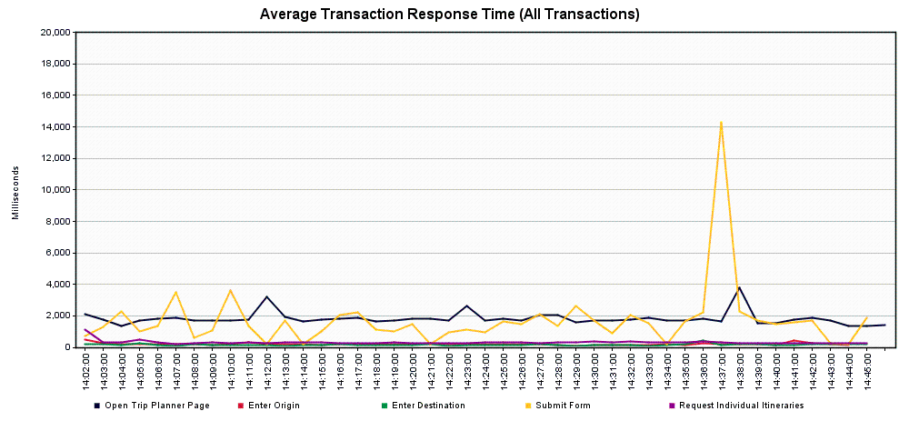

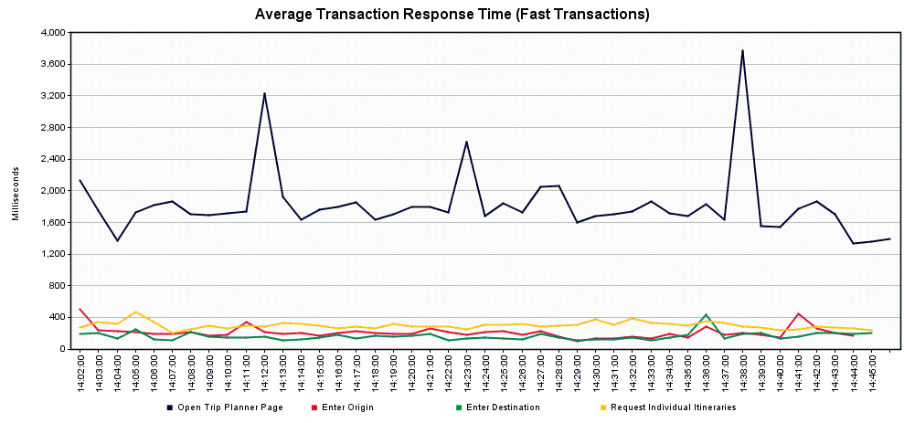

*Scenario 4.1.6 – Trip Planner Future Capacity – Year 5 (145 users/10% increase over previous year)*

Tool: JMeter

JMeter Setup: 5 users, 60 second ramp-up, 29 loops

Server: TRPPLNWEBS001

Start Time: 2019-May-22 10:49 AM (PDT)

End Time: 2019-May-22 11:39 AM (PDT)

Notes: The Submit transaction response times are consistent with the previous run, 1% of users would appear to see response times of 9 seconds or more.

Running Users

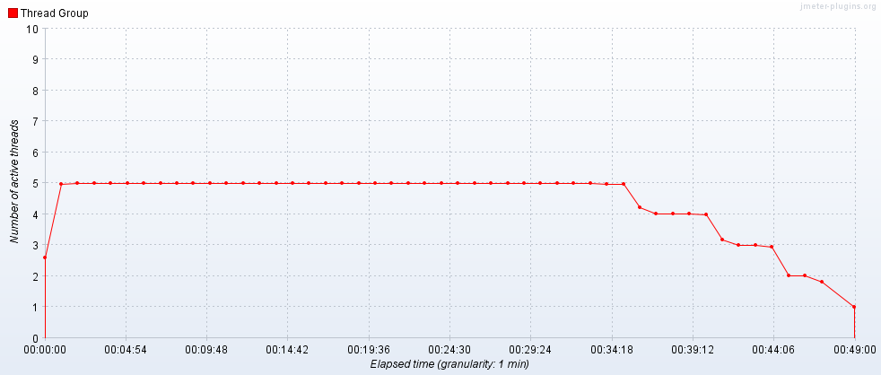

Hits per Second

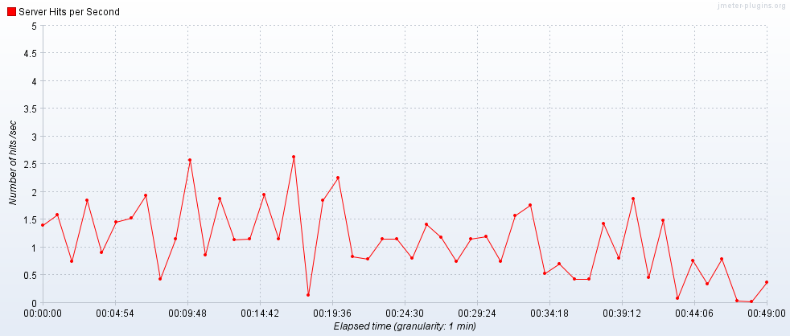

Transactions per Second

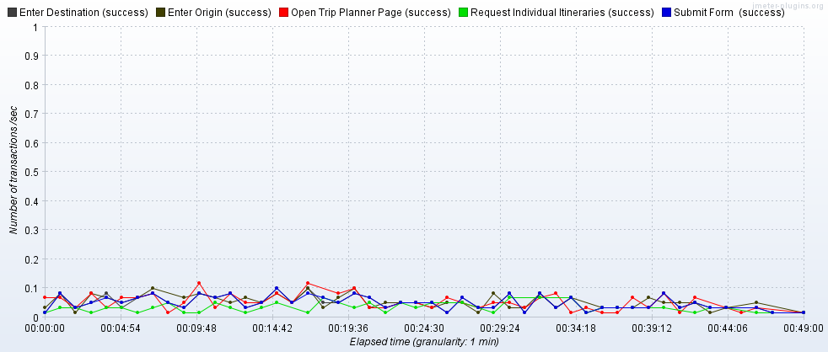

Transaction Statistics

|  |  |  |  |  |  |  |  |  |  |  |  |  |
| --- | --- | --- | --- | --- | --- | --- | --- | --- | --- | --- | --- | --- |
| Label | # Samples | Average | Median | 90% Line | 95% Line | 99% Line | Min | Max | Error % | Throughput | Received KB/sec | Sent KB/sec |
| Open Trip Planner Page | 145 | 1647 | 1544 | 1734 | 1943 | 6096 | 1210 | 6143 | 0.00% | 0.04961 | 214.71 | 1.2 |
| Enter Origin | 145 | 208 | 183 | 272 | 370 | 697 | 98 | 865 | 0.00% | 0.04965 | 0.21 | 0.03 |
| Enter Destination | 145 | 149 | 127 | 197 | 245 | 452 | 93 | 750 | 0.00% | 0.04962 | 0.18 | 0.03 |
| Submit | 145 | 1568 | 1490 | 2589 | 2757 | 9632 | 101 | 24198 | 0.00% | 0.0496 | 7.43 | 0.45 |
| Request Individual Itineraries | 83 | 281 | 272 | 362 | 381 | 388 | 84 | 416 | 0.00% | 0.02842 | 3.97 | 0.34 |
| TOTAL | 3998 | 259 | 6 | 1209 | 1556 | 2487 | 2 | 24198 | 0.00% | 1.35035 | 439.4 | 3.37 |

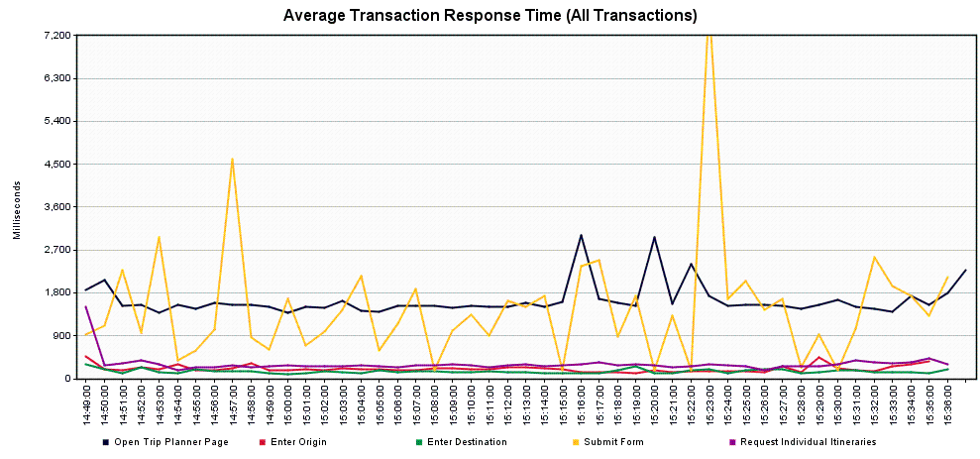

**Scenario 4.2 – Trip Planner Future Capacity – Load Balancer**

Scope: This was completed as a series of runs to examine how the service would cope with an expected 10% yearly increase, for 5 years. Given a typical daily usage of approximately 1400 users/hour, a load level of 180 users/hour was the starting target for two servers in staging.

*Scenario 4.2.1 – Trip Planner Future Capacity – Year 0 (baseline/current)*

Tool: JMeter

JMeter Setup: 6 users, 60 second ramp-up, 30 loops

Server: tripplanning.stg.translink.ca

Start Time: 2019-May-27 06:48 AM (PDT)

End Time: 2019-May-27 07:39 AM (PDT)

Notes: The response times are generally good; the Submit transaction does encounter a bit of slowness, with 1% of users seeing response times of 11 seconds or more.

Running Users

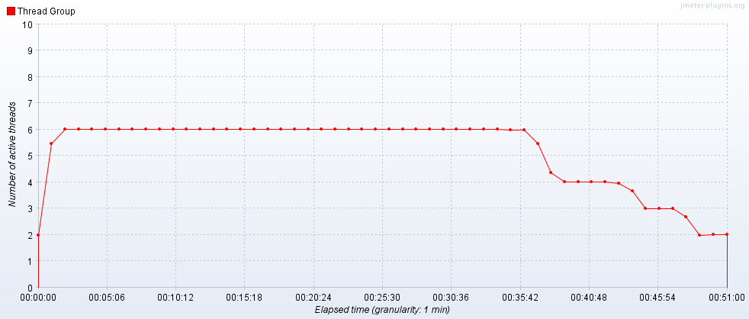

Hits per Second

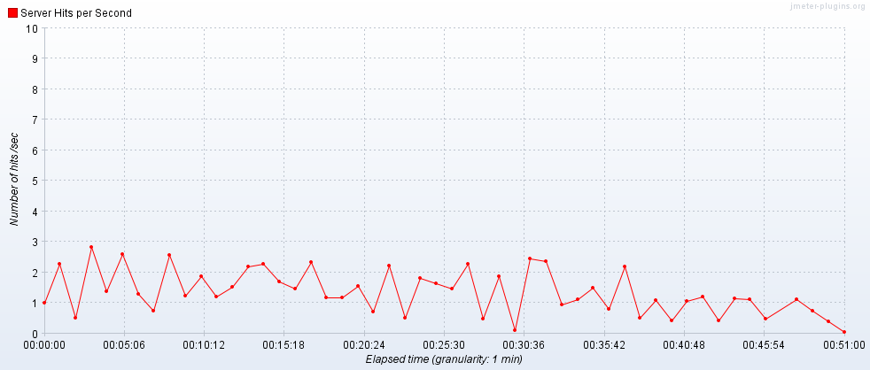

Transactions per Second

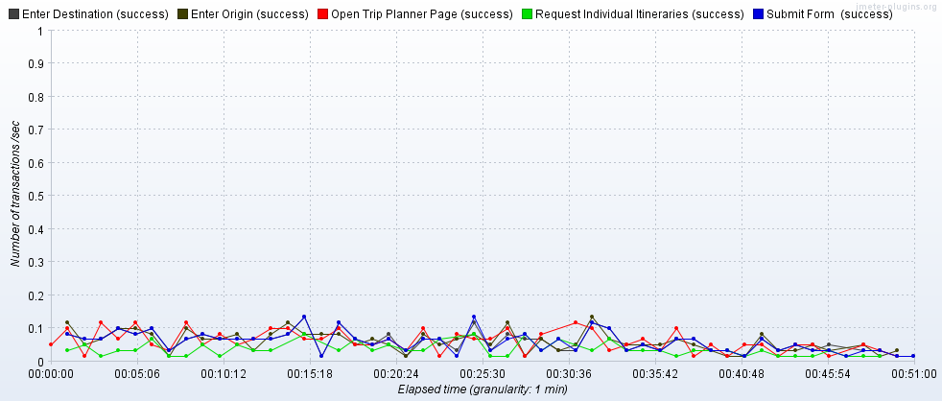

Transaction Statistics

|  |  |  |  |  |  |  |  |  |  |  |  |  |
| --- | --- | --- | --- | --- | --- | --- | --- | --- | --- | --- | --- | --- |
| Label | # Samples | Average | Median | 90% Line | 95% Line | 99% Line | Min | Max | Error % | Throughput | Received KB/sec | Sent KB/sec |
| Open Trip Planner Page | 180 | 2008 | 1955 | 2215 | 2525 | 3508 | 1477 | 5765 | 0.00% | 0.06006 | 259.36 | 2.01 |
| Enter Origin | 180 | 202 | 171 | 400 | 457 | 638 | 95 | 969 | 0.00% | 0.06019 | 0.24 | 0.04 |
| Enter Destination | 180 | 147 | 120 | 196 | 241 | 453 | 92 | 838 | 0.00% | 0.06016 | 0.25 | 0.04 |
| Submit | 180 | 2110 | 2397 | 3605 | 4120 | 11831 | 125 | 24210 | 0.00% | 0.06016 | 8.49 | 0.56 |
| Request Individual Itineraries | 99 | 513 | 535 | 771 | 823 | 853 | 88 | 907 | 0.00% | 0.03397 | 4.69 | 0.44 |
| TOTAL | 4959 | 324 | 11 | 1547 | 2037 | 3329 | 3 | 24210 | 0.00% | 1.63495 | 530.28 | 5.23 |

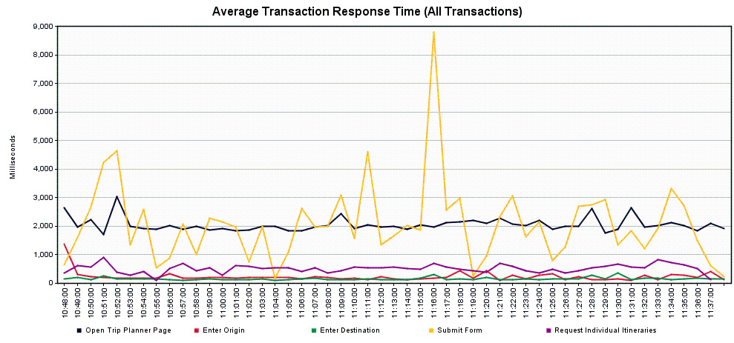

*Scenario 4.2.2 – Trip Planner Future Capacity – Year 1 (198 users/10% increase over previous year)*

Tool: JMeter

JMeter Setup: 8 users, 60 second ramp-up, 25 loops

Server: tripplanning.stg.translink.ca

Start Time: 2019-May-27 07:47 AM (PDT)

End Time: 2019-May-27 08:28 AM (PDT)

Notes: The Open Trip Planner Page transaction had some slight slowdowns, with 10% of users likely seeing a response time of 6 seconds or more. Similar to the previous run, the Submit transaction had 1% of users likely seeing a response time of 11 seconds or more.

Running Users

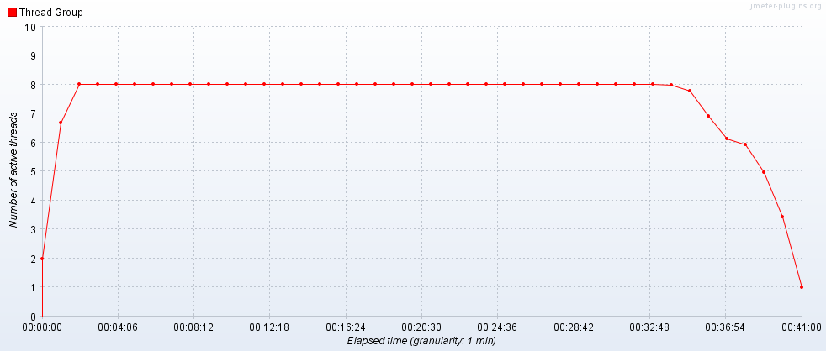

Hits per Second

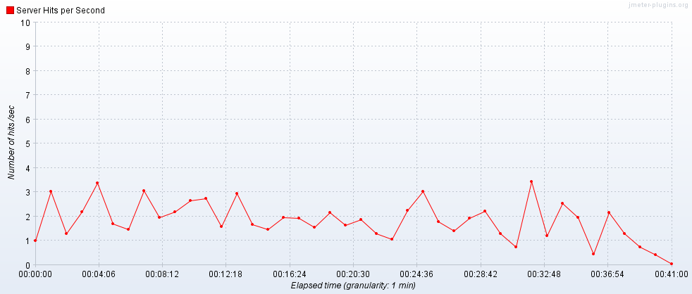

Transactions per Second

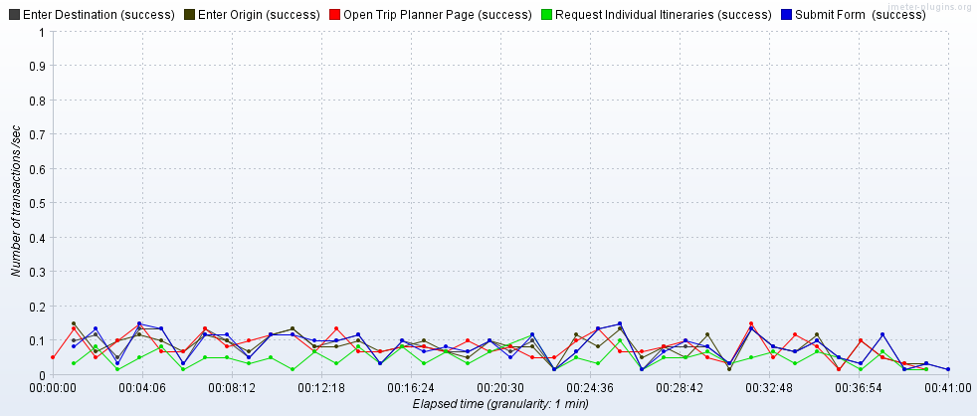

Transaction Statistics

|  |  |  |  |  |  |  |  |  |  |  |  |  |
| --- | --- | --- | --- | --- | --- | --- | --- | --- | --- | --- | --- | --- |
| Label | # Samples | Average | Median | 90% Line | 95% Line | 99% Line | Min | Max | Error % | Throughput | Received KB/sec | Sent KB/sec |
| Open Trip Planner Page | 200 | 3456 | 3123 | 6094 | 6425 | 7202 | 1693 | 8455 | 0.00% | 0.08339 | 360.11 | 2.79 |
| Enter Origin | 200 | 258 | 198 | 482 | 544 | 926 | 93 | 1190 | 0.00% | 0.0836 | 0.32 | 0.05 |
| Enter Destination | 200 | 212 | 181 | 306 | 416 | 725 | 89 | 1664 | 0.00% | 0.08363 | 0.34 | 0.05 |
| Submit | 200 | 2273 | 2511 | 4005 | 4624 | 11313 | 119 | 29206 | 0.00% | 0.08363 | 12.61 | 0.81 |
| Request Individual Itineraries | 114 | 622 | 599 | 936 | 1018 | 1233 | 113 | 1280 | 0.00% | 0.04909 | 7.04 | 0.64 |
| TOTAL | 5514 | 449 | 34 | 1815 | 3062 | 5472 | 3 | 29206 | 0.00% | 2.26702 | 736.3 | 7.31 |

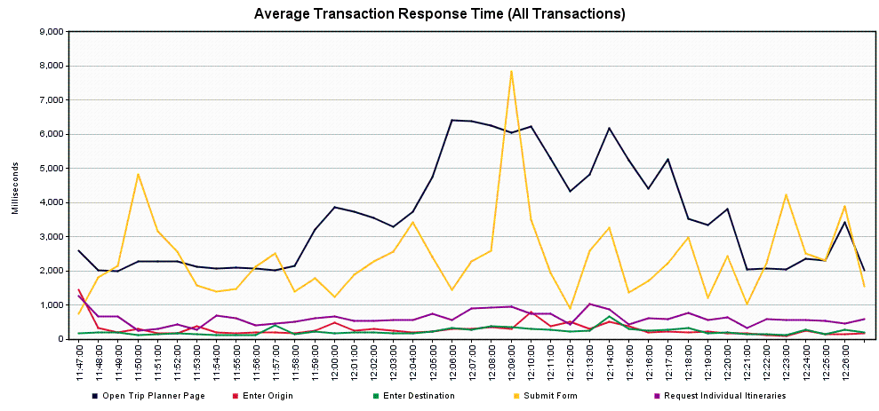

*Scenario 4.2.3 – Trip Planner Future Capacity – Year 2 (218 users/10% increase over previous year)*

Tool: JMeter

JMeter Setup: 8 users, 60 second ramp-up, 28 loops

Server: tripplanning.stg.translink.ca

Start Time: 2019-May-27 09:11 AM (PDT)

End Time: 2019-May-27 09:56 AM (PDT)

Notes: The Open Trip Planner Page response times reverted back to normal. The Submit transaction response times took a sharp jump, with 5% of users likely seeing response times of 20 seconds or more, and 1% of users seeing response times of 96 seconds or more. There was 1 error – one Enter Origin transaction encountered a 400 error, making a bad request to a Google API. The error doesn’t appear to be related to the Trip Planner service.

Running Users

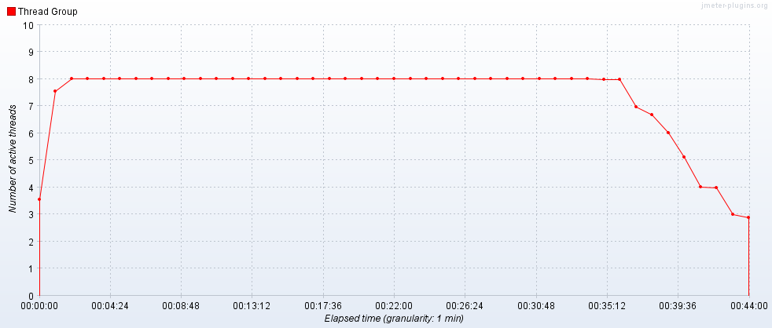

Hits per Second

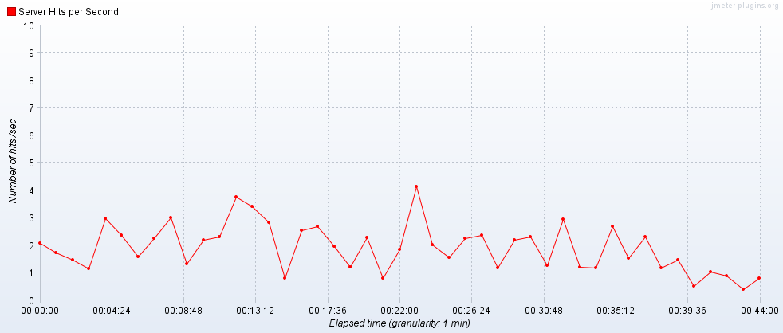

Transactions per Second

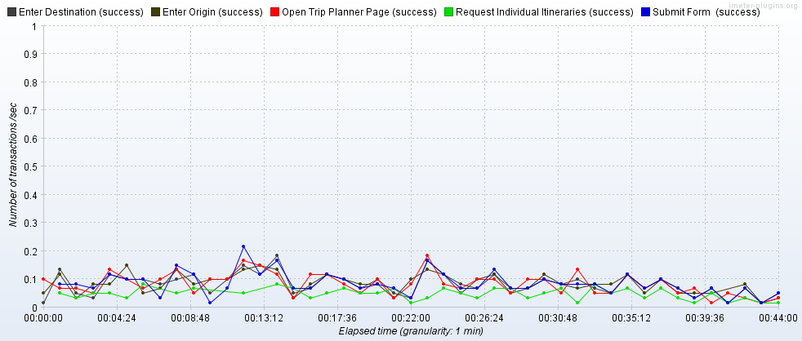

Transaction Statistics

|  |  |  |  |  |  |  |  |  |  |  |  |  |
| --- | --- | --- | --- | --- | --- | --- | --- | --- | --- | --- | --- | --- |
| Label | # Samples | Average | Median | 90% Line | 95% Line | 99% Line | Min | Max | Error % | Throughput | Received KB/sec | Sent KB/sec |
| Open Trip Planner Page | 224 | 1432 | 1749 | 2191 | 2294 | 2850 | 514 | 4131 | 0.00% | 0.08508 | 208.26 | 1.91 |
| Enter Origin | 224 | 255 | 187 | 462 | 592 | 877 | 13 | 6009 | 0.45% | 0.08511 | 0.69 | 0.07 |
| Enter Destination | 223 | 182 | 140 | 268 | 390 | 686 | 12 | 2339 | 0.00% | 0.08469 | 0.31 | 0.05 |
| Submit | 223 | 5673 | 2586 | 5096 | 20633 | 95540 | 4 | 104555 | 0.00% | 0.08469 | 11.92 | 0.76 |
| Request Individual Itineraries | 115 | 574 | 545 | 812 | 963 | 1574 | 103 | 3035 | 0.00% | 0.04428 | 6.64 | 0.58 |
| TOTAL | 6159 | 546 | 9 | 610 | 1975 | 3925 | 3 | 104555 | 0.03% | 2.30649 | 436.16 | 5.5 |

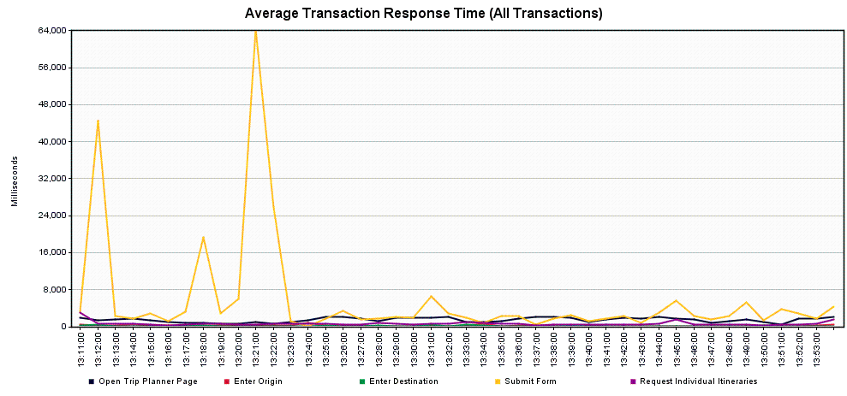

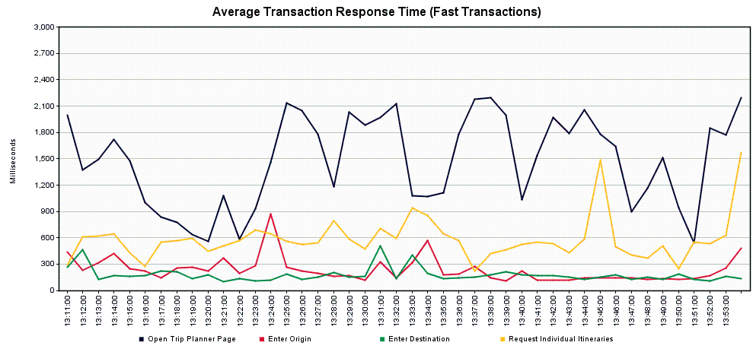

*Scenario 4.2.4 – Trip Planner Future Capacity – Year 3 (240 users/10% increase over previous year)*

Tool: JMeter

JMeter Setup: 8 users, 60 second ramp-up, 30 loops

Server: tripplanning.stg.translink.ca

Start Time: 2019-May-27 10:11 AM (PDT)

End Time: 2019-May-27 11:01 AM (PDT)

Notes: The Submit transaction response times revert to nearly normal, 1% of users would appear to see response times of 11 seconds or more. There were 4 errors, all appeared to be making bad request to the Twitter API (HTTP 400 error), but don’t appear to be related to the Trip Planner service.

Running Users

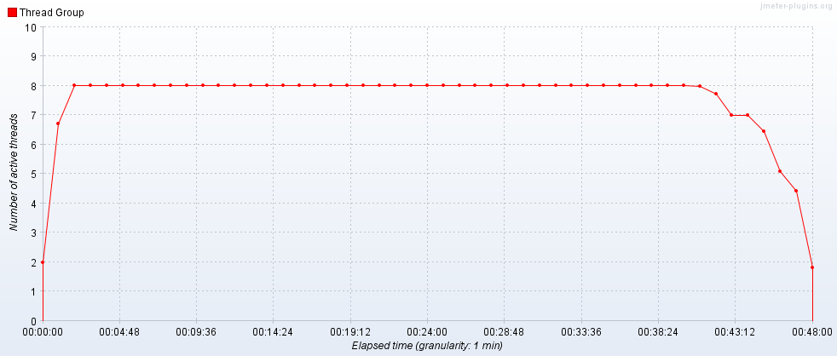

Hits per Second

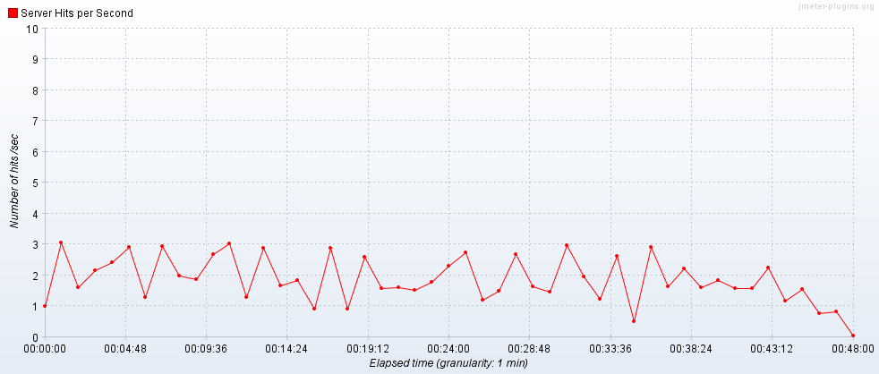

Transactions per Second

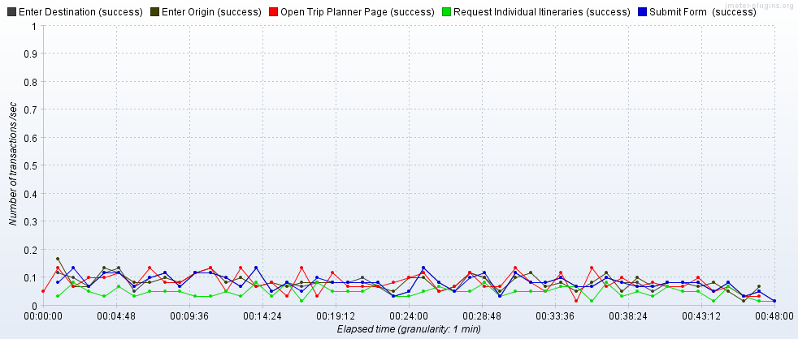

Transaction Statistics

|  |  |  |  |  |  |  |  |  |  |  |  |  |
| --- | --- | --- | --- | --- | --- | --- | --- | --- | --- | --- | --- | --- |
| Label | # Samples | Average | Median | 90% Line | 95% Line | 99% Line | Min | Max | Error % | Throughput | Received KB/sec | Sent KB/sec |
| Open Trip Planner Page | 240 | 1955 | 1968 | 2220 | 2701 | 8726 | 533 | 9129 | 0.83% | 0.0852 | 318.49 | 2.58 |
| Enter Origin | 238 | 219 | 169 | 307 | 504 | 1120 | 93 | 4255 | 0.42% | 0.0846 | 0.67 | 0.06 |
| Enter Destination | 237 | 171 | 127 | 223 | 315 | 671 | 90 | 4155 | 0.42% | 0.08418 | 0.66 | 0.06 |
| Submit | 236 | 2113 | 2480 | 3651 | 4293 | 10479 | 49 | 26347 | 0.00% | 0.08371 | 13.09 | 0.83 |
| Request Individual Itineraries | 141 | 510 | 526 | 770 | 825 | 910 | 92 | 1001 | 0.00% | 0.05007 | 7.15 | 0.64 |
| TOTAL | 6569 | 323 | 18 | 1536 | 2084 | 3453 | 3 | 26347 | 0.12% | 2.2976 | 656.01 | 6.96 |

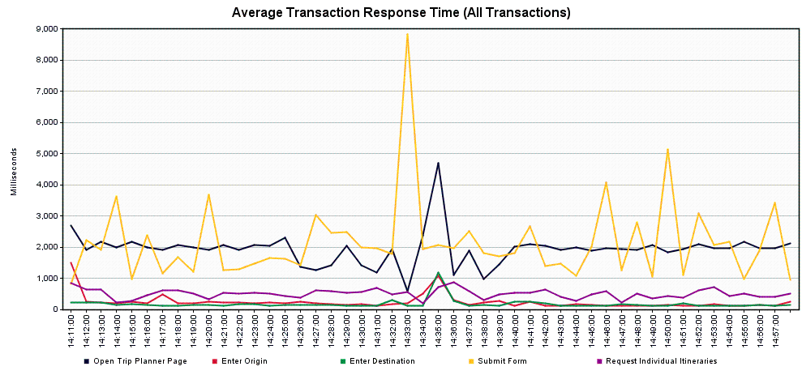

*Scenario 4.2.5 – Trip Planner Future Capacity – Year 4 (260 users/10% increase over previous year)*

Tool: JMeter

JMeter Setup: 10 users, 60 second ramp-up, 26 loops

Server: tripplanning.stg.translink.ca

Start Time: 2019-May-28 05:06 AM (PDT)

End Time: 2019-May-28 05:47 AM (PDT)

Notes: These results come approximately a day after the previous run. The Submit transaction shows an increase in response times, with 10% of users likely seeing response times of 6 seconds or more, and 1% of users seeing response times of 30 seconds or more.

Running Users

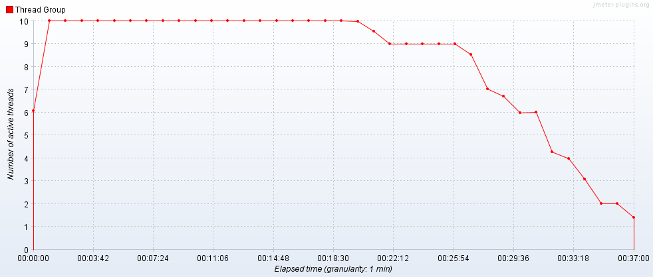

Hits per Second

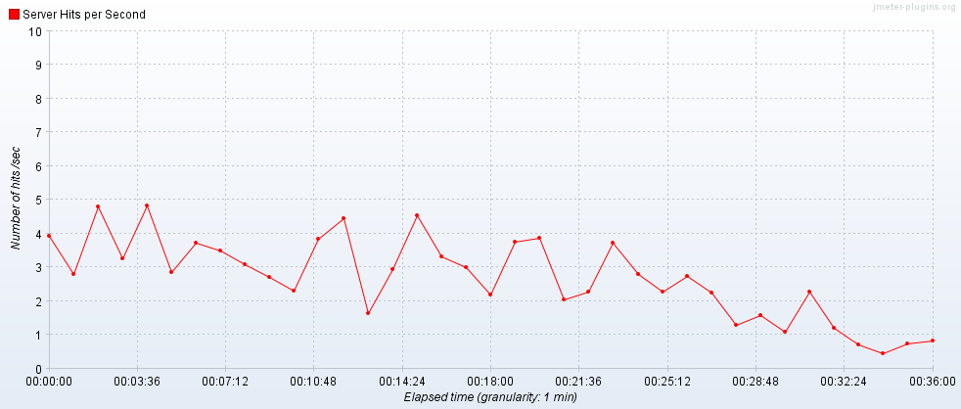

Transactions per Second

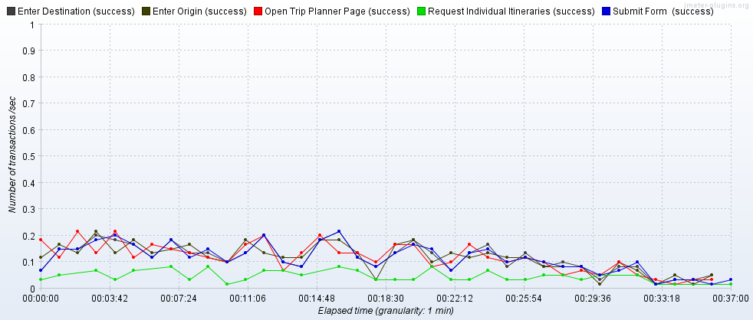

Transaction Statistics

|  |  |  |  |  |  |  |  |  |  |  |  |  |
| --- | --- | --- | --- | --- | --- | --- | --- | --- | --- | --- | --- | --- |
| Label | # Samples | Average | Median | 90% Line | 95% Line | 99% Line | Min | Max | Error % | Throughput | Received KB/sec | Sent KB/sec |
| Open Trip Planner Page | 260 | 1953 | 1872 | 2202 | 2423 | 3432 | 1485 | 7883 | 0.00% | 0.11925 | 514.62 | 3.99 |
| Enter Origin | 260 | 209 | 172 | 310 | 423 | 625 | 88 | 2356 | 0.00% | 0.11977 | 0.47 | 0.08 |
| Enter Destination | 260 | 192 | 134 | 220 | 342 | 595 | 91 | 5489 | 0.00% | 0.11976 | 0.43 | 0.08 |
| Submit | 260 | 3349 | 980 | 5850 | 18650 | 30196 | 105 | 31975 | 0.00% | 0.11964 | 9.95 | 0.76 |
| Request Individual Itineraries | 90 | 500 | 522 | 778 | 793 | 845 | 64 | 870 | 0.00% | 0.04148 | 5.33 | 0.5 |
| TOTAL | 7110 | 417 | 8 | 1437 | 1900 | 4791 | 3 | 31975 | 0.00% | 3.20706 | 1033.48 | 9.65 |

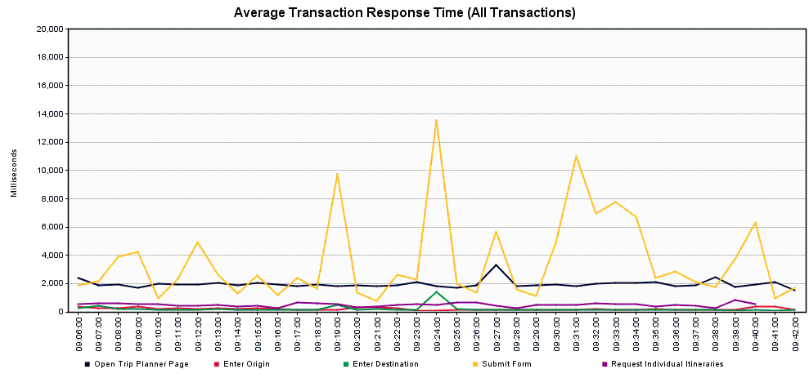

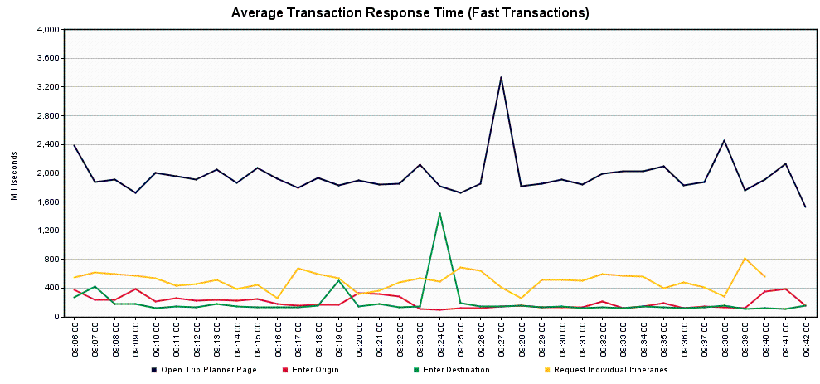

*Scenario 4.2.6 – Trip Planner Future Capacity – Year 5 (290 users/10% increase over previous year)*

Tool: JMeter

JMeter Setup: 10 users, 60 second ramp-up, 29 loops

Server: tripplanning.stg.translink.ca

Start Time: 2019-May-28 06:28 AM (PDT)

End Time: 2019-May-28 07:17 AM (PDT)

Notes: All of the transactions have reverted to normal. Even the Submit transaction – with only 1% of users likely seeing response times of 6 seconds or more.

Running Users

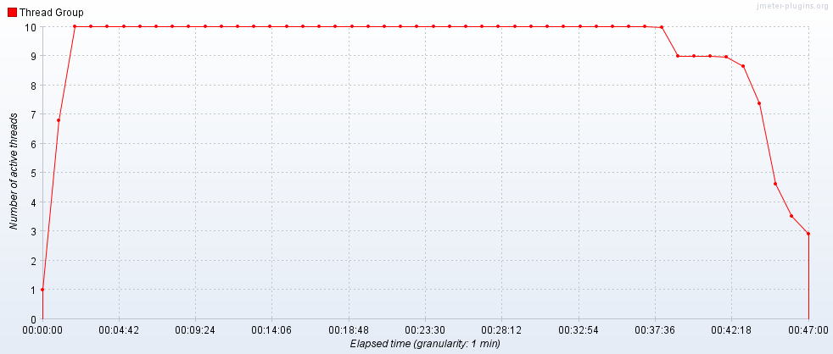

Hits per Second

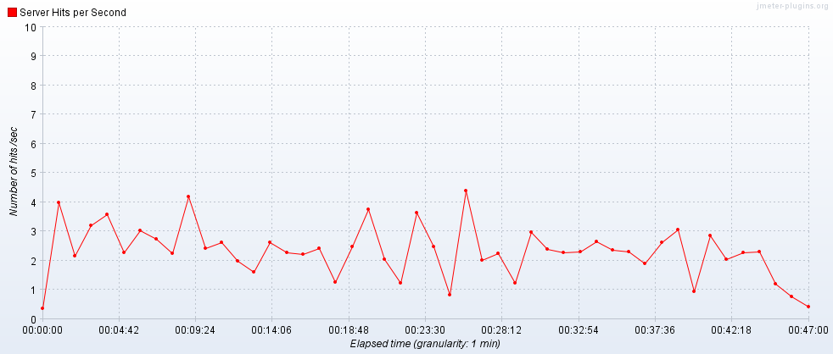

Transactions per Second

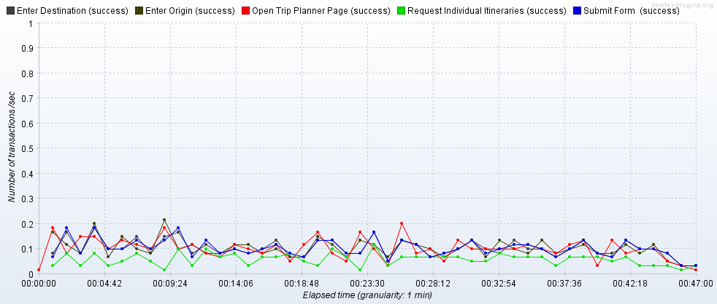

Transaction Statistics

|  |  |  |  |  |  |  |  |  |  |  |  |  |
| --- | --- | --- | --- | --- | --- | --- | --- | --- | --- | --- | --- | --- |
| Label | # Samples | Average | Median | 90% Line | 95% Line | 99% Line | Min | Max | Error % | Throughput | Received KB/sec | Sent KB/sec |
| Open Trip Planner Page | 290 | 1999 | 1951 | 2191 | 2514 | 3389 | 1484 | 5735 | 0.00% | 0.10434 | 450.33 | 3.49 |
| Enter Origin | 290 | 169 | 139 | 267 | 392 | 528 | 86 | 1144 | 0.00% | 0.10444 | 0.43 | 0.07 |
| Enter Destination | 290 | 136 | 114 | 184 | 208 | 440 | 88 | 839 | 0.00% | 0.10448 | 0.36 | 0.07 |
| Submit | 290 | 1983 | 2399 | 3676 | 4131 | 6580 | 111 | 17253 | 0.00% | 0.10436 | 15.17 | 0.98 |
| Request Individual Itineraries | 164 | 509 | 519 | 770 | 828 | 854 | 85 | 1026 | 0.00% | 0.05908 | 8.32 | 0.75 |
| TOTAL | 7994 | 311 | 11 | 1591 | 2028 | 3394 | 3 | 17253 | 0.00% | 2.83643 | 919.7 | 9.09 |

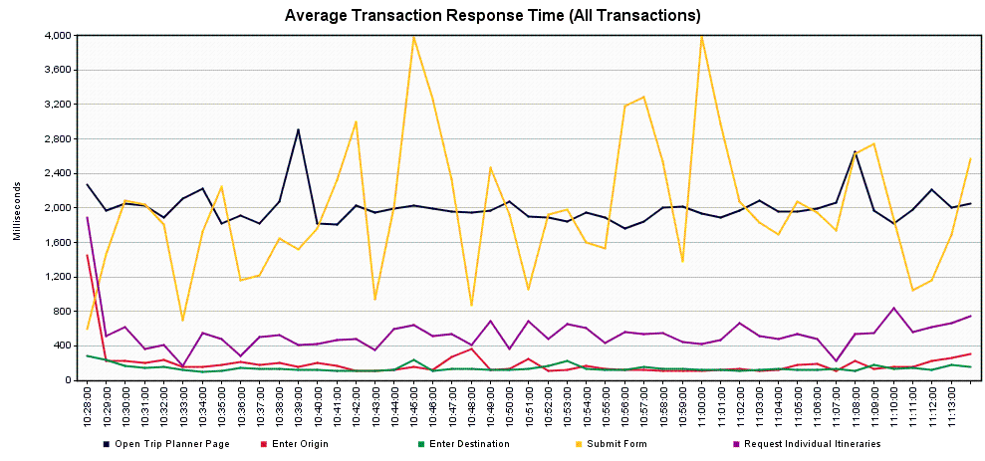

**Scenario 5.1 – Trip Planner Endurance Test – Single Server**

Scope: This run was completed to determine whether a very long run at peak loads causes any issues to the service. A load level of 250 users/hour was the target.

Tool: JMeter

JMeter Setup: 8 users, 60 second ramp-up, Loop “Forever”, Scheduler Enabled, Scheduler Duration 86400 seconds (24 Hours)

Server: TRPPLNWEBS002

Start Time: 2019-May-23 12:39 PM (PDT)

End Time: 2019-May-24 12:39 PM (PDT)

Notes: Overall, the service performed admirably. There were a few errors noted, though these are clustered around 9:26-9:27 AM on May 24th – all appeared to be “connection refused” errors. It should be noted that these are the only errors encountered in the entire set of runs completed against a single server. There was a jump in transactions and server hits around midnight, with a similar jump in the Network Data Transmit Rate, but no errors were reported from that time period.

The Submit transaction response times were where we saw the most variation, with 5% of users seeing response times of 12 seconds or more, and 1% of users seeing response time of 31 seconds or more.

Running Users

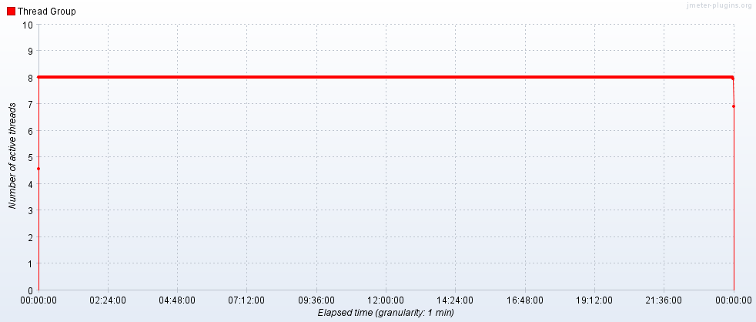

Hits per Second

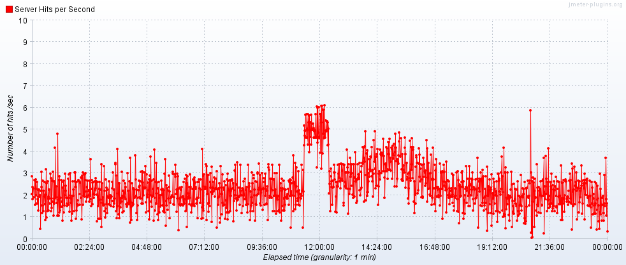

Transactions per Second

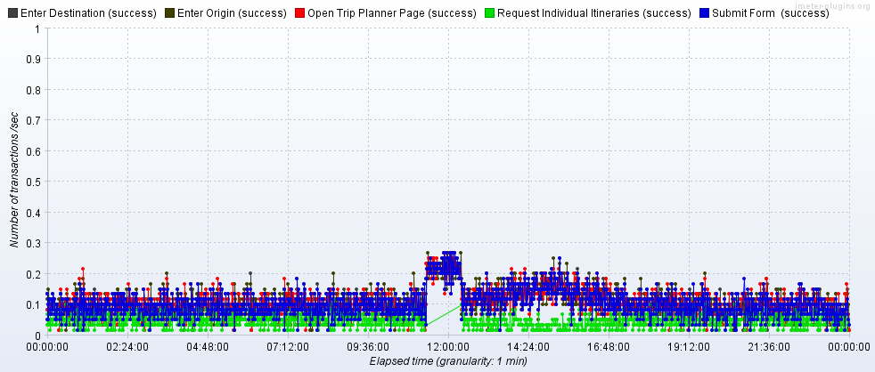

Transaction Statistics

|  |  |  |  |  |  |  |  |  |  |  |  |  |
| --- | --- | --- | --- | --- | --- | --- | --- | --- | --- | --- | --- | --- |
| Label | # Samples | Average | Median | 90% Line | 95% Line | 99% Line | Min | Max | Error % | Throughput | Received KB/sec | Sent KB/sec |
| Open Trip Planner Page | 9176 | 1447 | 1398 | 1684 | 1778 | 3147 | 928 | 22572 | 2.87% | 0.1062 | 446.16 | 2.5 |
| Enter Origin | 8912 | 139 | 116 | 194 | 232 | 447 | 76 | 4840 | 0.00% | 0.10319 | 0.54 | 0.06 |
| Enter Destination | 8910 | 134 | 114 | 190 | 222 | 374 | 78 | 2364 | 0.03% | 0.10317 | 0.53 | 0.06 |
| Submit | 8907 | 2568 | 338 | 3592 | 12472 | 31066 | 37 | 87287 | 0.02% | 0.10313 | 11.81 | 0.73 |
| Request Individual Itineraries | 3777 | 276 | 269 | 347 | 374 | 537 | 59 | 2390 | 0.00% | 0.04374 | 6.61 | 0.51 |
| TOTAL | 244931 | 315 | 7 | 949 | 1409 | 2824 | 2 | 87287 | 0.22% | 2.83471 | 918.04 | 6.69 |

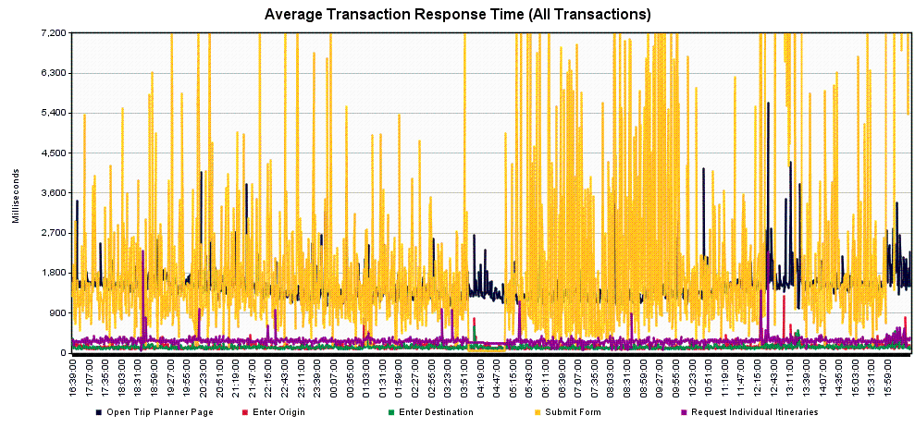

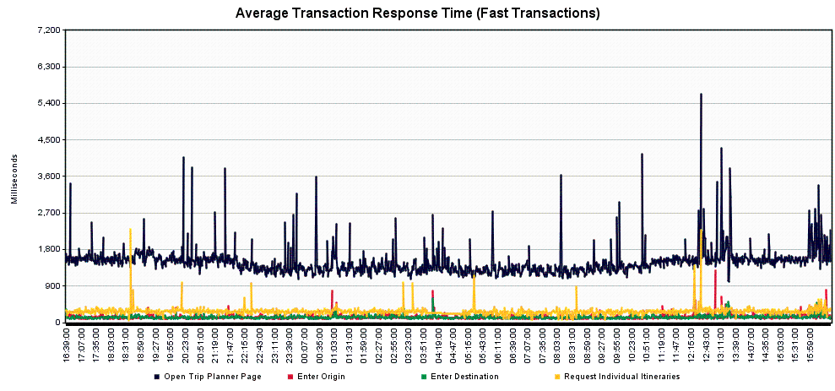

**Scenario 5.2 – Trip Planner Endurance Test – Load Balancer**

Scope: This run was completed to determine whether a very long run at peak loads causes any issues to the service. A load level of 500 users/hour was the target.

Tool: JMeter

JMeter Setup: 16 users, 60 second ramp-up, Loop “Forever”, Scheduler Enabled, Scheduler Duration 86400 seconds (24 Hours)

Server: tripplanning.stg.translink.ca

Start Time: 2019-May-30 07:51 AM (PDT)

End Time: 2019-May-31 07:51 AM (PDT)

Notes: Overall, the service performed admirably. There were three errors noted, and all seemed to be related to external APIs and not the service directly. There was a jump in transactions and server hits around midnight, with a similar jump in the Network Data Transmit Rate, but no errors were reported from that time period.

The Submit transaction response times were where we saw the most variation, with 5% of users seeing response times of 6 seconds or more, and 1% of users seeing response time of 30 seconds or more.

Running Users

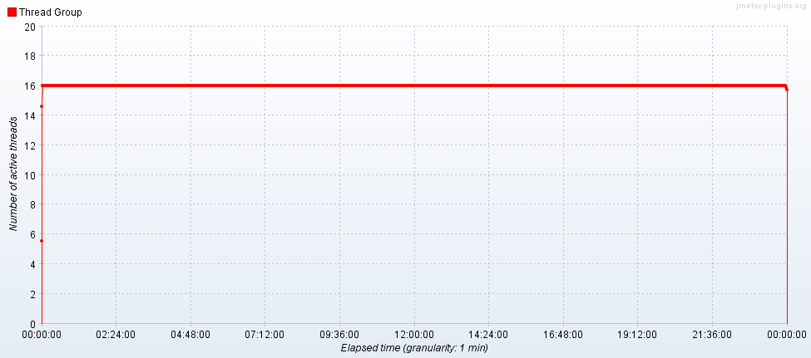

Hits per Second

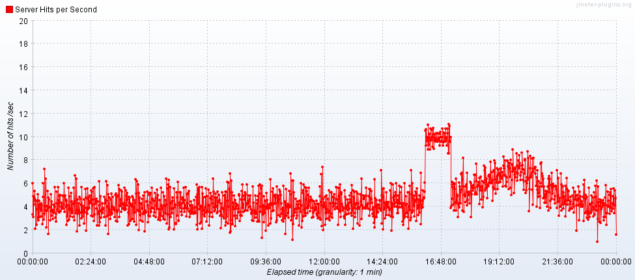

Transactions per Second

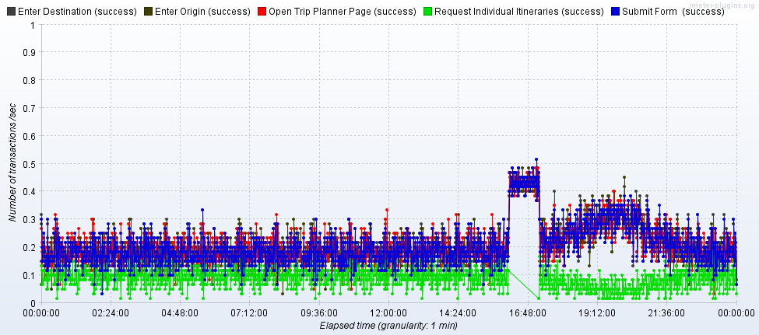

Transaction Statistics

|  |  |  |  |  |  |  |  |  |  |  |  |  |
| --- | --- | --- | --- | --- | --- | --- | --- | --- | --- | --- | --- | --- |
| Label | # Samples | Average | Median | 90% Line | 95% Line | 99% Line | Min | Max | Error % | Throughput | Received KB/sec | Sent KB/sec |
| Open Trip Planner Page | 17812 | 1864 | 1835 | 2103 | 2246 | 2920 | 1287 | 20827 | 0.01% | 0.20615 | 890.12 | 6.9 |
| Enter Origin | 17806 | 159 | 118 | 303 | 406 | 676 | 83 | 2321 | 0.00% | 0.20616 | 1.08 | 0.13 |
| Enter Destination | 17803 | 156 | 117 | 282 | 402 | 632 | 82 | 4887 | 0.01% | 0.20615 | 1.1 | 0.13 |
| Submit | 17802 | 2121 | 373 | 3996 | 5978 | 29466 | 38 | 35965 | 0.00% | 0.20614 | 23.51 | 1.57 |
| Request Individual Itineraries | 7548 | 553 | 540 | 813 | 843 | 1037 | 61 | 3722 | 0.00% | 0.08741 | 13.16 | 1.11 |
| TOTAL | 488365 | 313 | 8 | 1295 | 1839 | 3471 | 3 | 35965 | 0.00% | 5.65228 | 1831.6 | 17.49 |

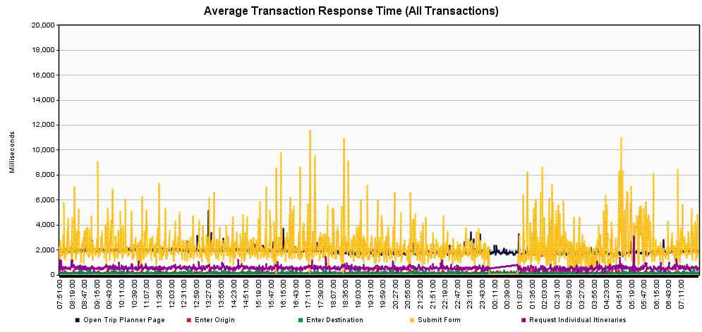

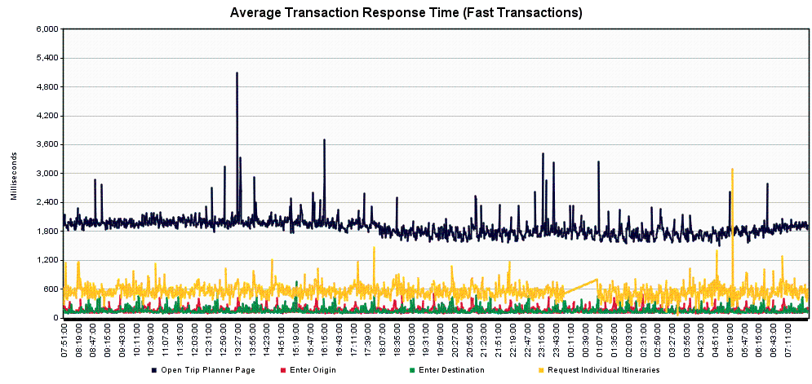

Server Graphs

***May 22nd:***

Here we see scenario **1.1 Trip Planner Historical Load** applied to TRPPLNWEBS001.

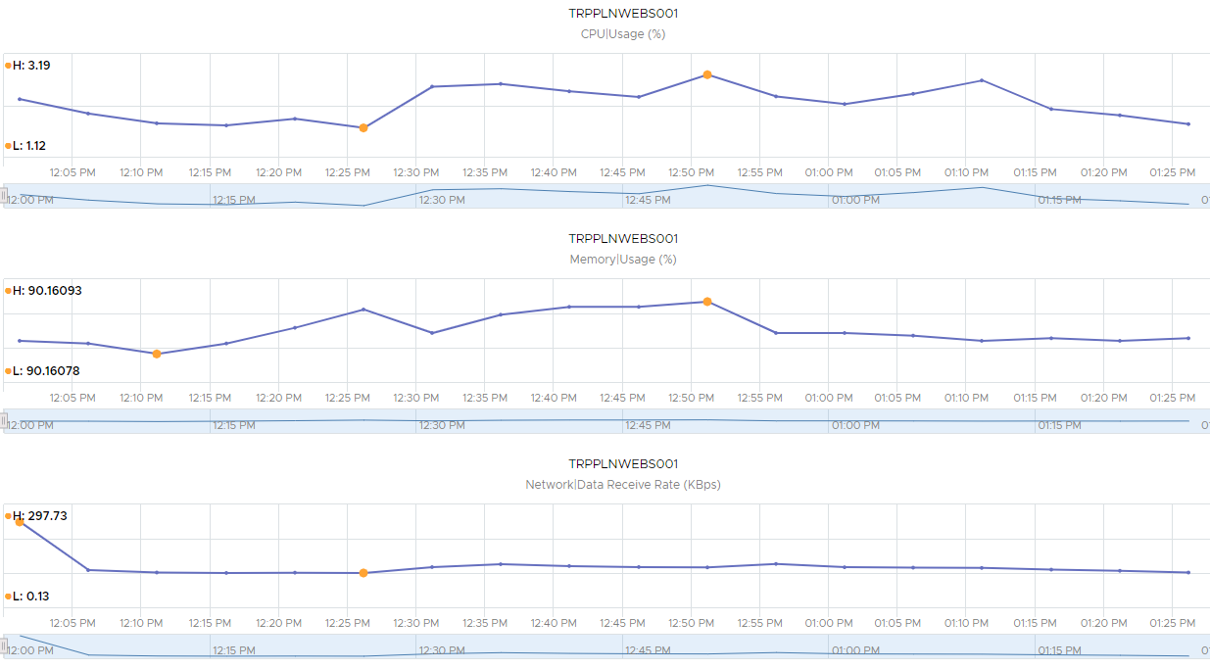

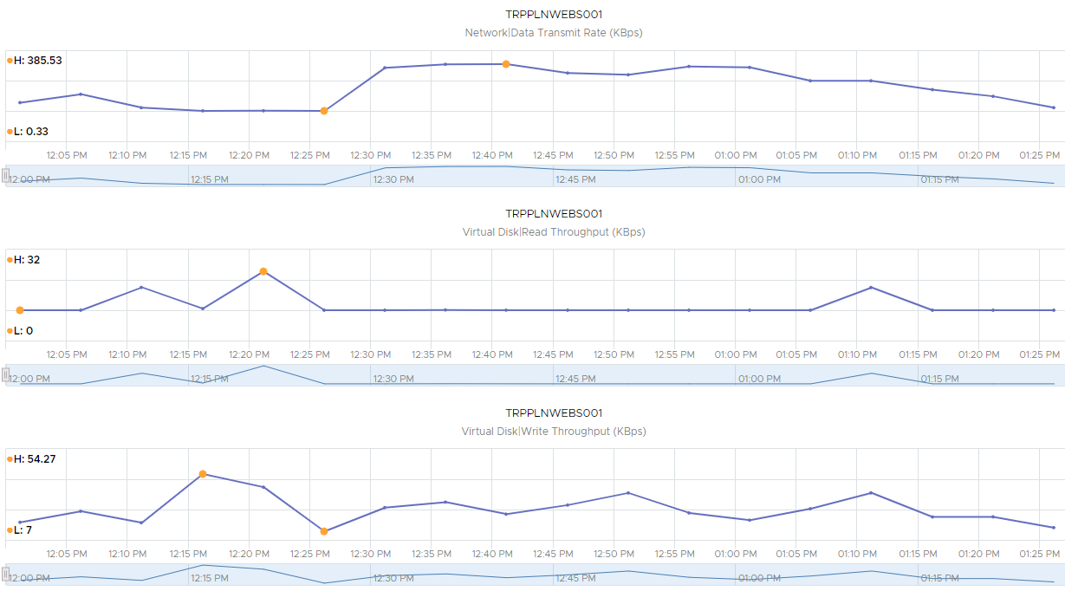

Here we see the 6 runs of the scenario **4.1 Trip Planner Capacity Test** applied to TRPPLNWEBS001.

*Baseline*

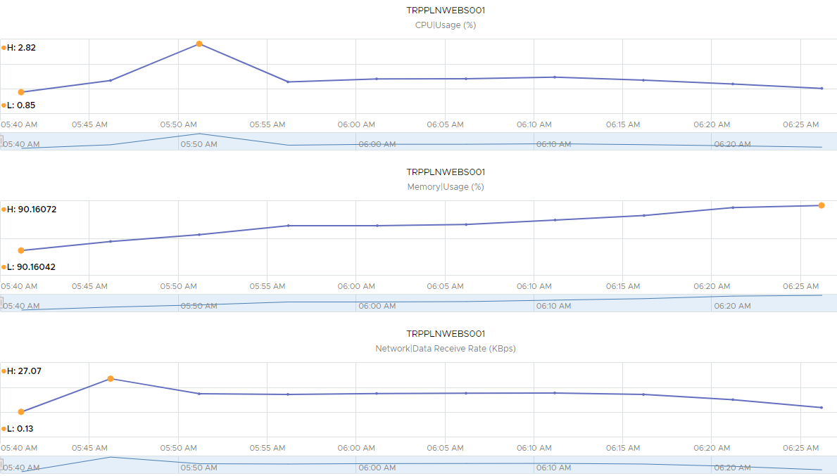

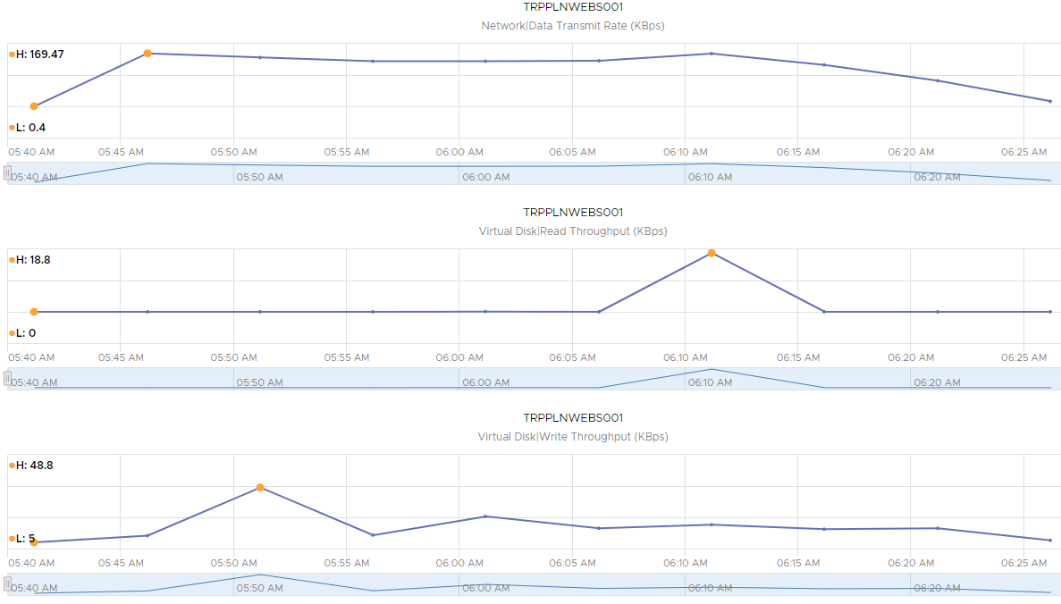

*Year 1*

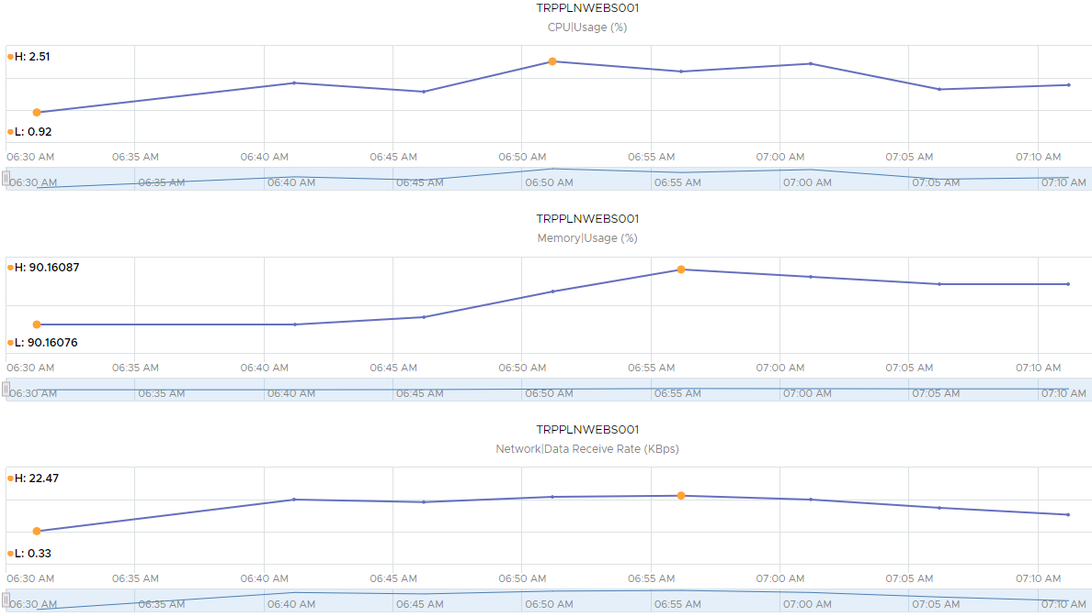

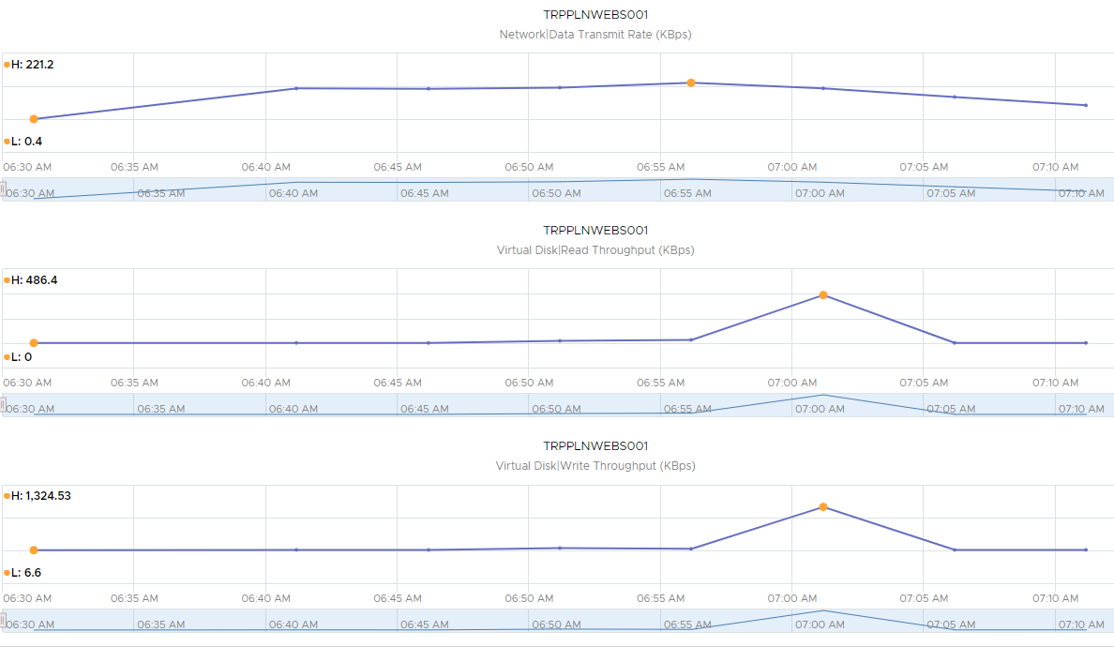

*Year 2*

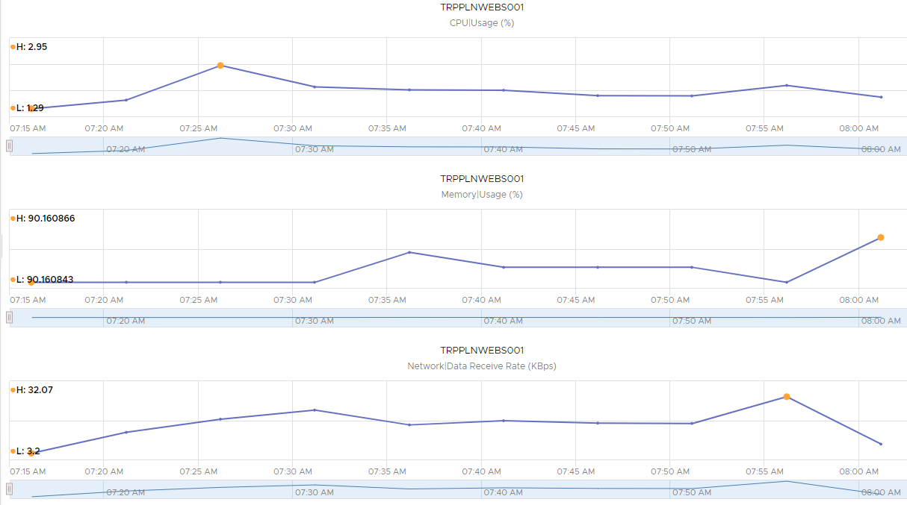

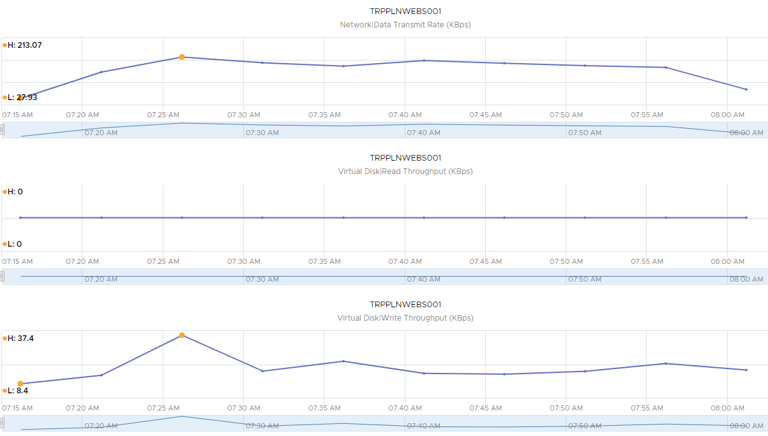

*Year 3*

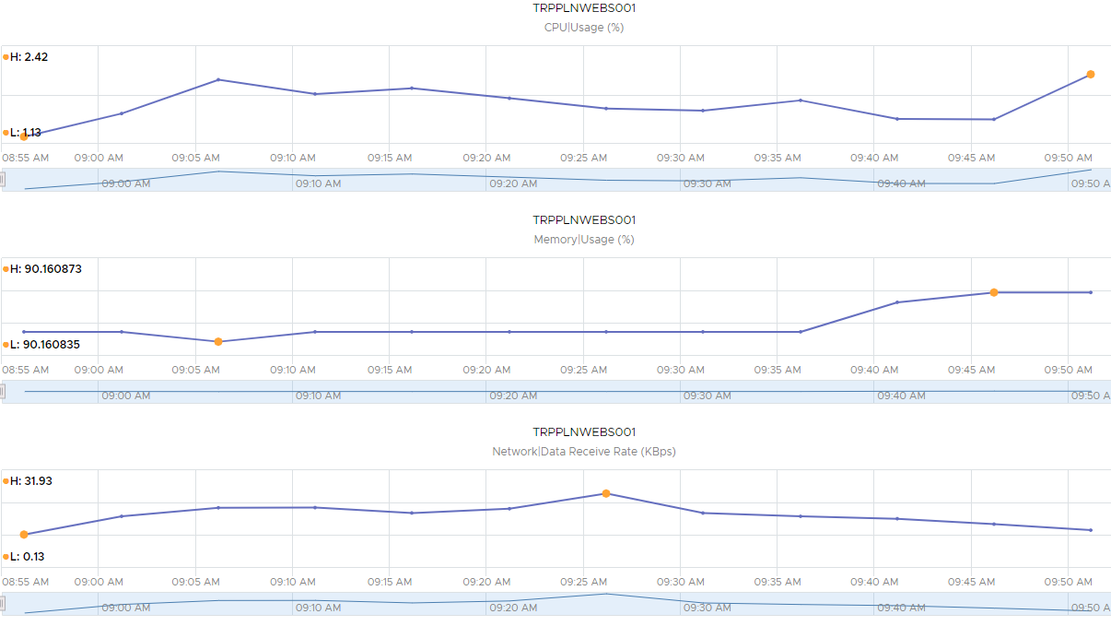

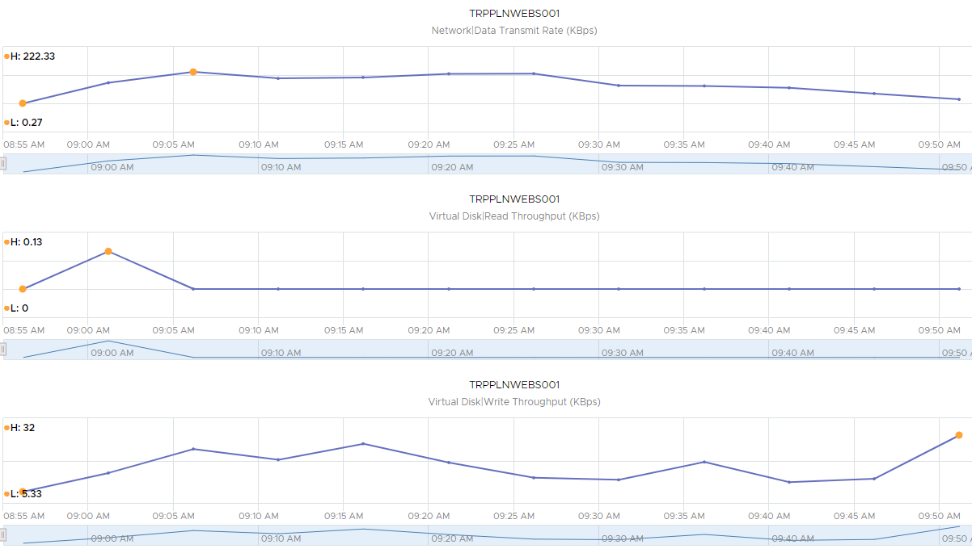

*Year 4*

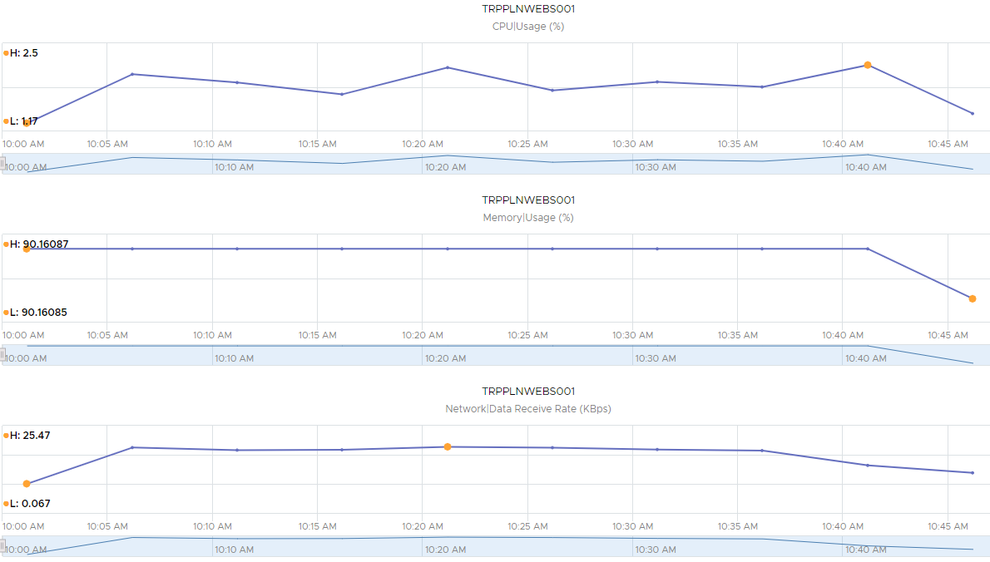

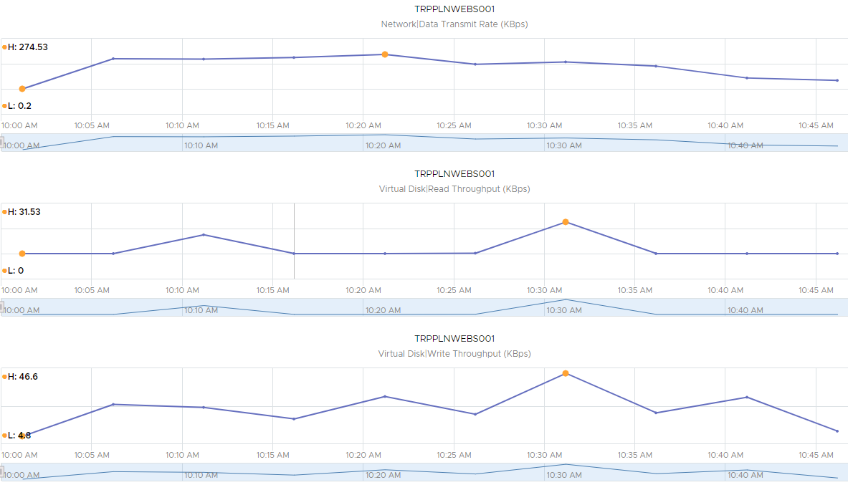

*Year 5*

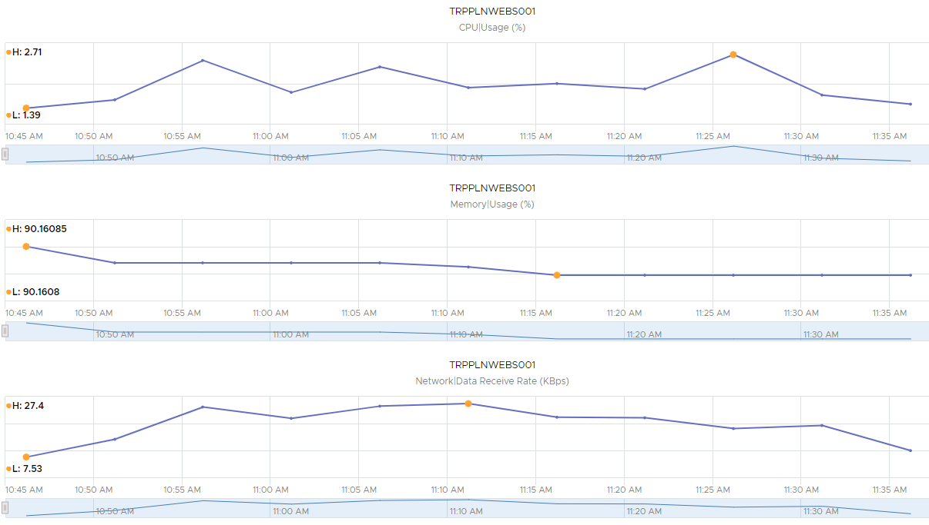

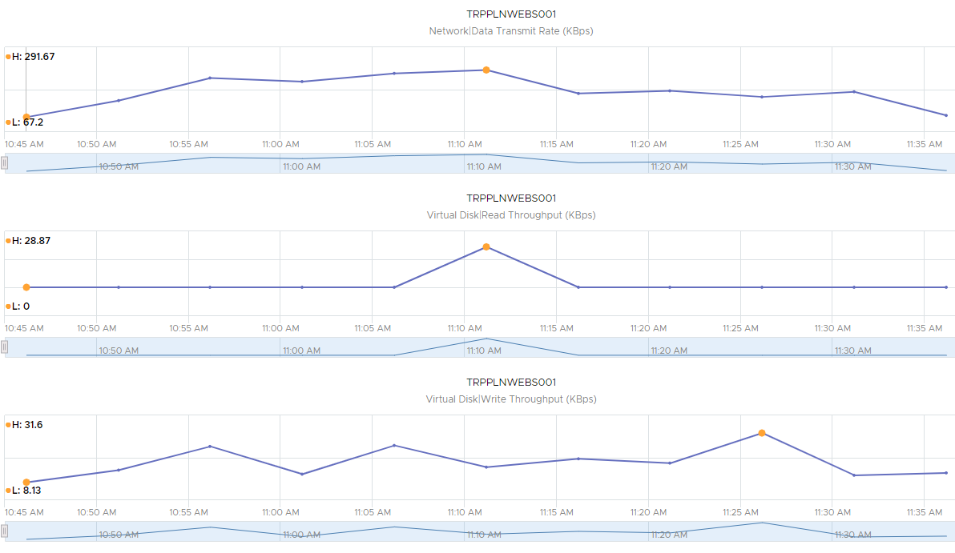

***May 23rd:***

Here we have the server metrics for the 7 runs conducted in scenario **2.1 Trip Planner Determine Failure Point,** as applied to TRPPLNWEBS002.

*16 Users*

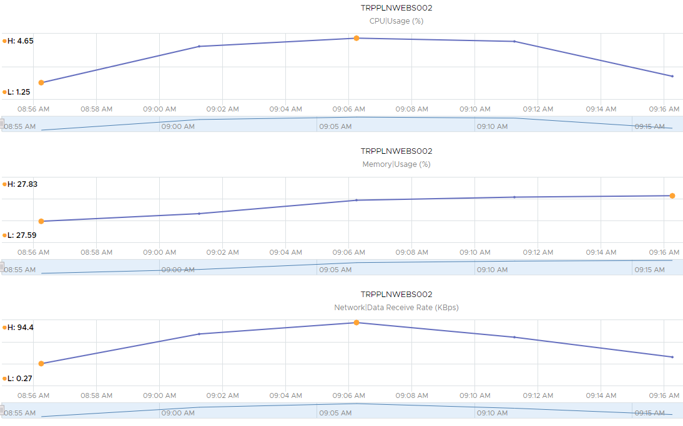

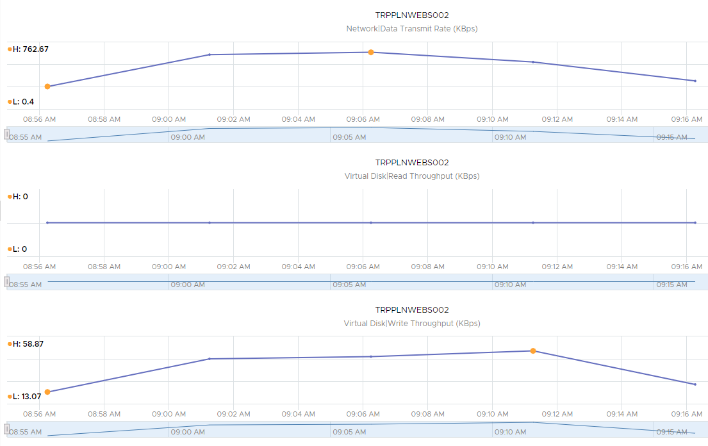

*32 Users*

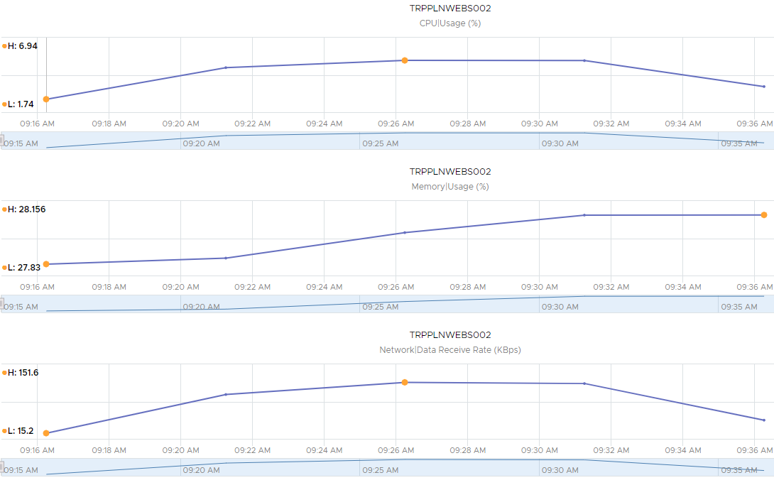

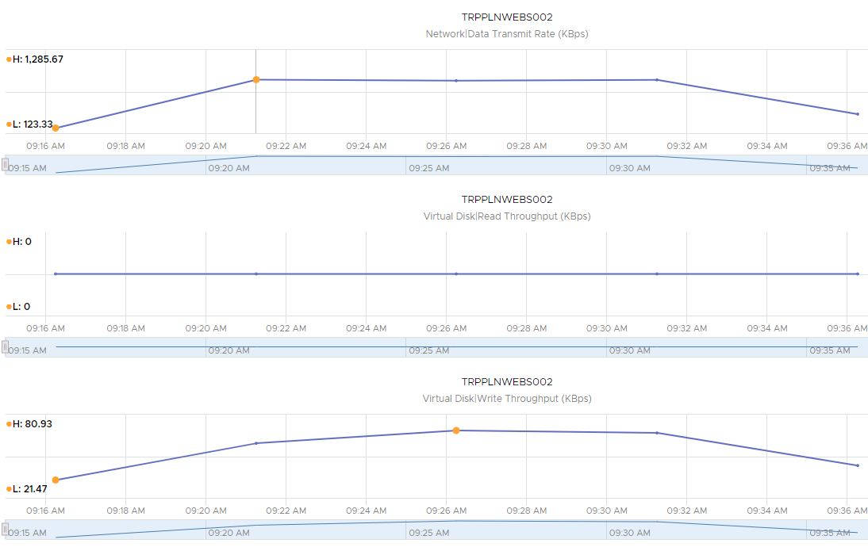

*48 Users*

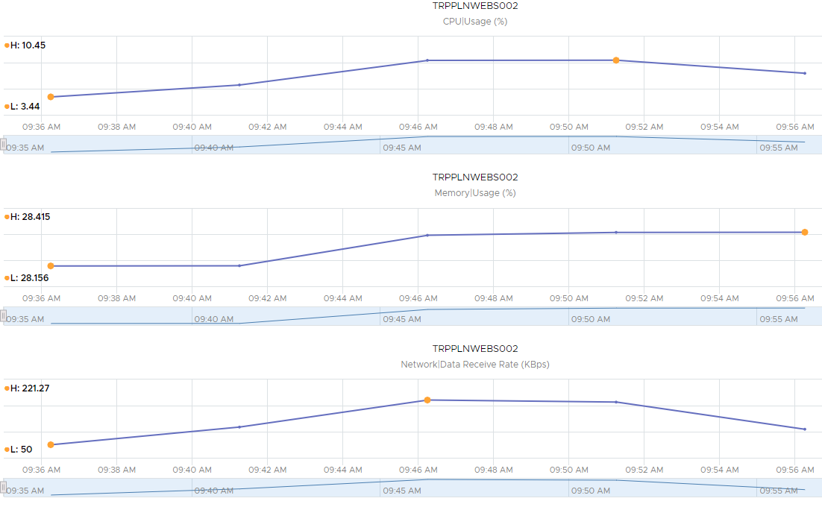

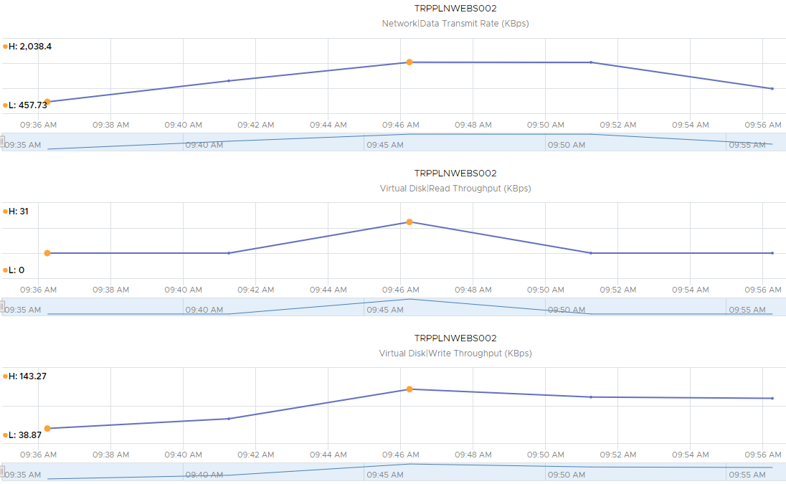

*64 Users*

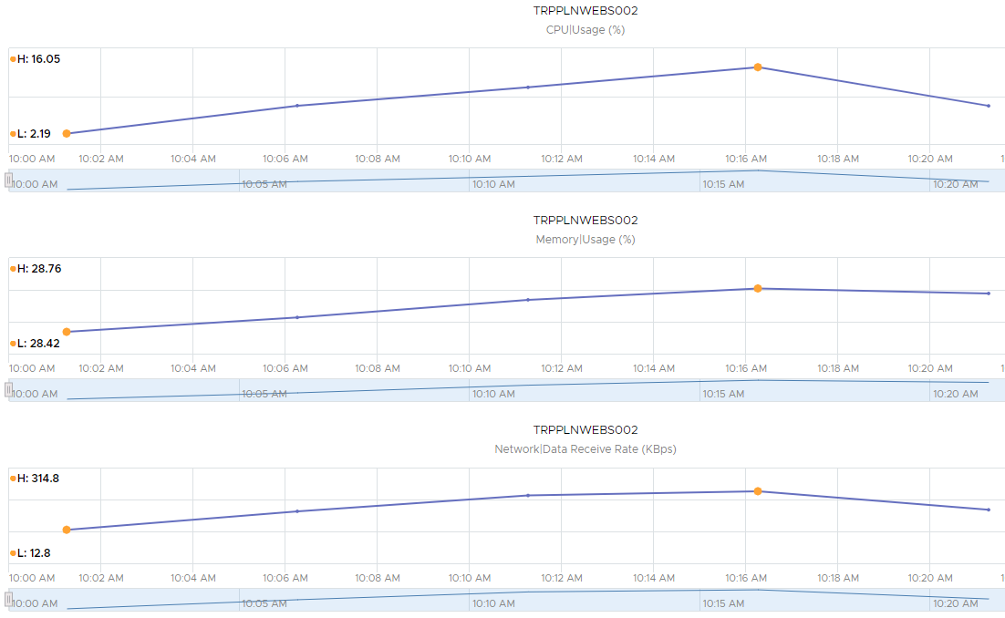

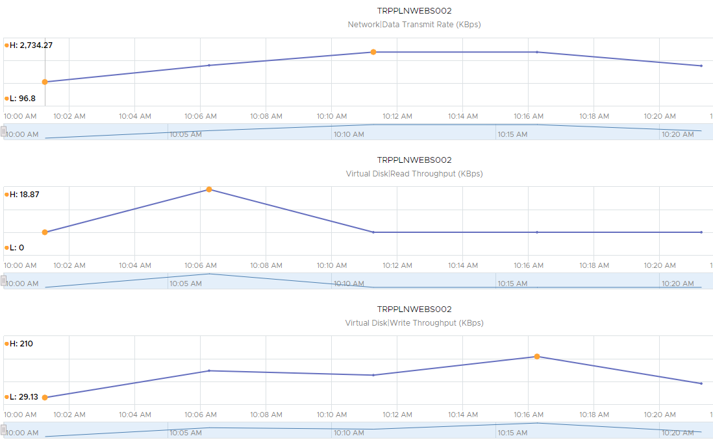

*80 Users*

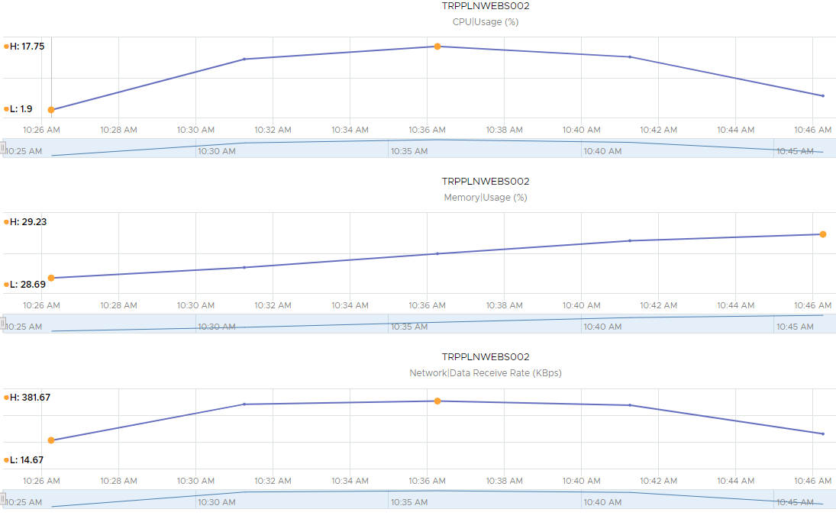

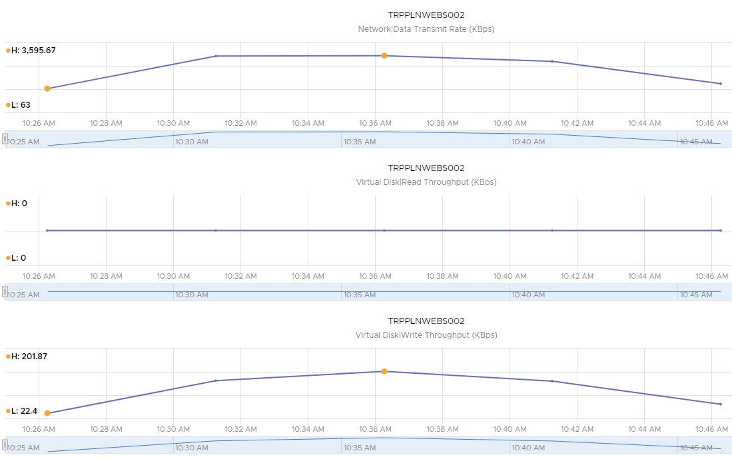

*100 Users*

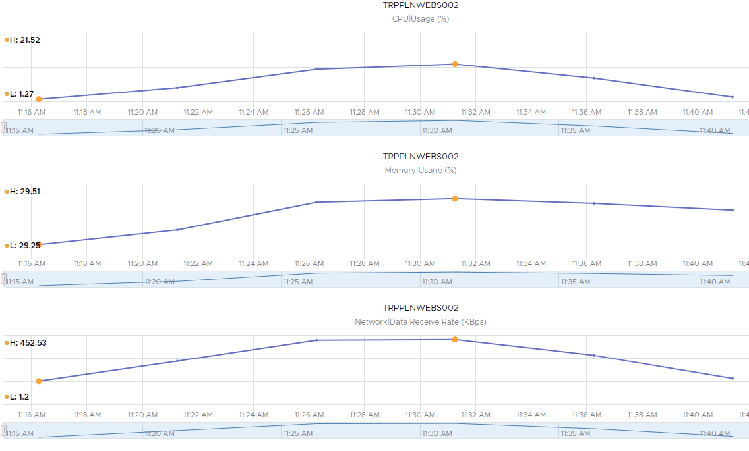

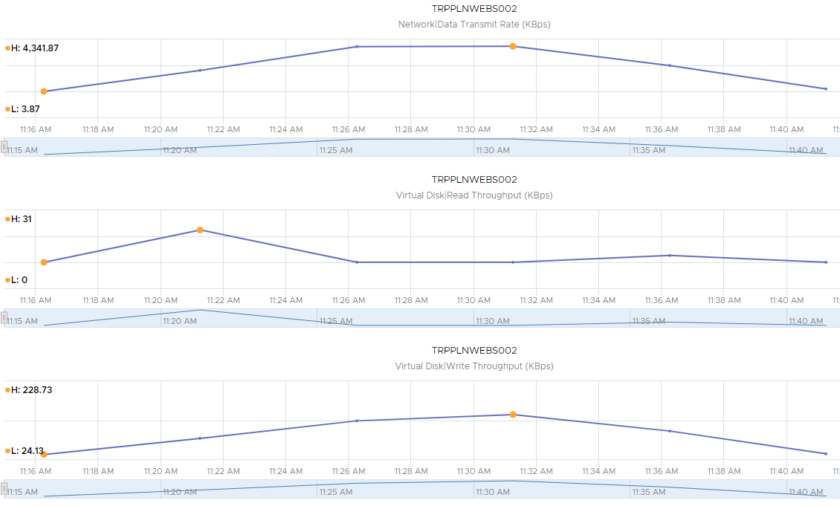

*125 Users*

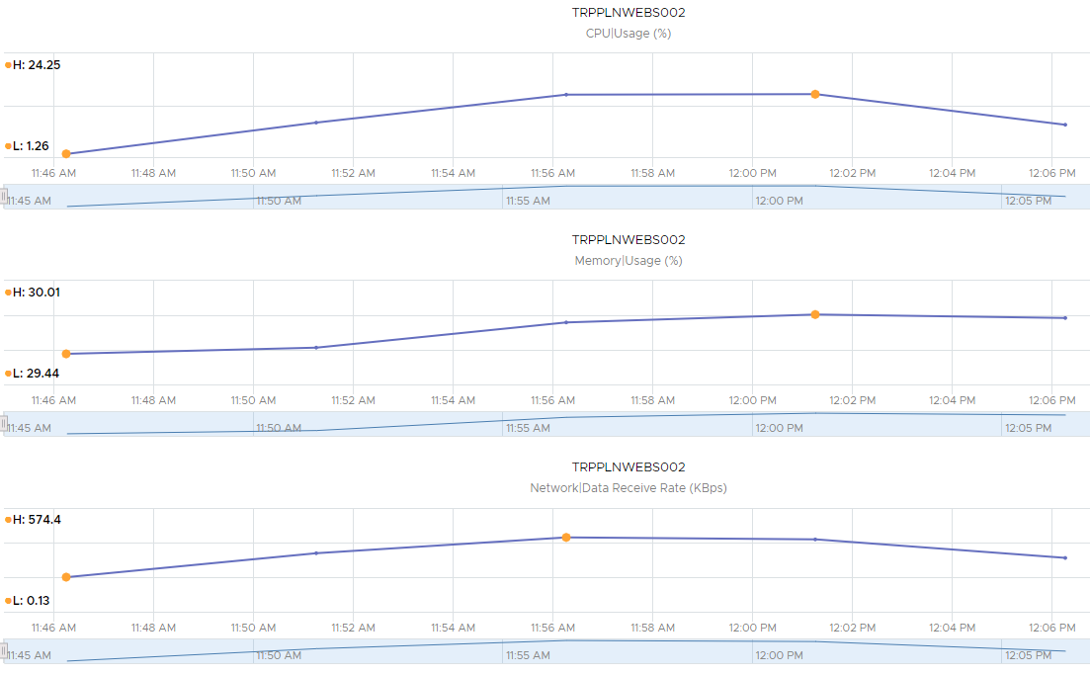

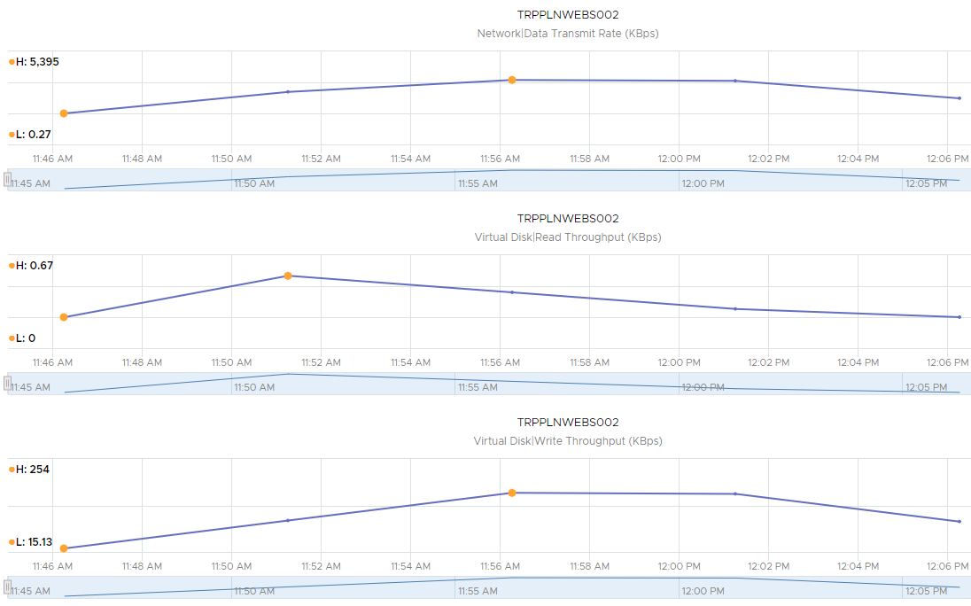

Here we see the server metrics for scenario **5.1 Trip Planner Endurance Test** as applied to TRPPLNWEBS002

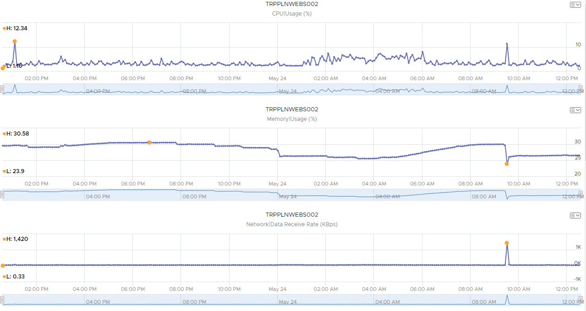

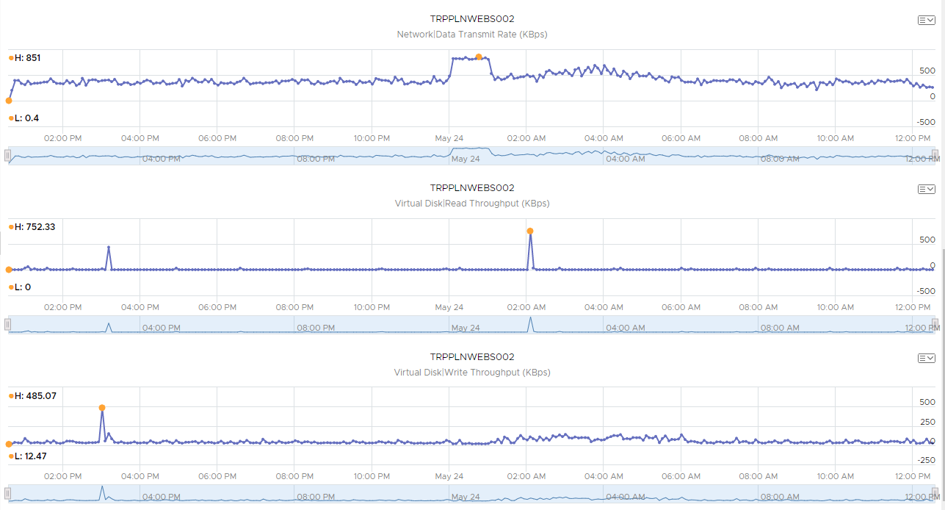

***May 27th***:

Here we see the server metrics for scenario **3.1 Trip Planner Spike Test** as applied to TRPPLNWEBS002.

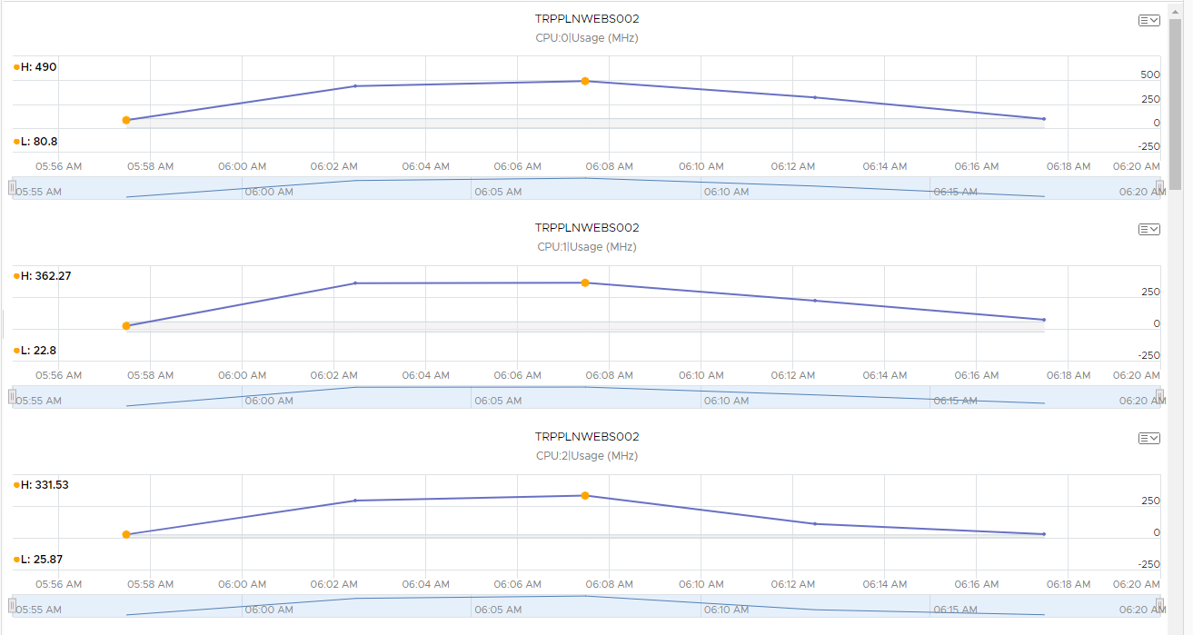

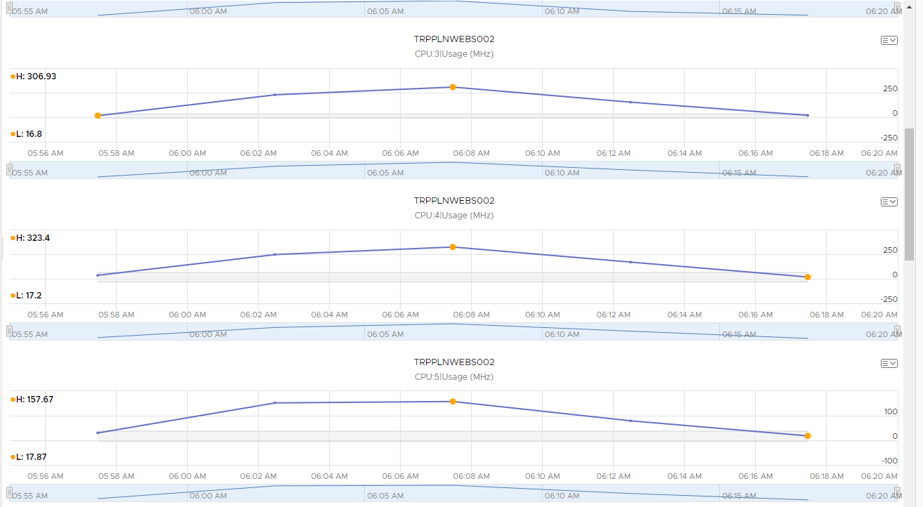

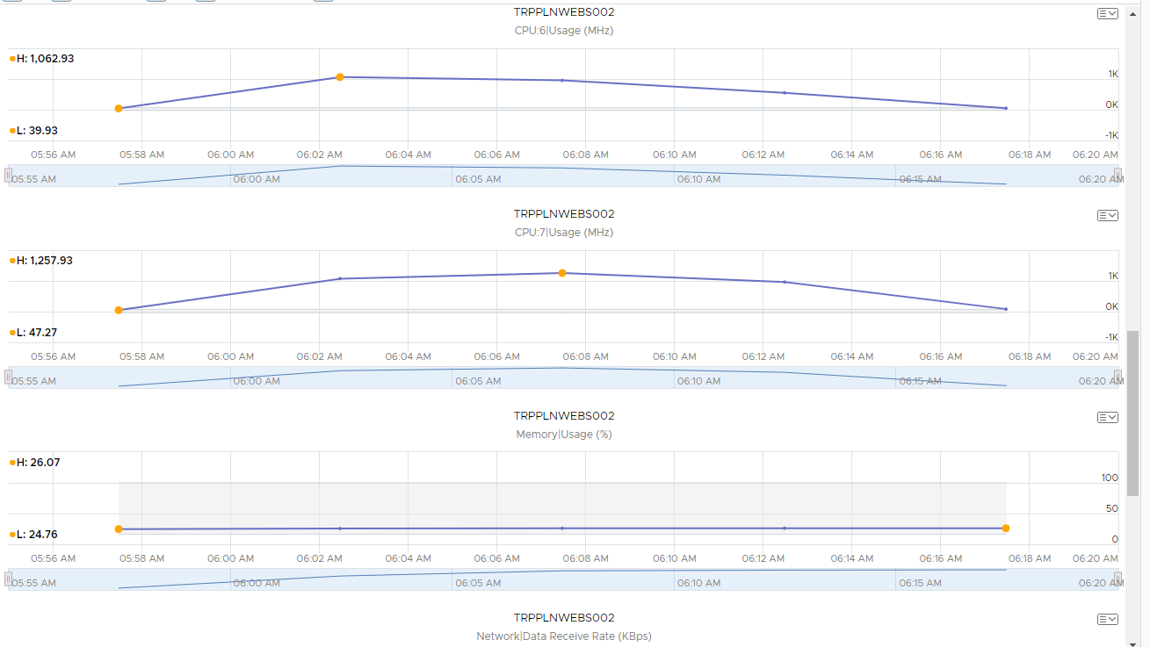

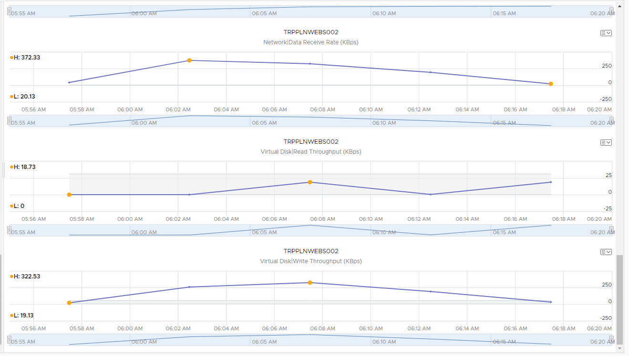

We followed the previous test with **Scenario 4.2 Trip Planner Future Capacity** against the load balancer. The first four runs are evident in the morning metrics for both servers.

*TRPPLNWEBS001*

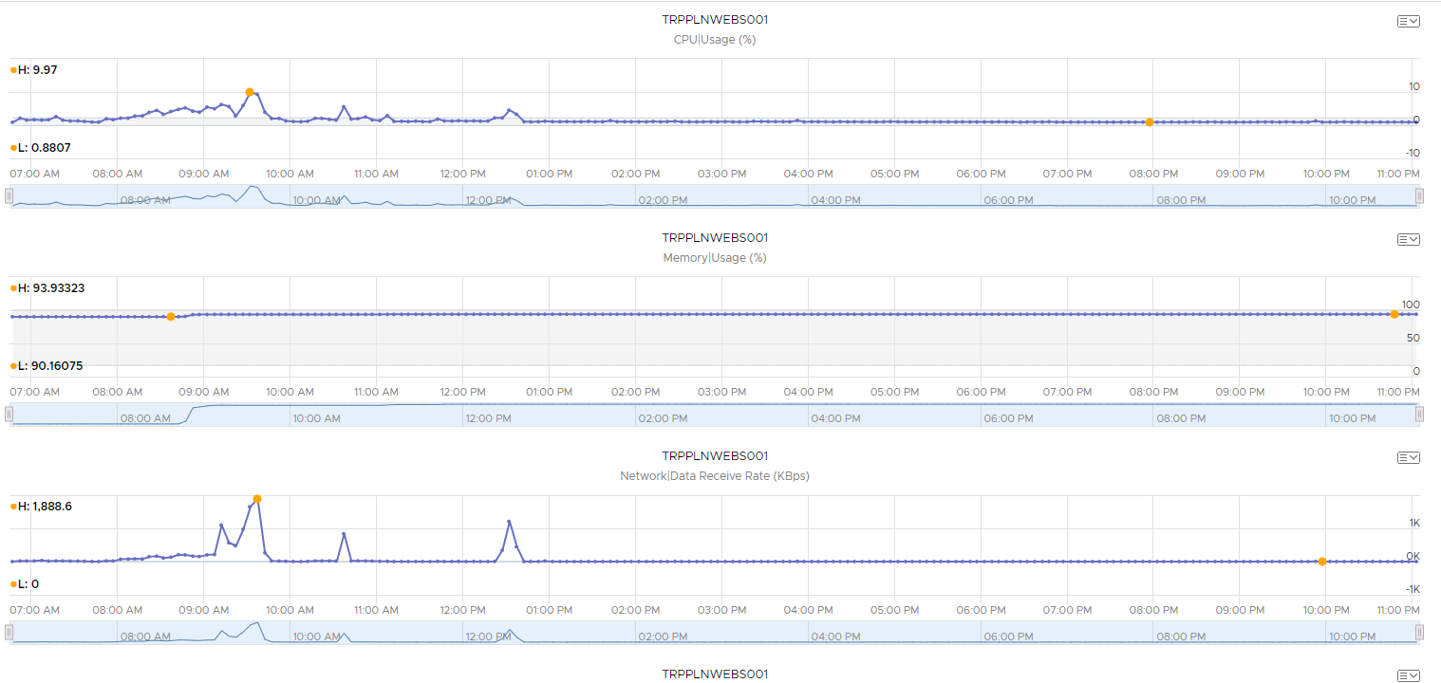

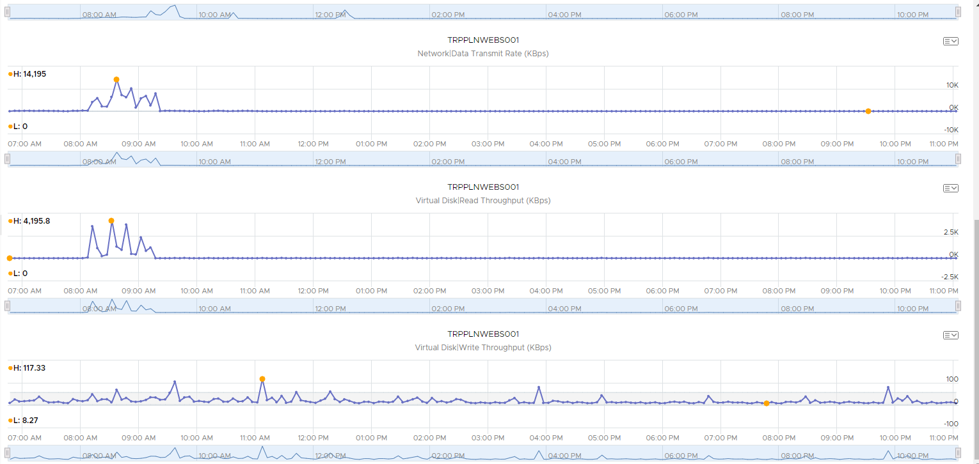

*TRPPLNWEBS002*

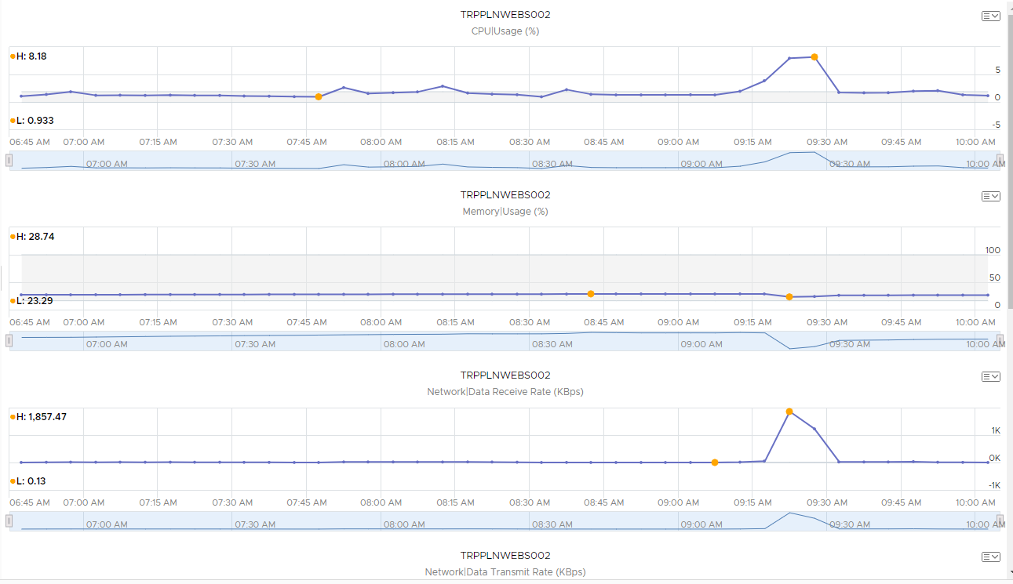

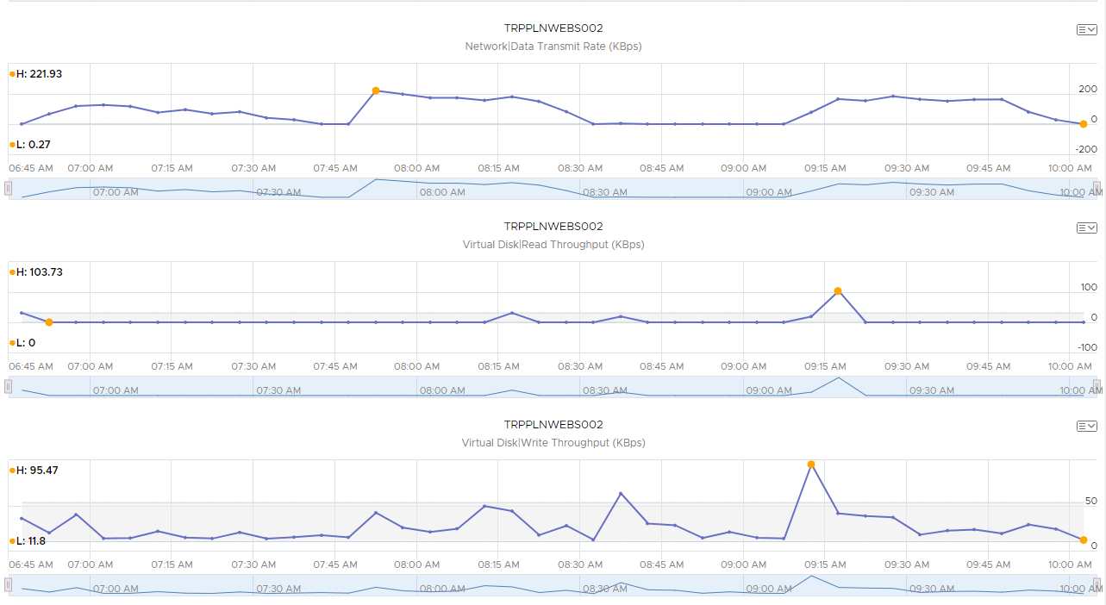

***May 28th***:

The remaining runs for **Scenario 4.2 Trip Planner Future Capacity** were run in the early morning, finishing by 7:17 AM. This was followed by **Scenario 1.2 Trip Planner Historical Peak** (starting at 7:42 AM)) and **Scenario 3.2 Trip Planner Spike Test**, all against the load balancer. The spike test provides the clearest peak, starting at about 9:45 AM.

*TRPPLNWEBS001*

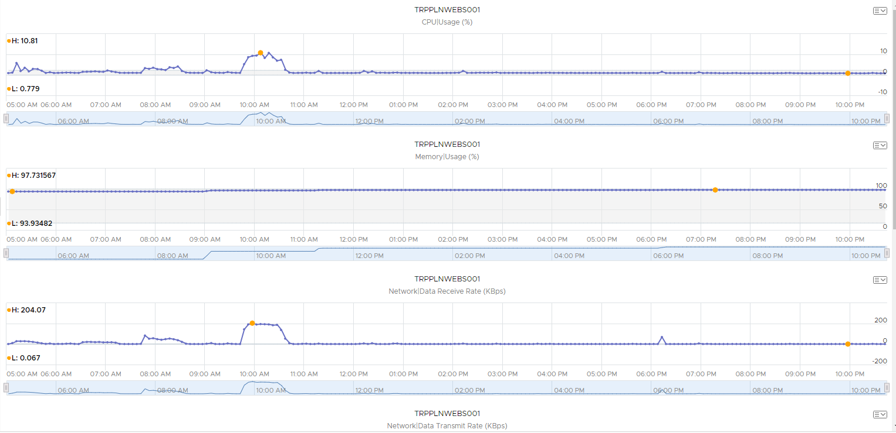

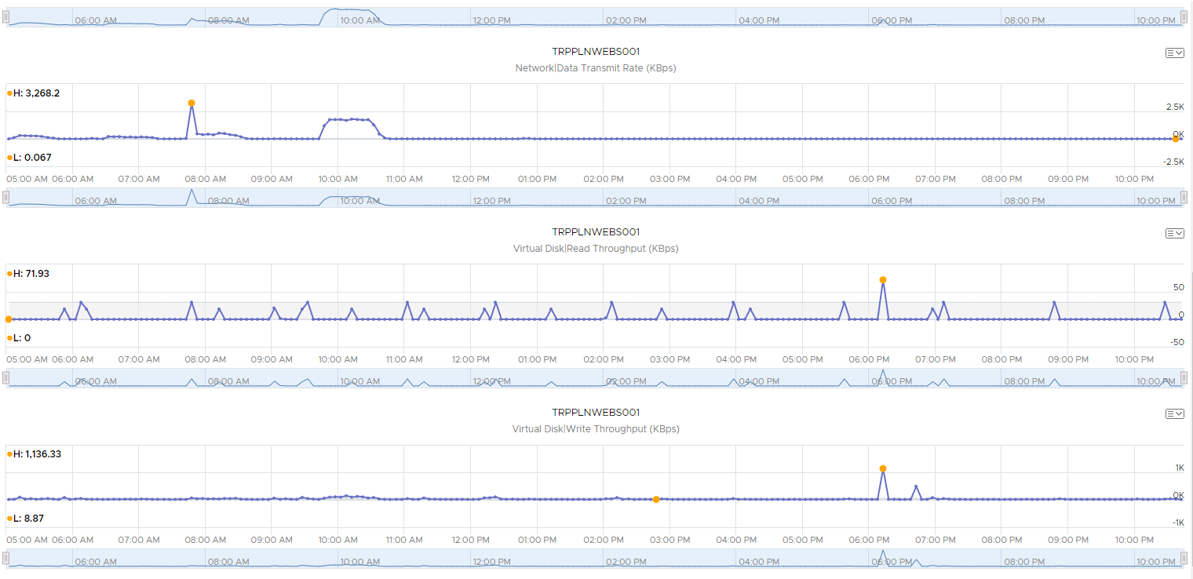

*TRPPLNWEBS002*

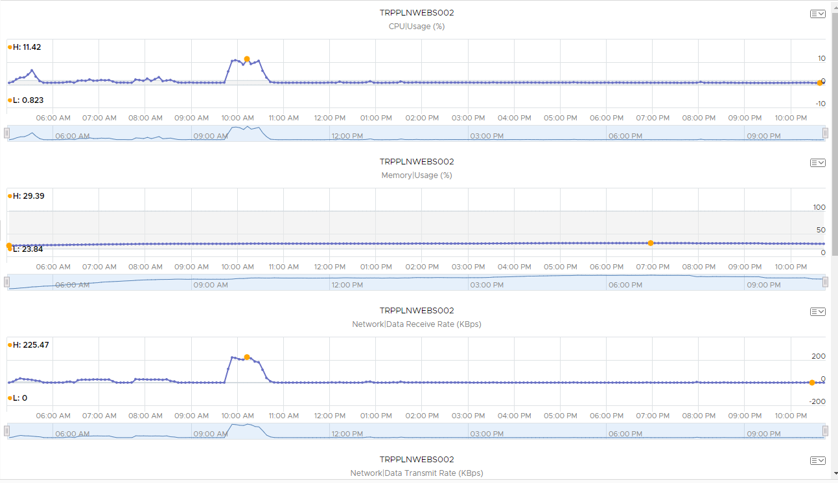

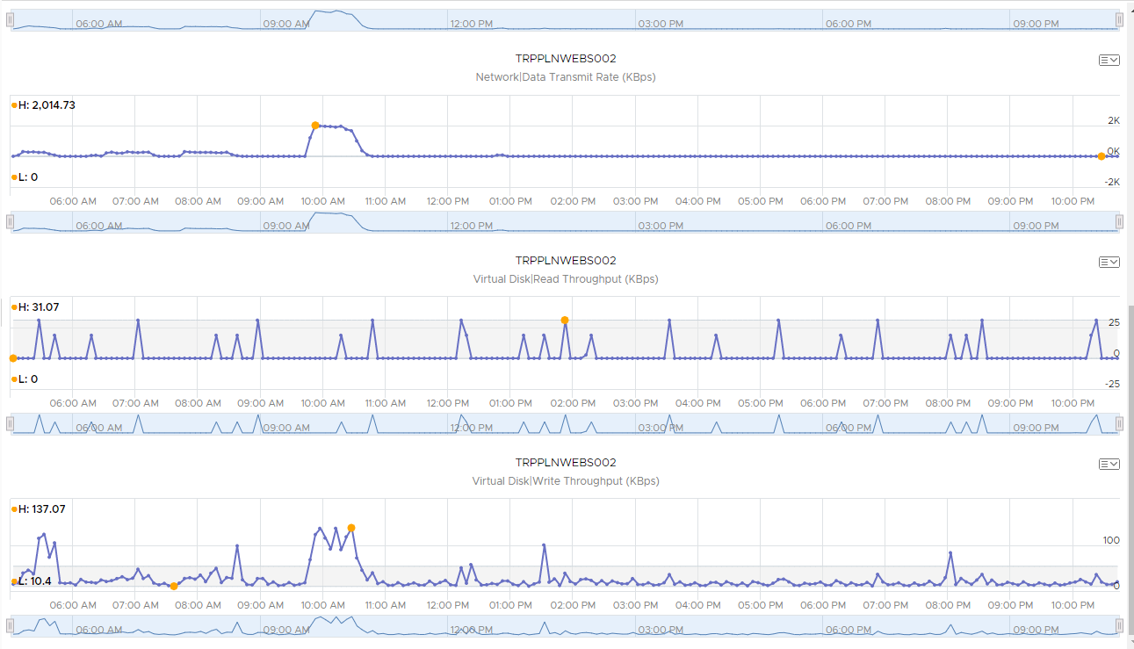

***May 29th***:

Here we see the effects of the load tests that were run for **Scenario 2.2 Determine Failure Point**. The CPU usage shows the load most clearly – we have the first 5 runs, followed by a short break, then the last 2 runs.

*TRPPLNWEBS001*

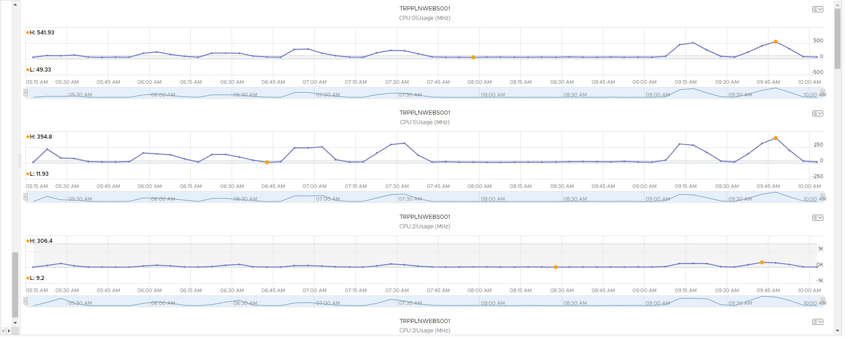

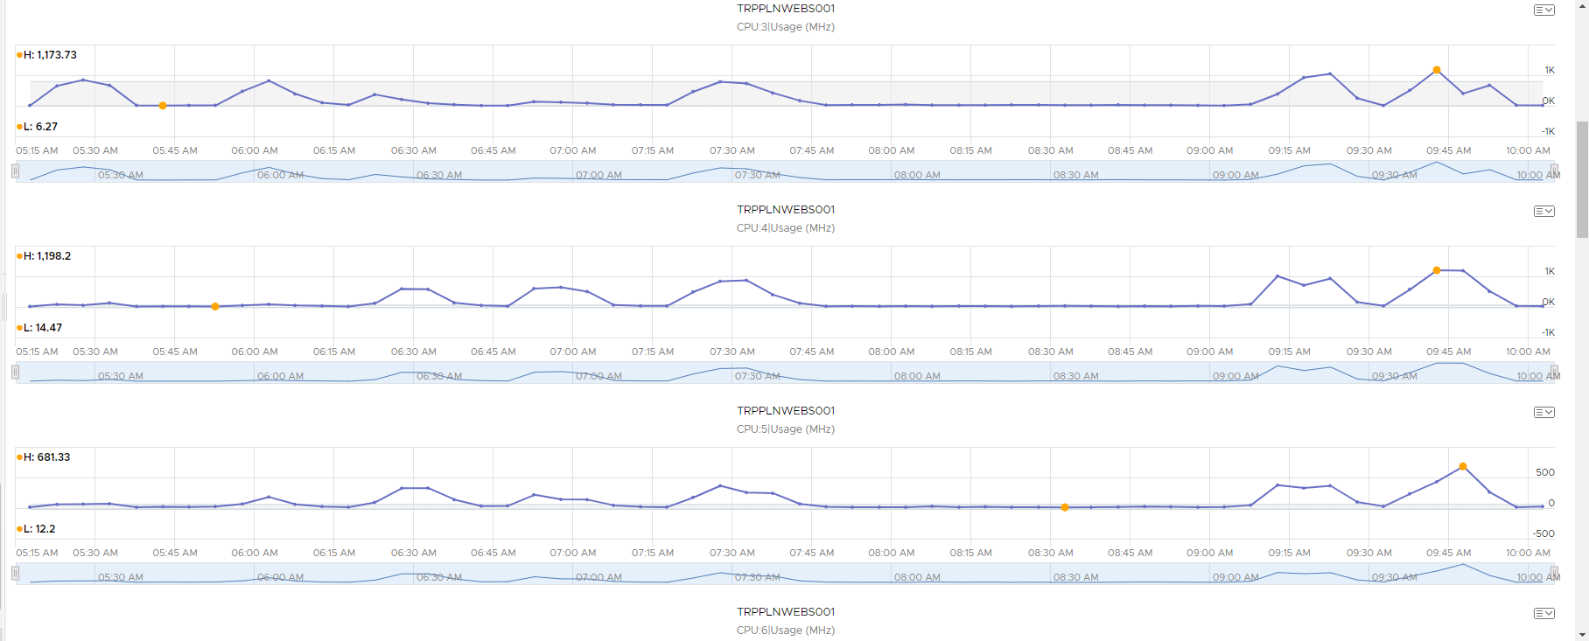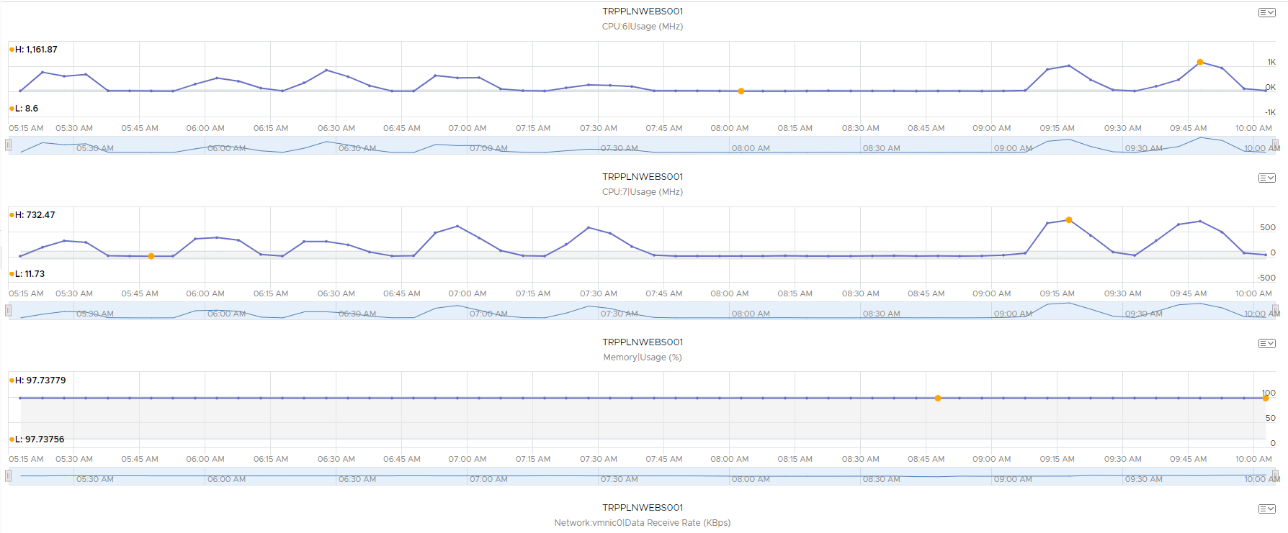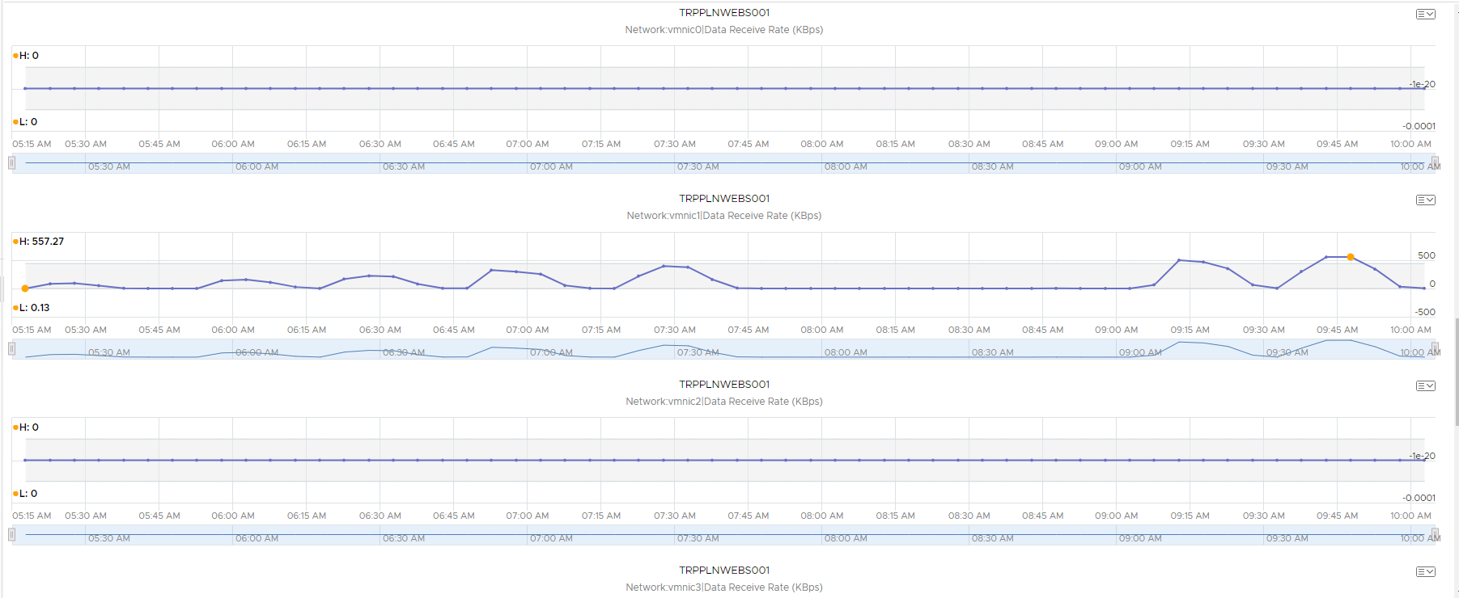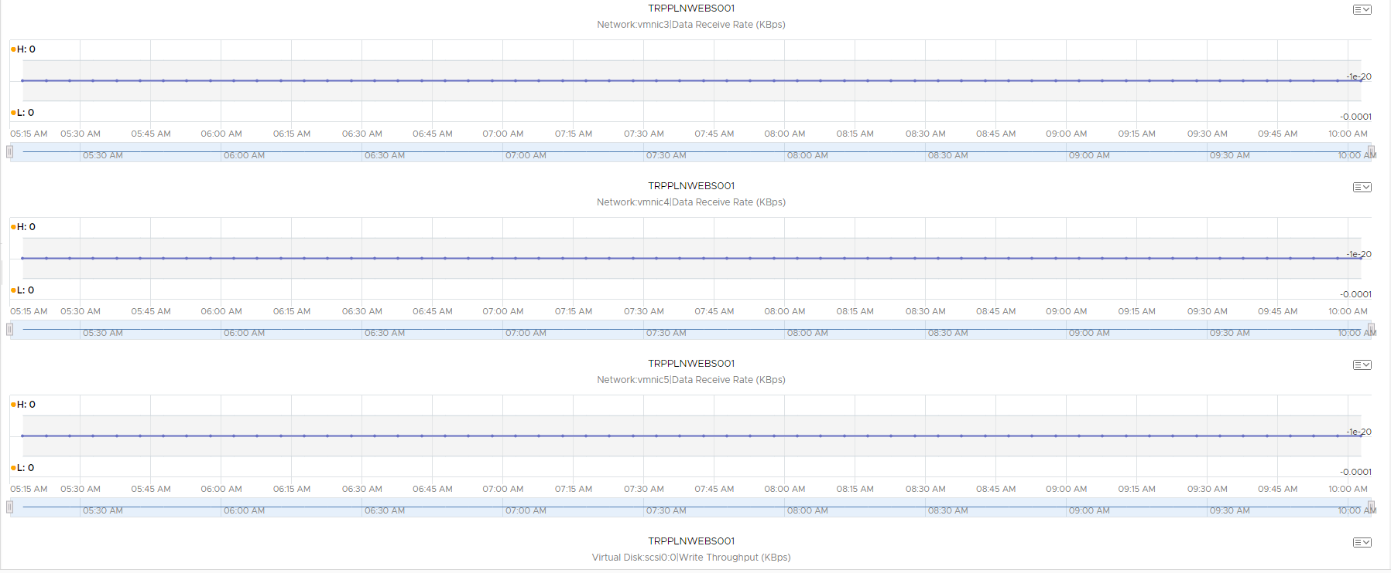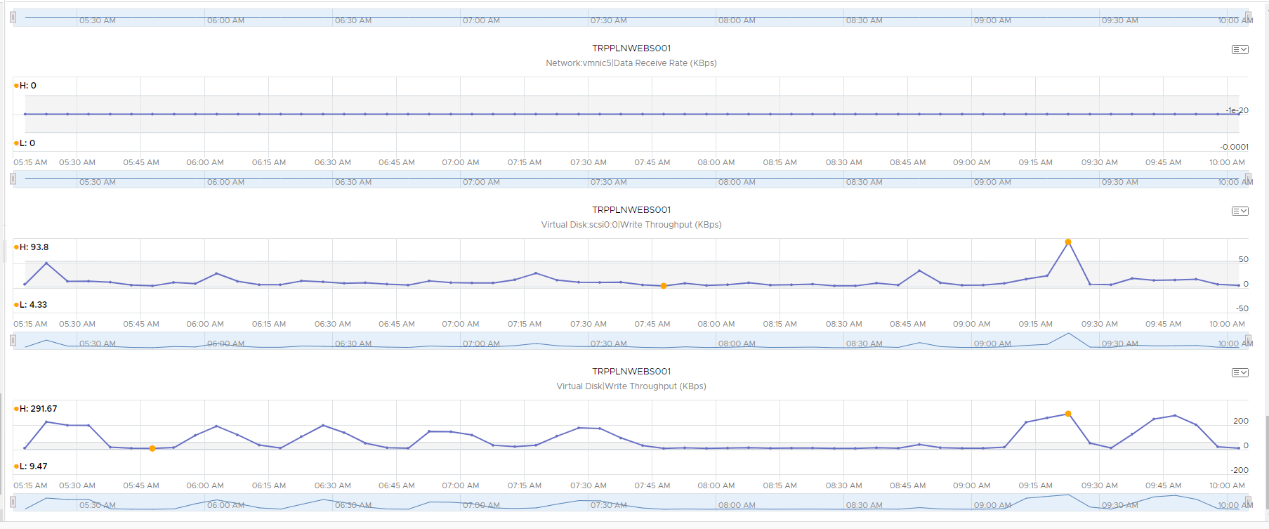

*TRPPLNWEBS002*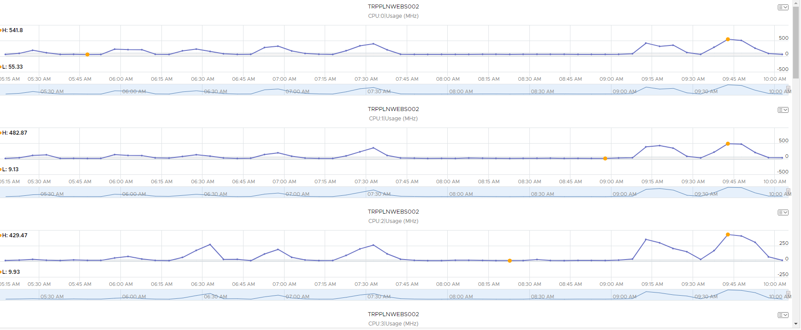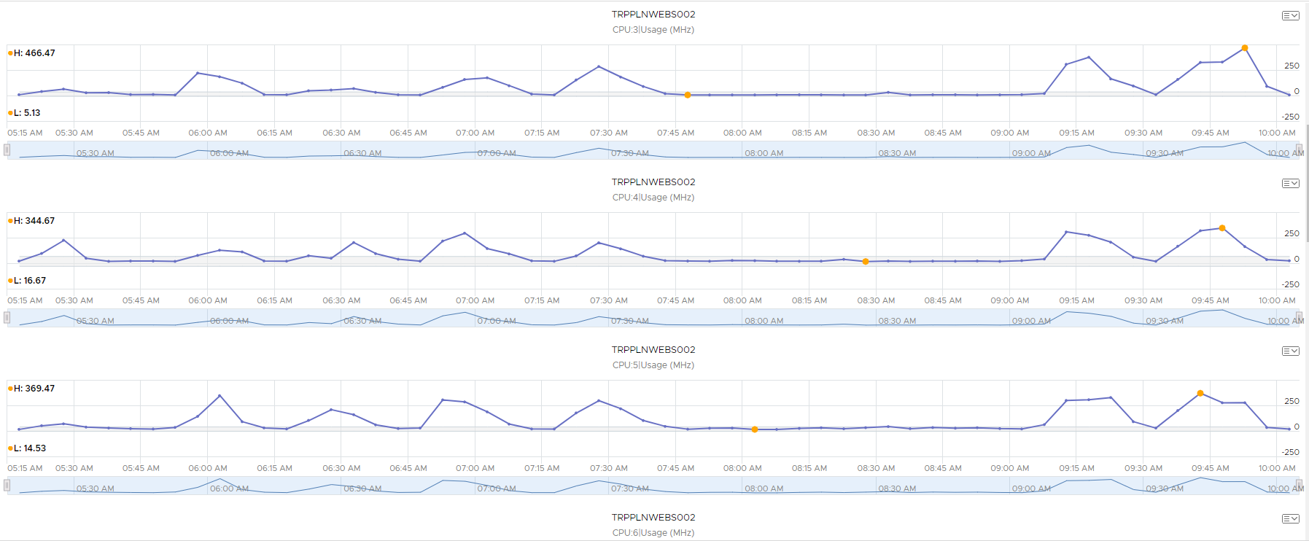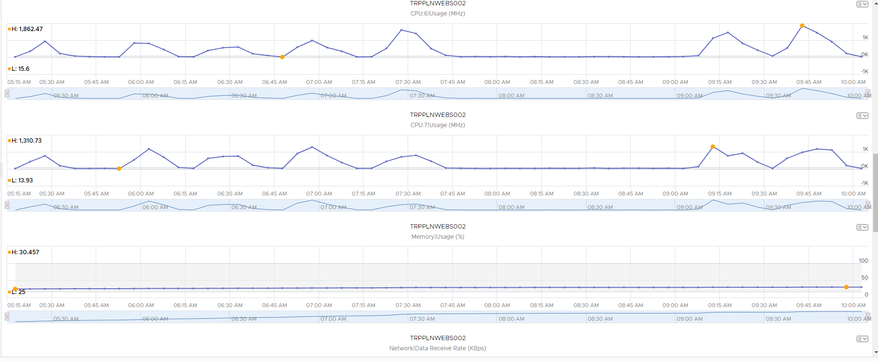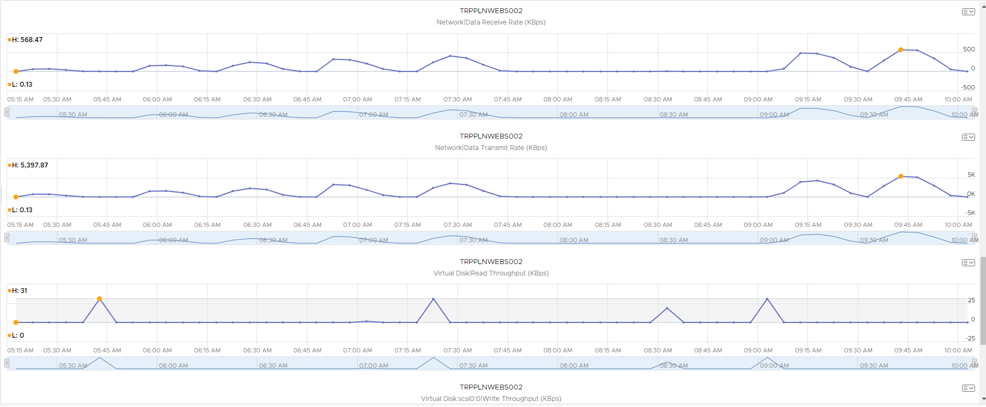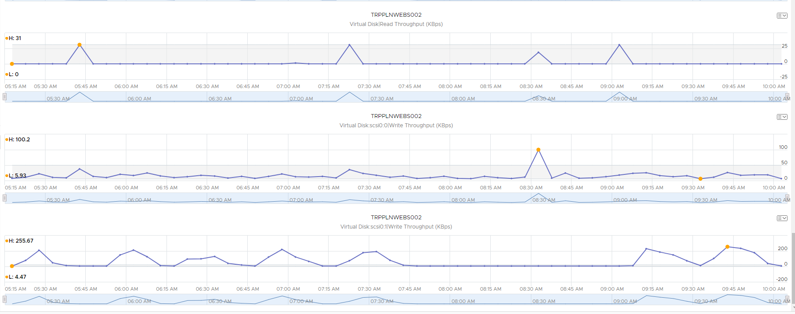

***May 30th – 31st***:

This covers the final 24 stress test **Scenario 5.2 Trip Planner Endurance Test**. It looks as though TRPPLNWEBS002 handled the bulk of the work after about 3:45 PM on May 30th.

*TRPPLNWEBS001*

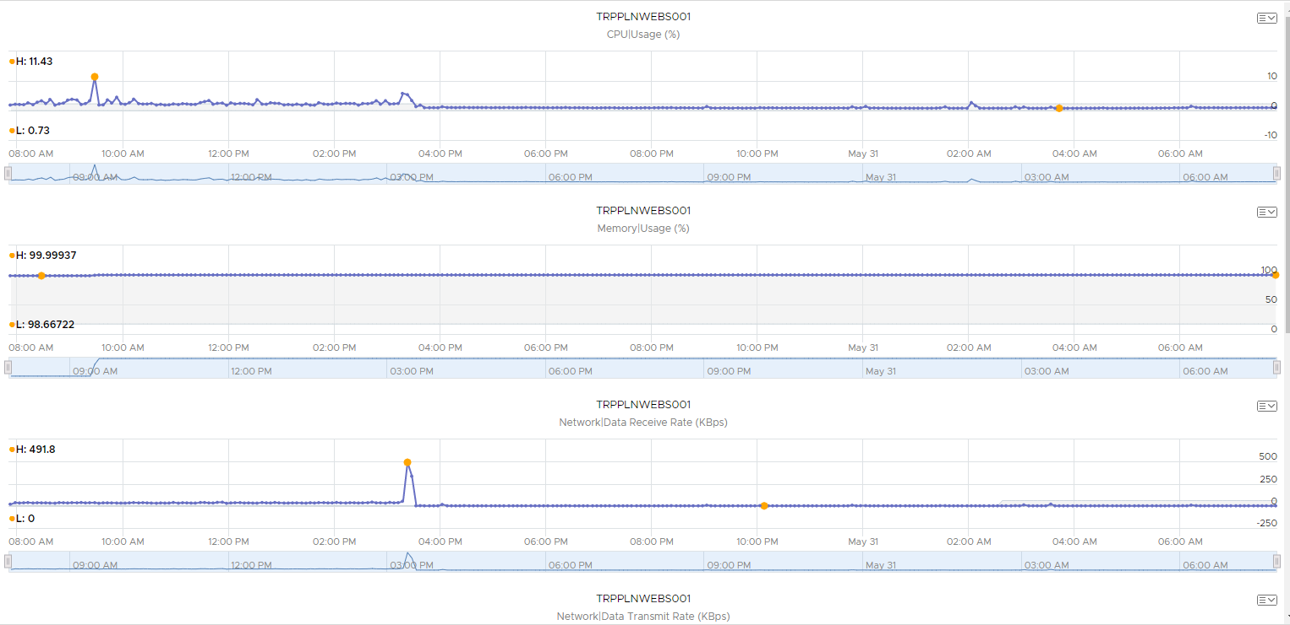

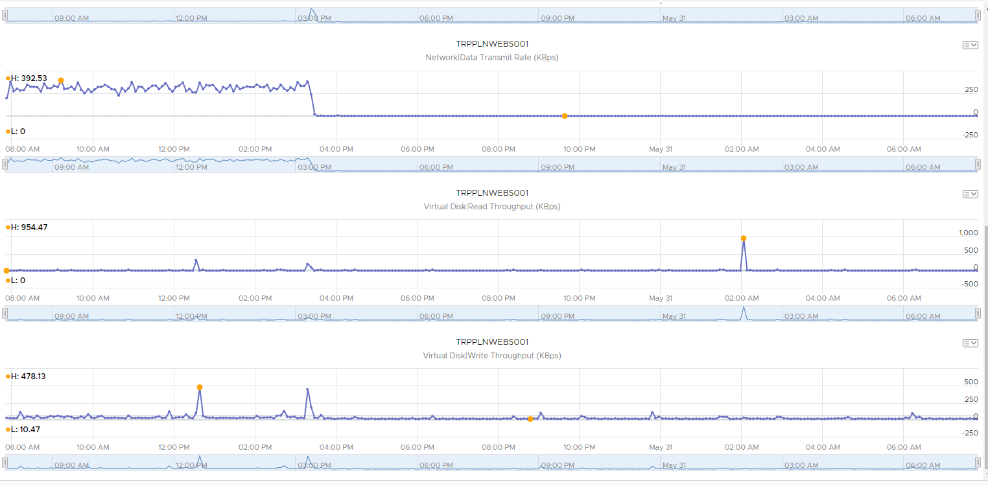

*TRPPLNWEBS002*

